Primitives call by value , instance – call by ref

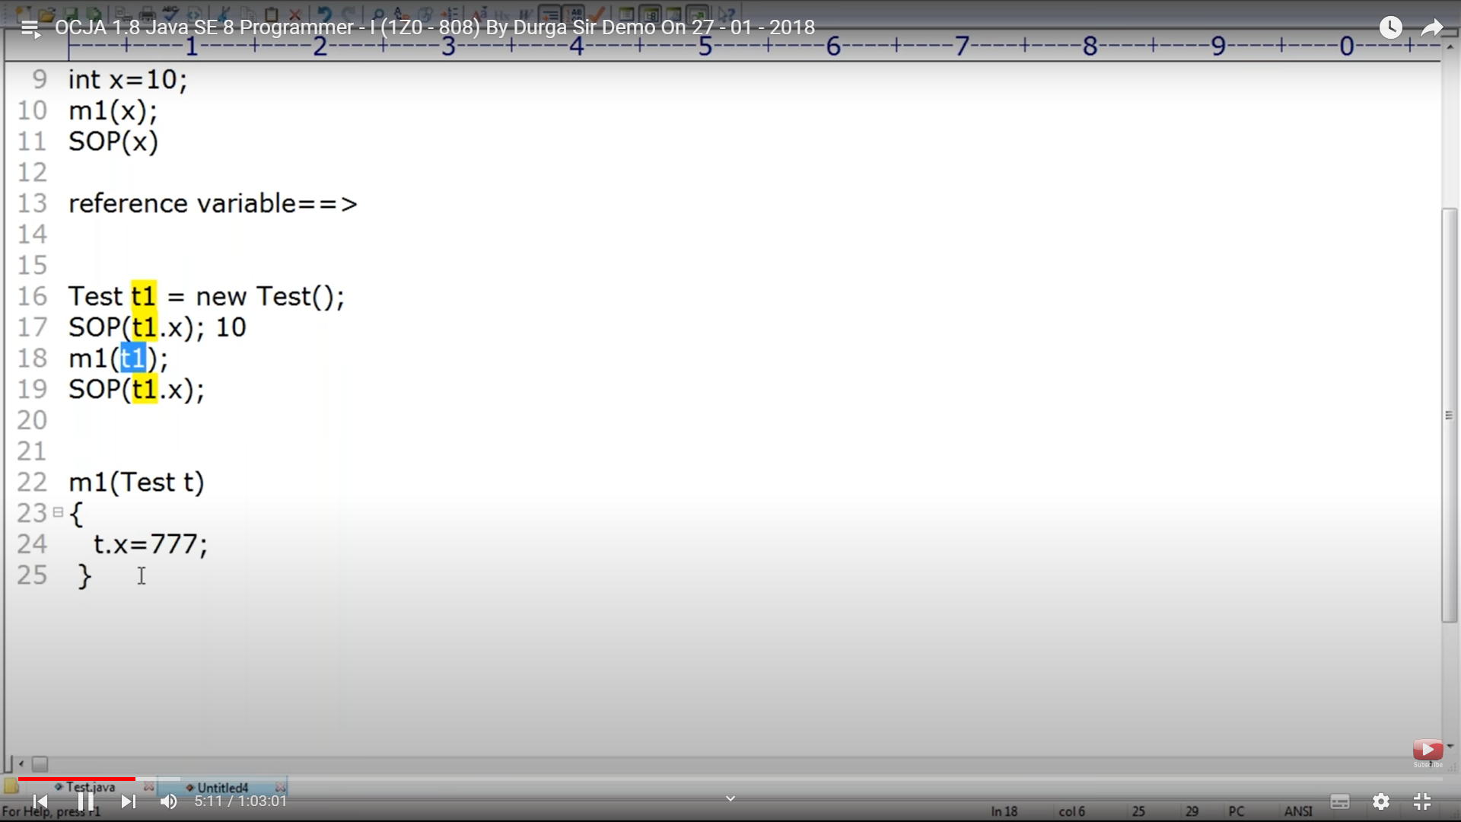

Passing primitives.

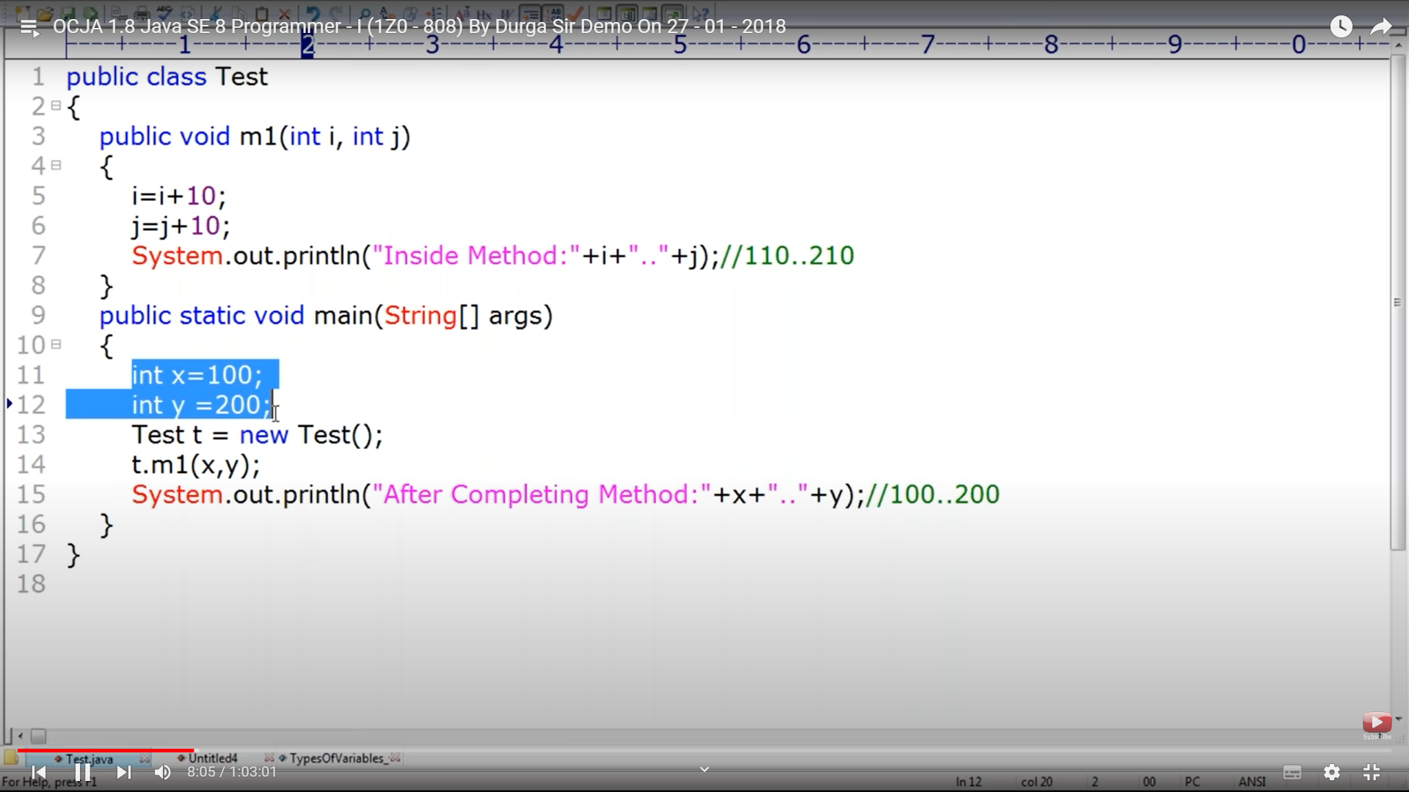

Local variable I and j is not impacted by instance methods and const.

3.. 5

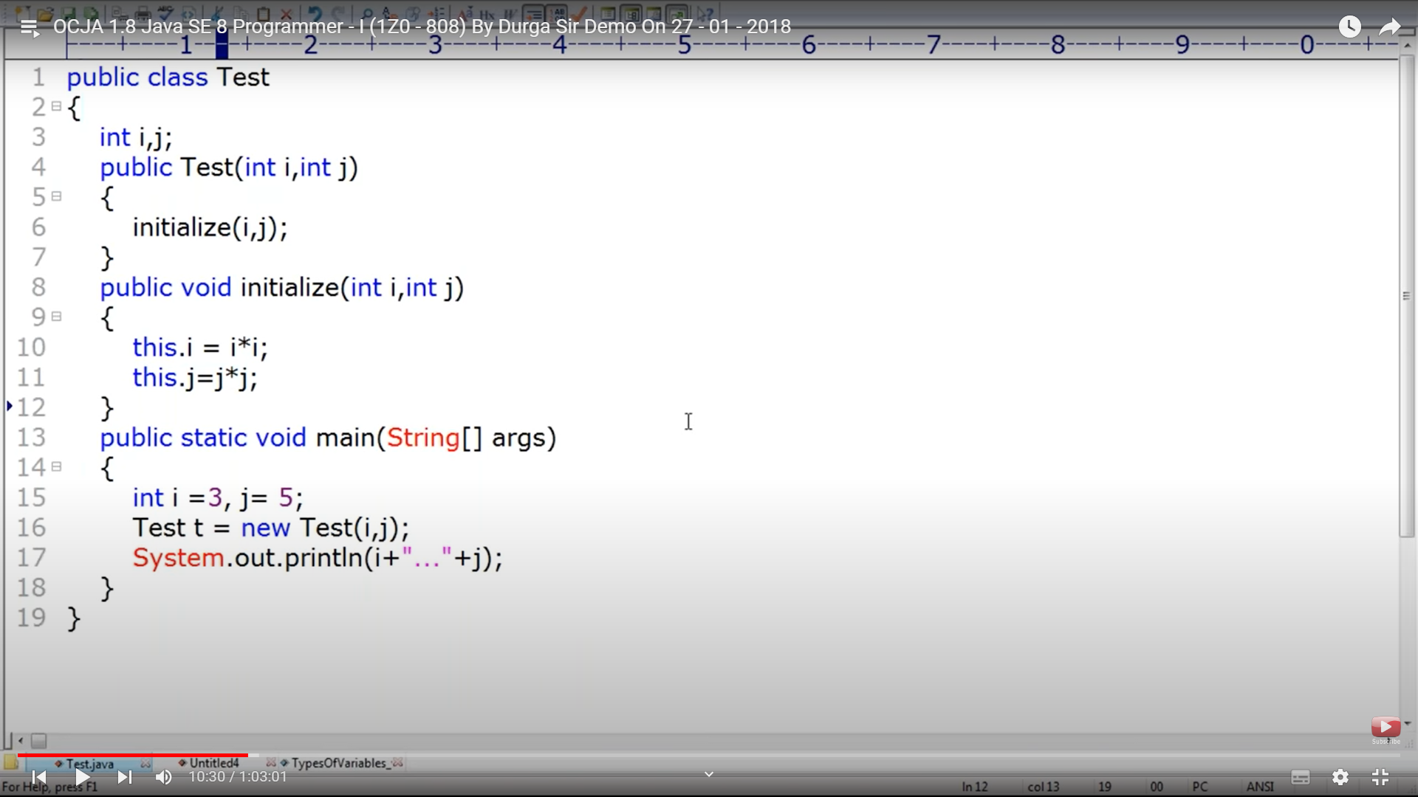

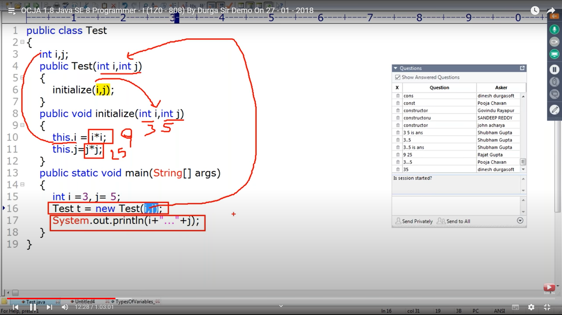

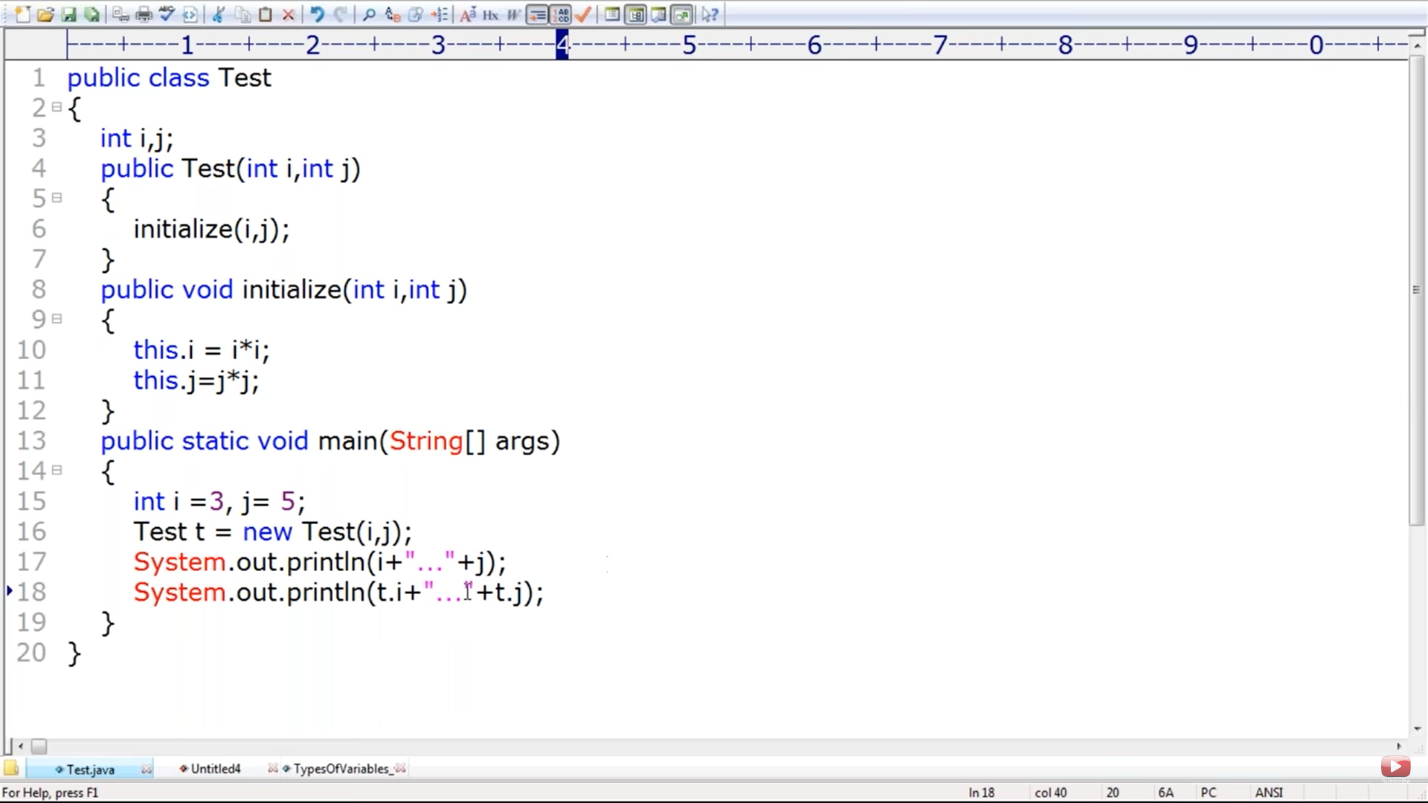

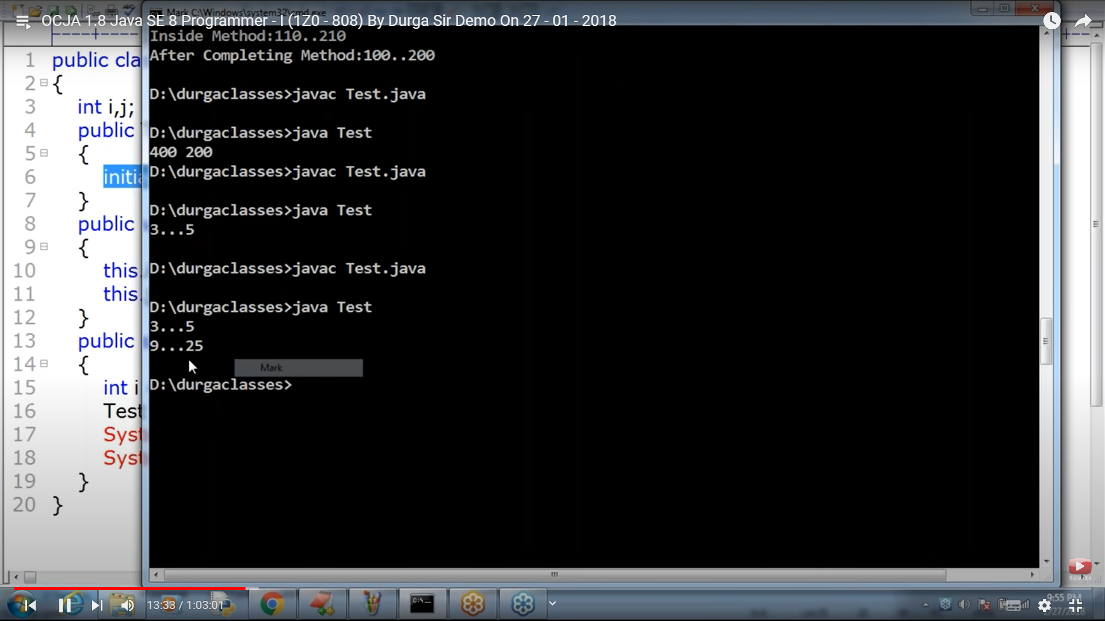

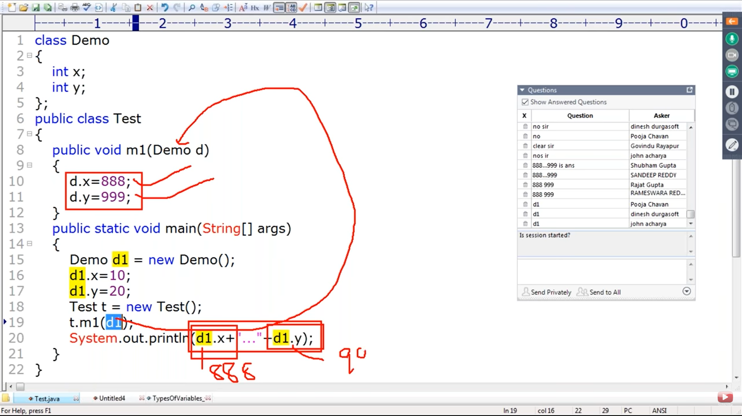

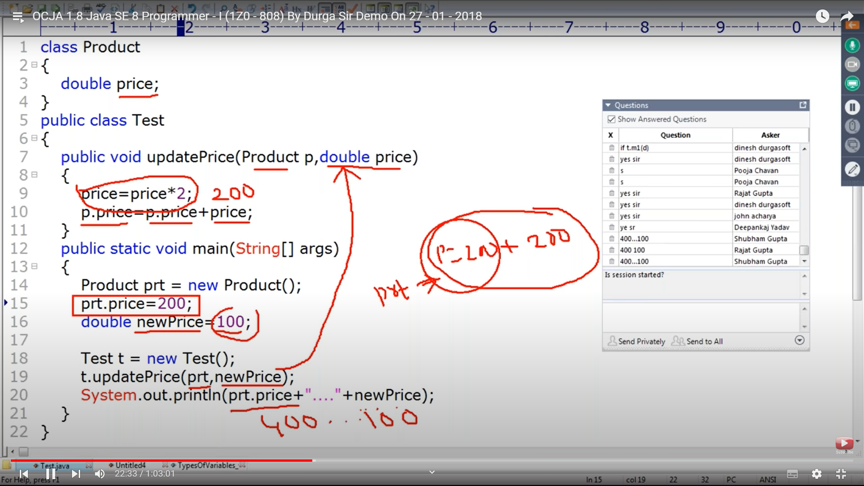

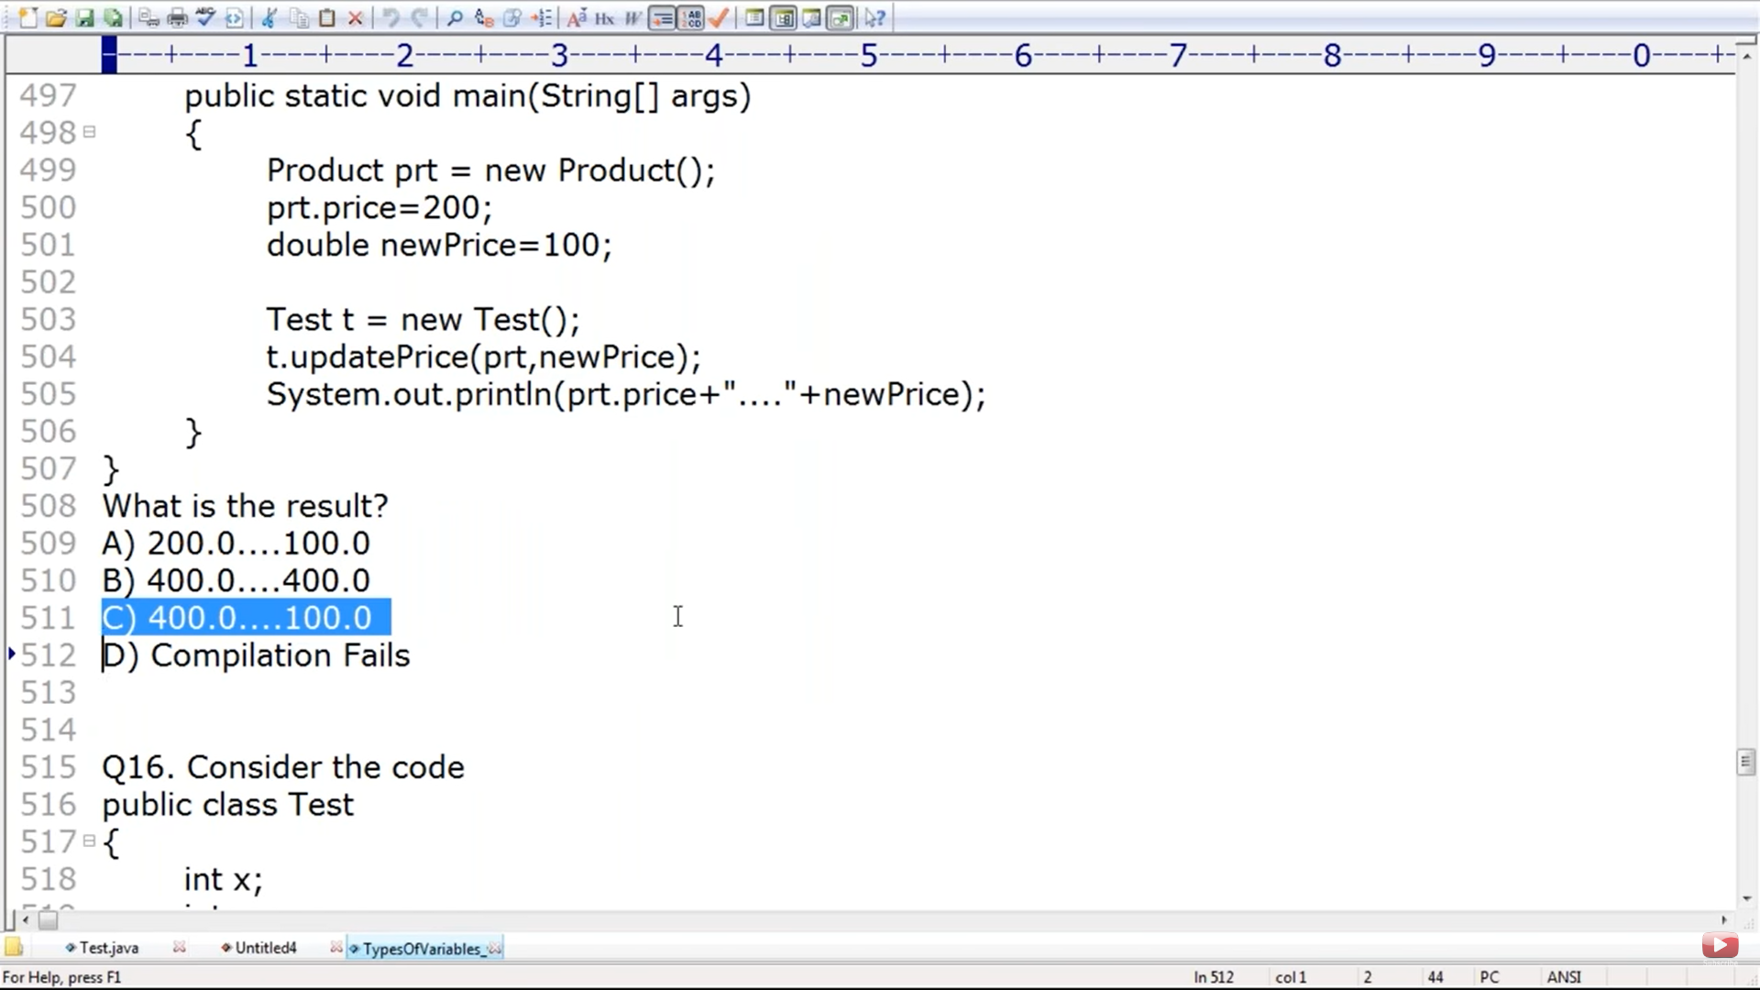

Int y in doStuff are local variables updating local variable y will not impact t1.y

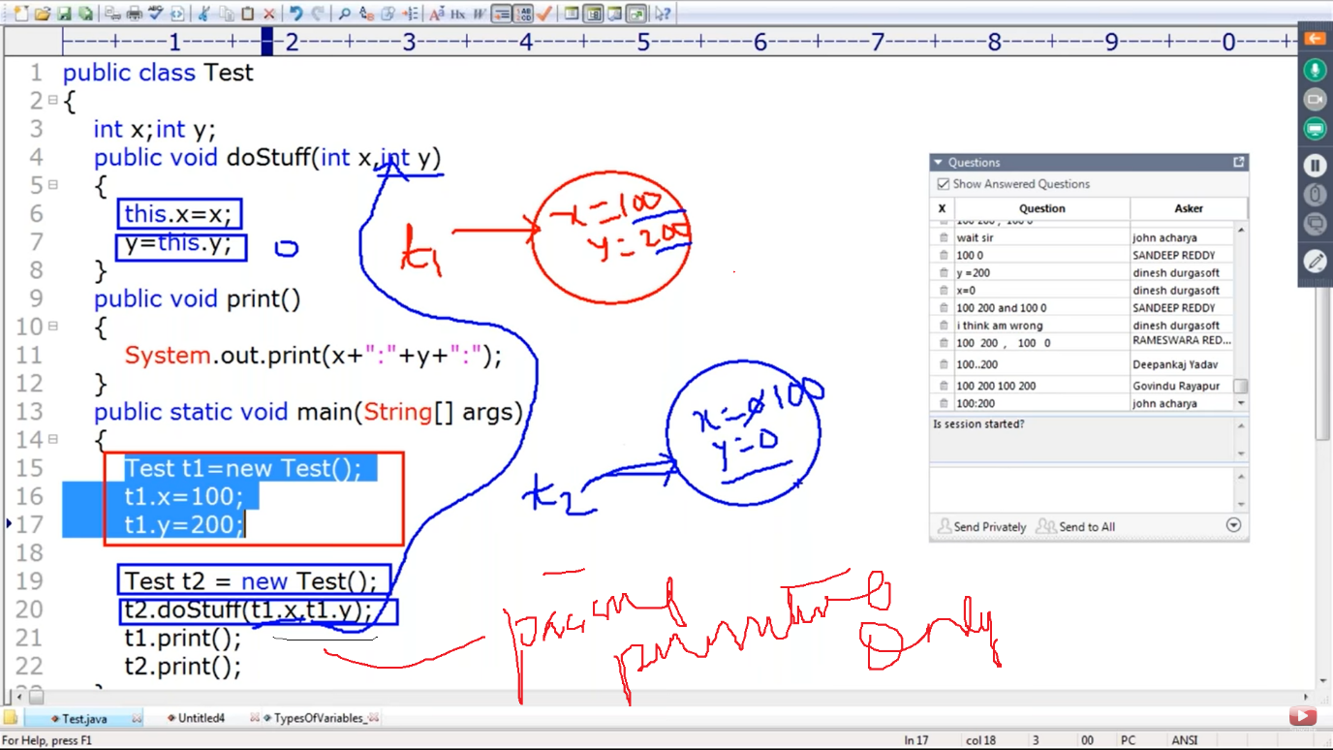

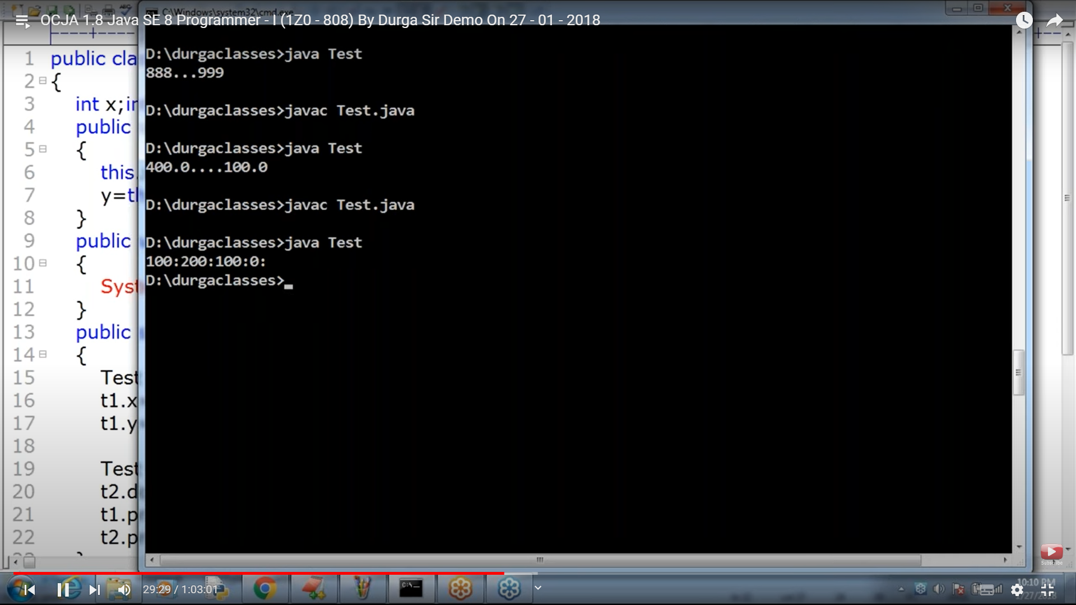

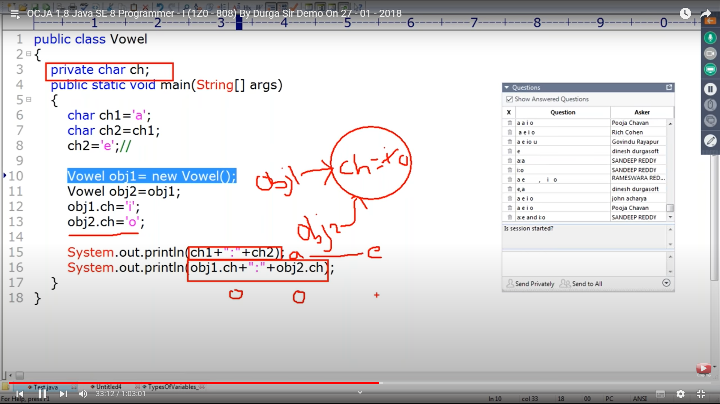

Will the class compile – yes . The class will compile even if we don’t hv a main method. At run time JVM will throw error , Main method not available

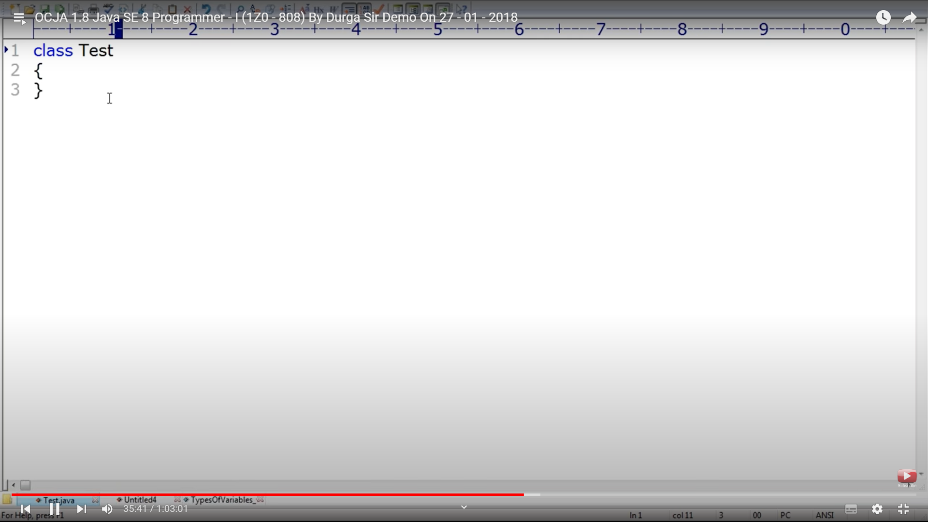

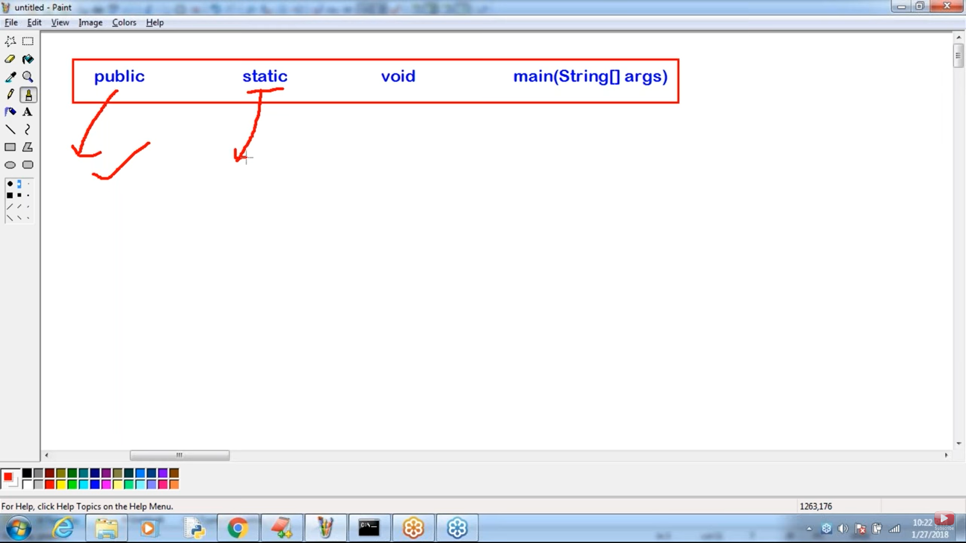

Since main method should be accessed by JVM from any where main method is public

JVM should be accessed by JVM without creating any object , so its static. When its static it needs not object creation to access it

Since it’s called by JVM and returning a value to JVM has no value Hence its void

Main method can be final , synchronized and Strictfp

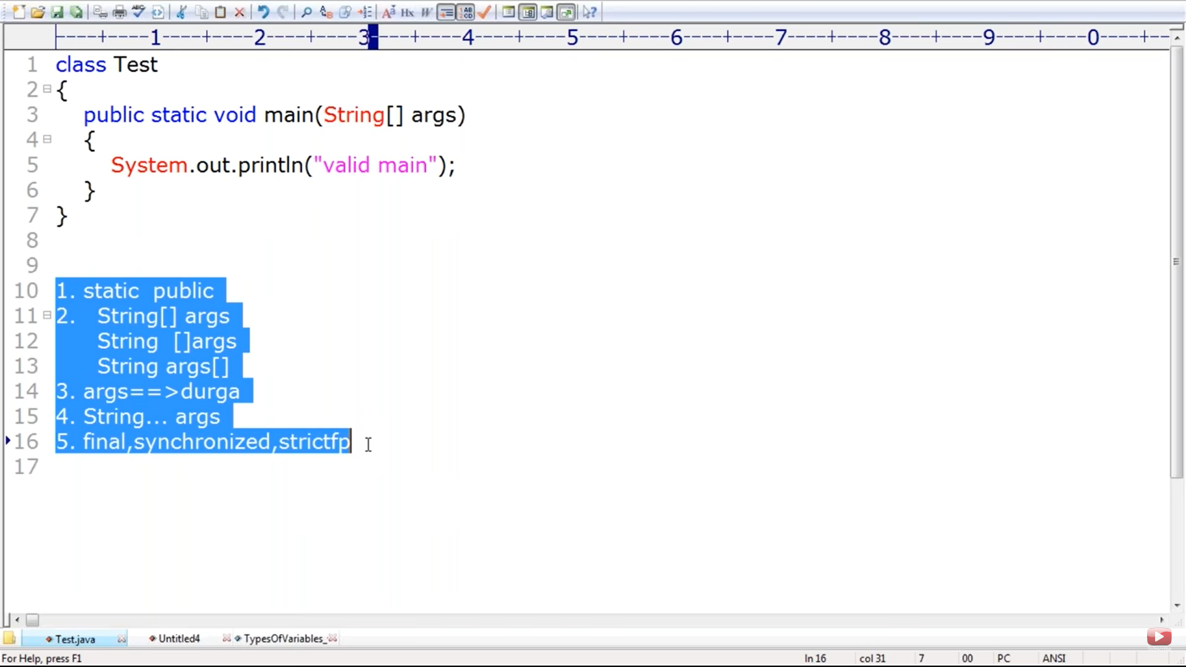

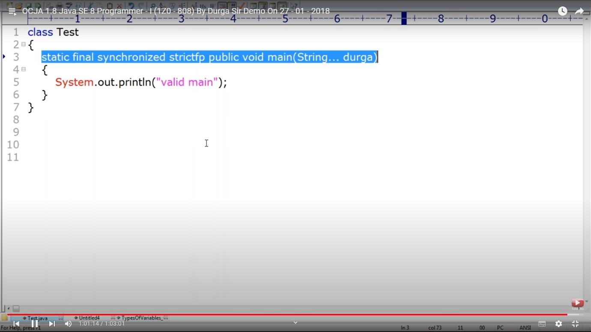

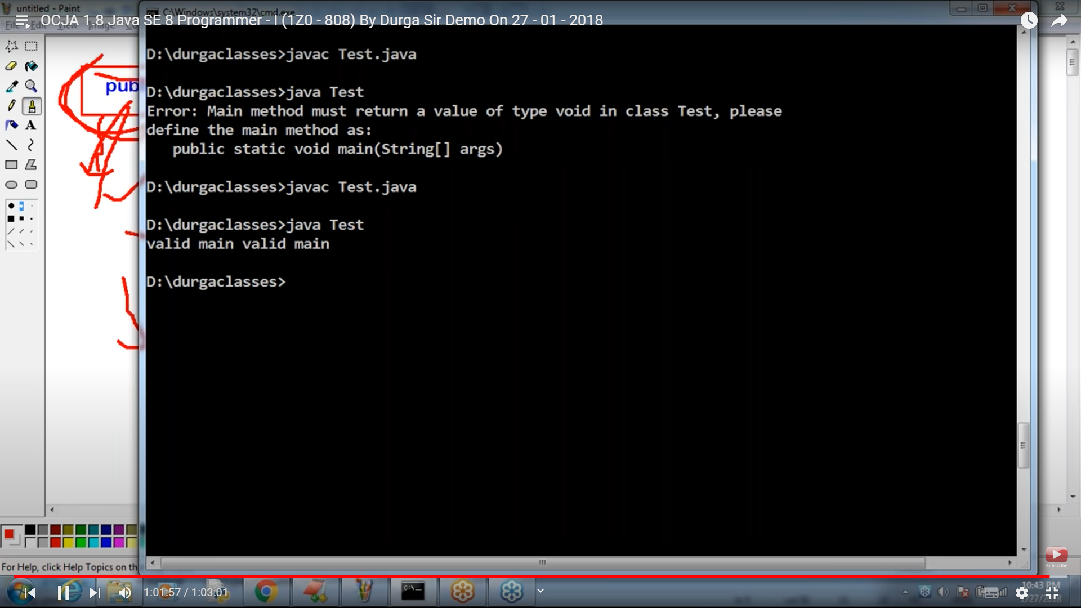

Main – should be lower case

String… args – an array of string

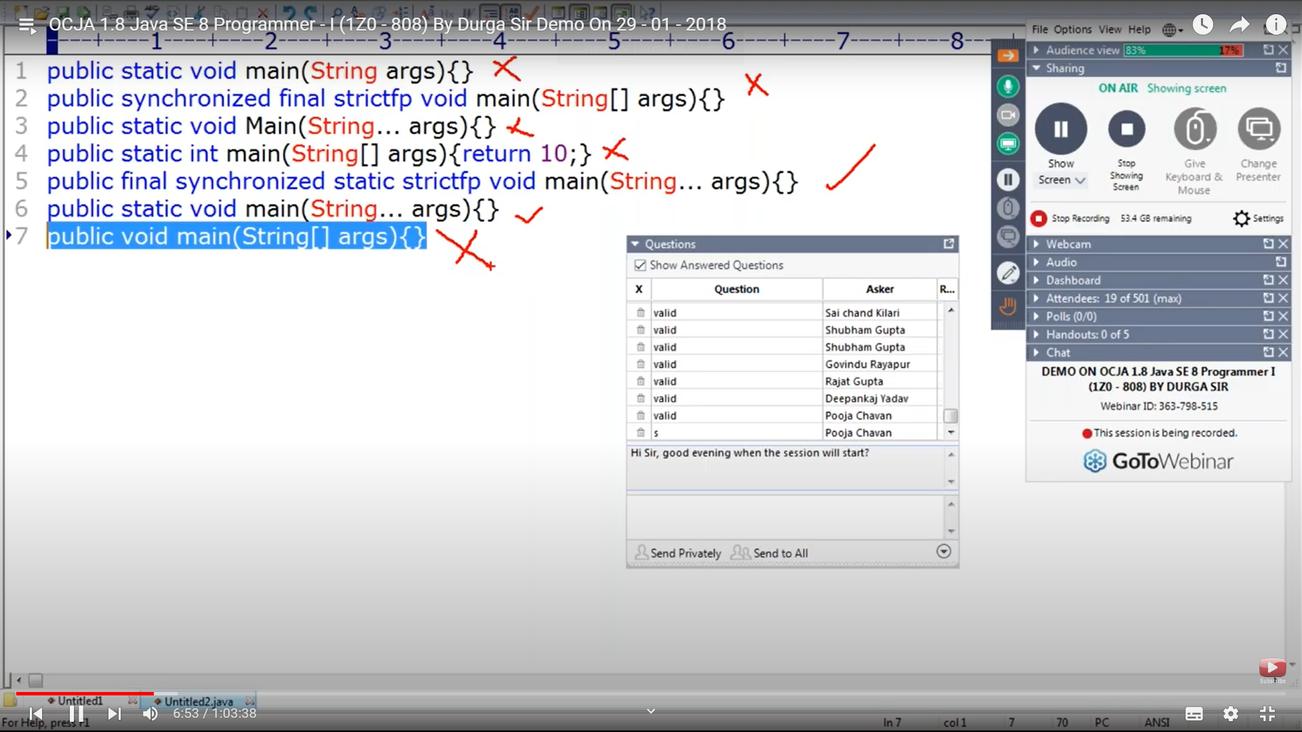

The above will not throw compile time error. Cos compiled has no knowledge of main method. These will be treated as normal methods

Overloading main method compilation works fine. JVM will not throw an error but JVM will look for the right main method

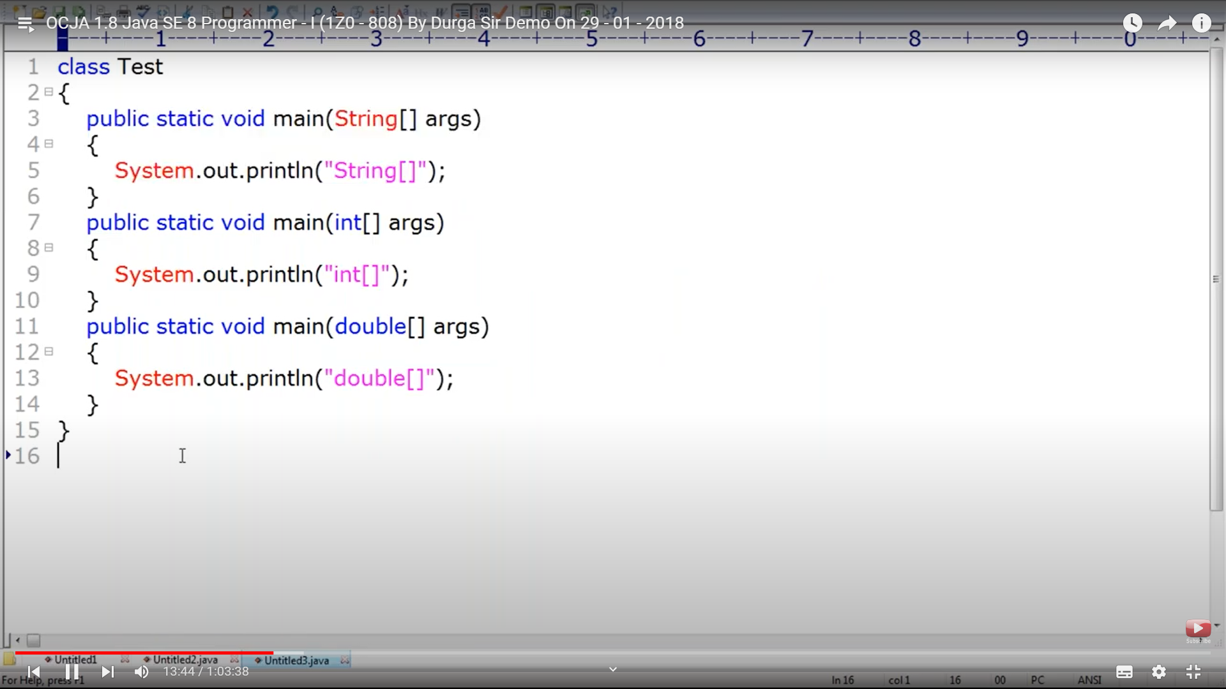

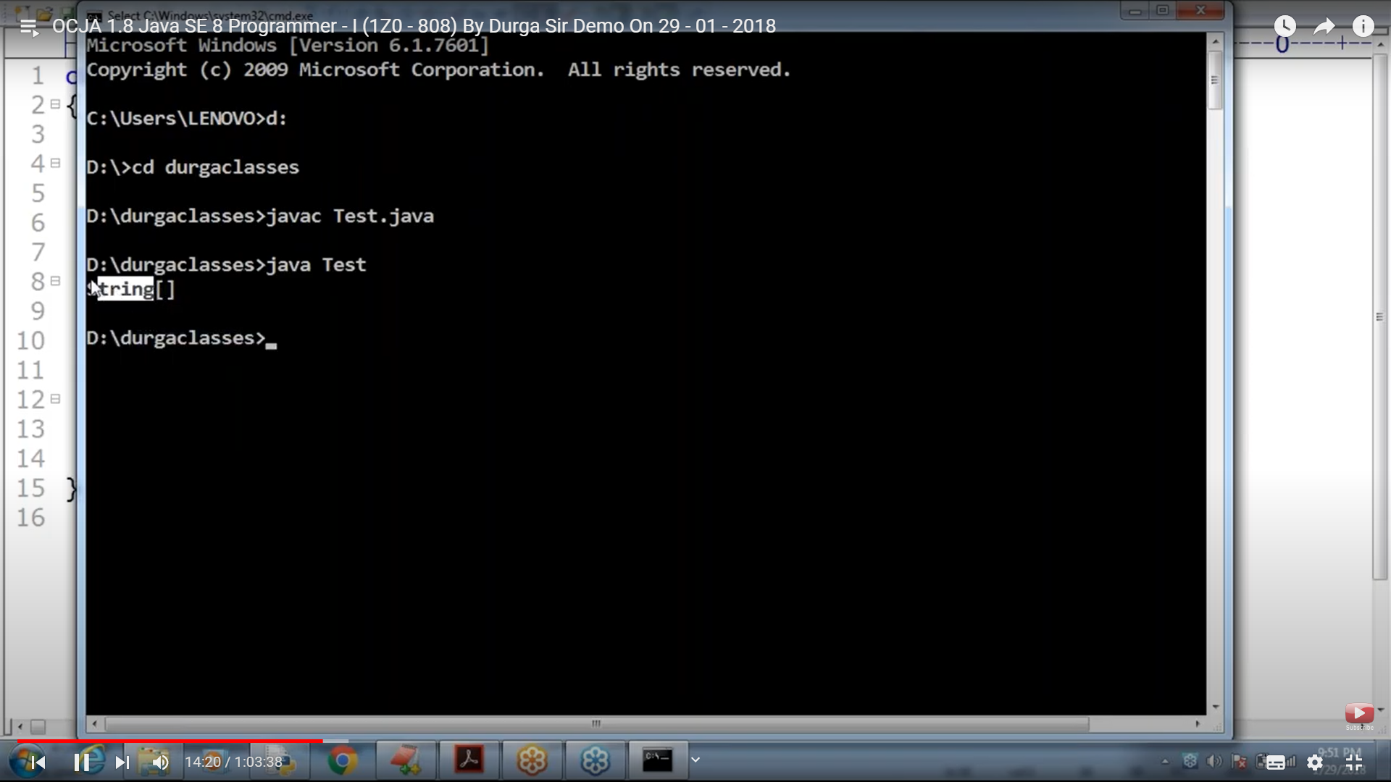

Compile time error methods having same signature and arguments.

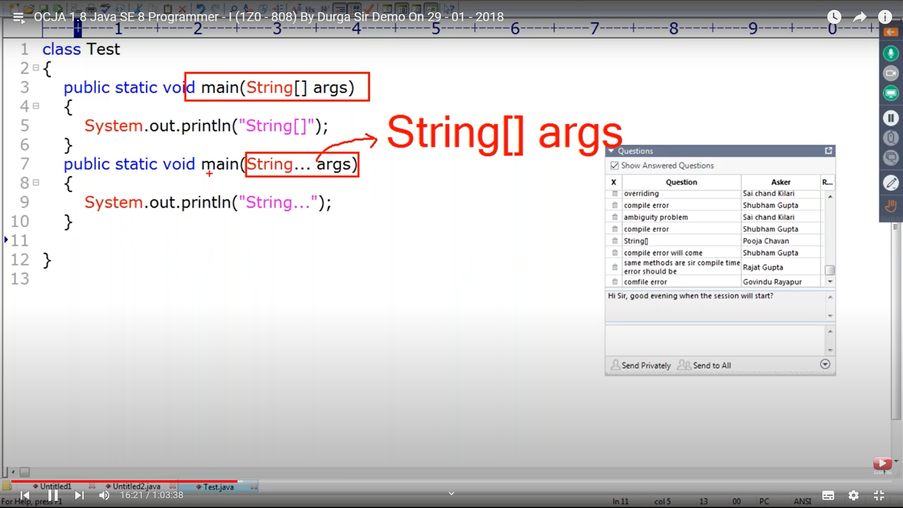

No compile or run time , line 8 is two dimensional array – var args

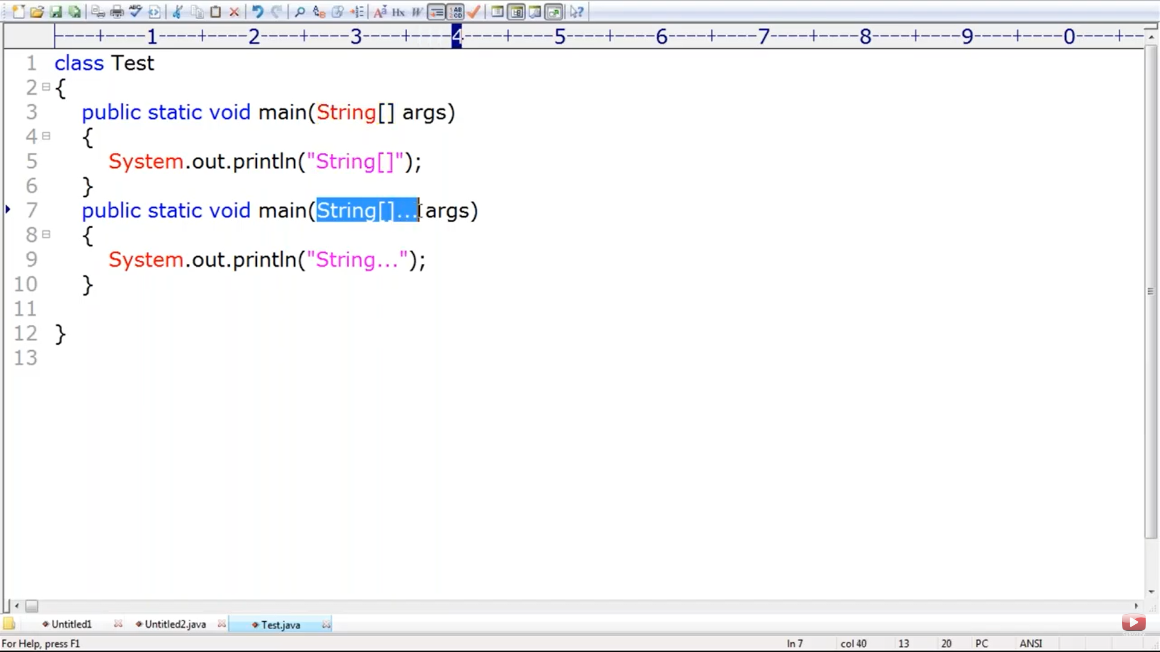

Inheritance is acceptable for all static class including main method

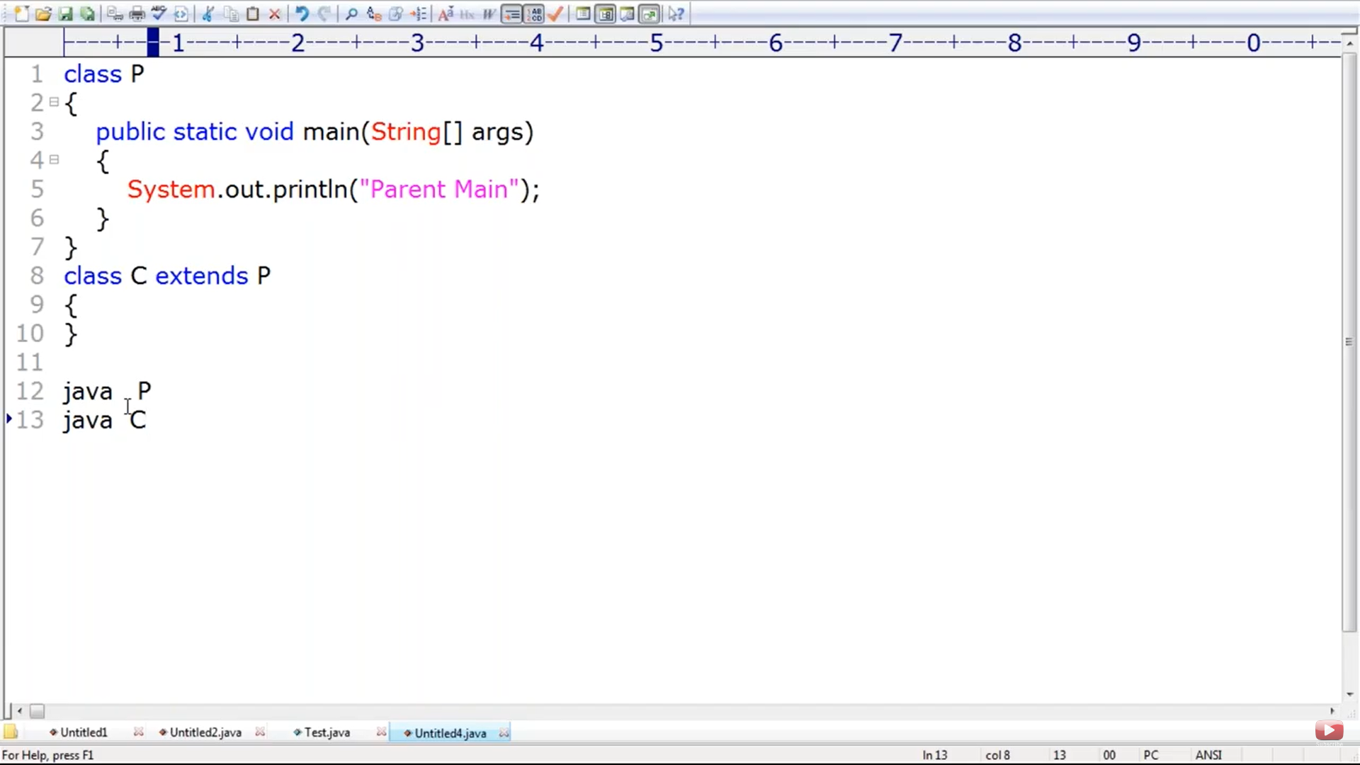

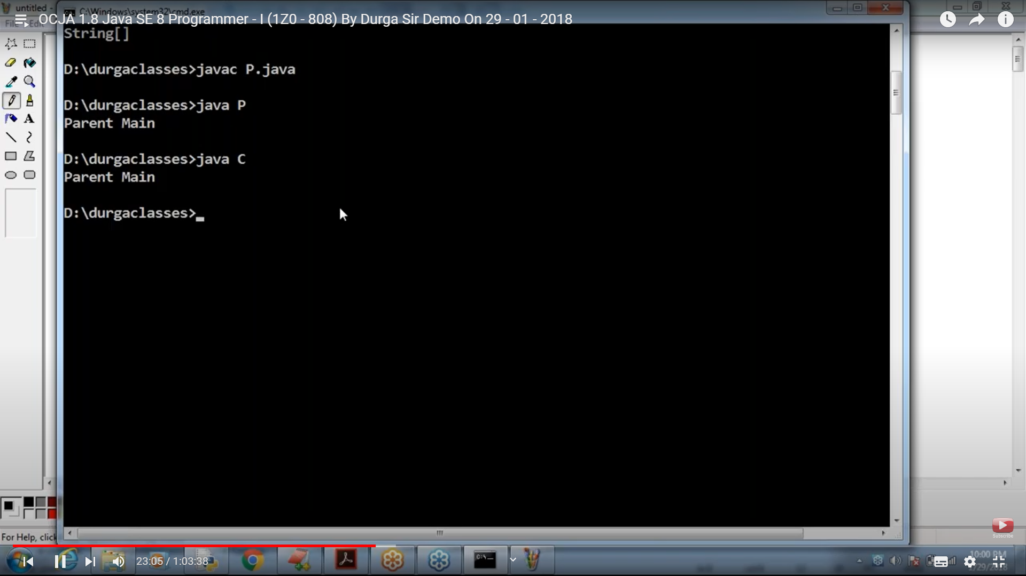

The below will not throw an error. Overriding for main method is accepted. So the below will work fine. But the below is not overriding this is method hiding we will see. But the below will work fine

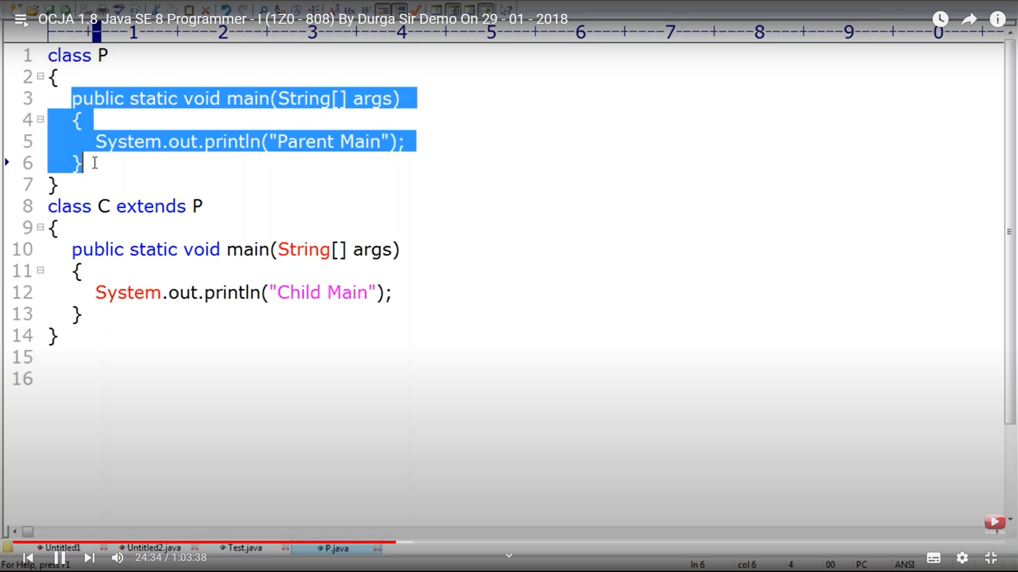

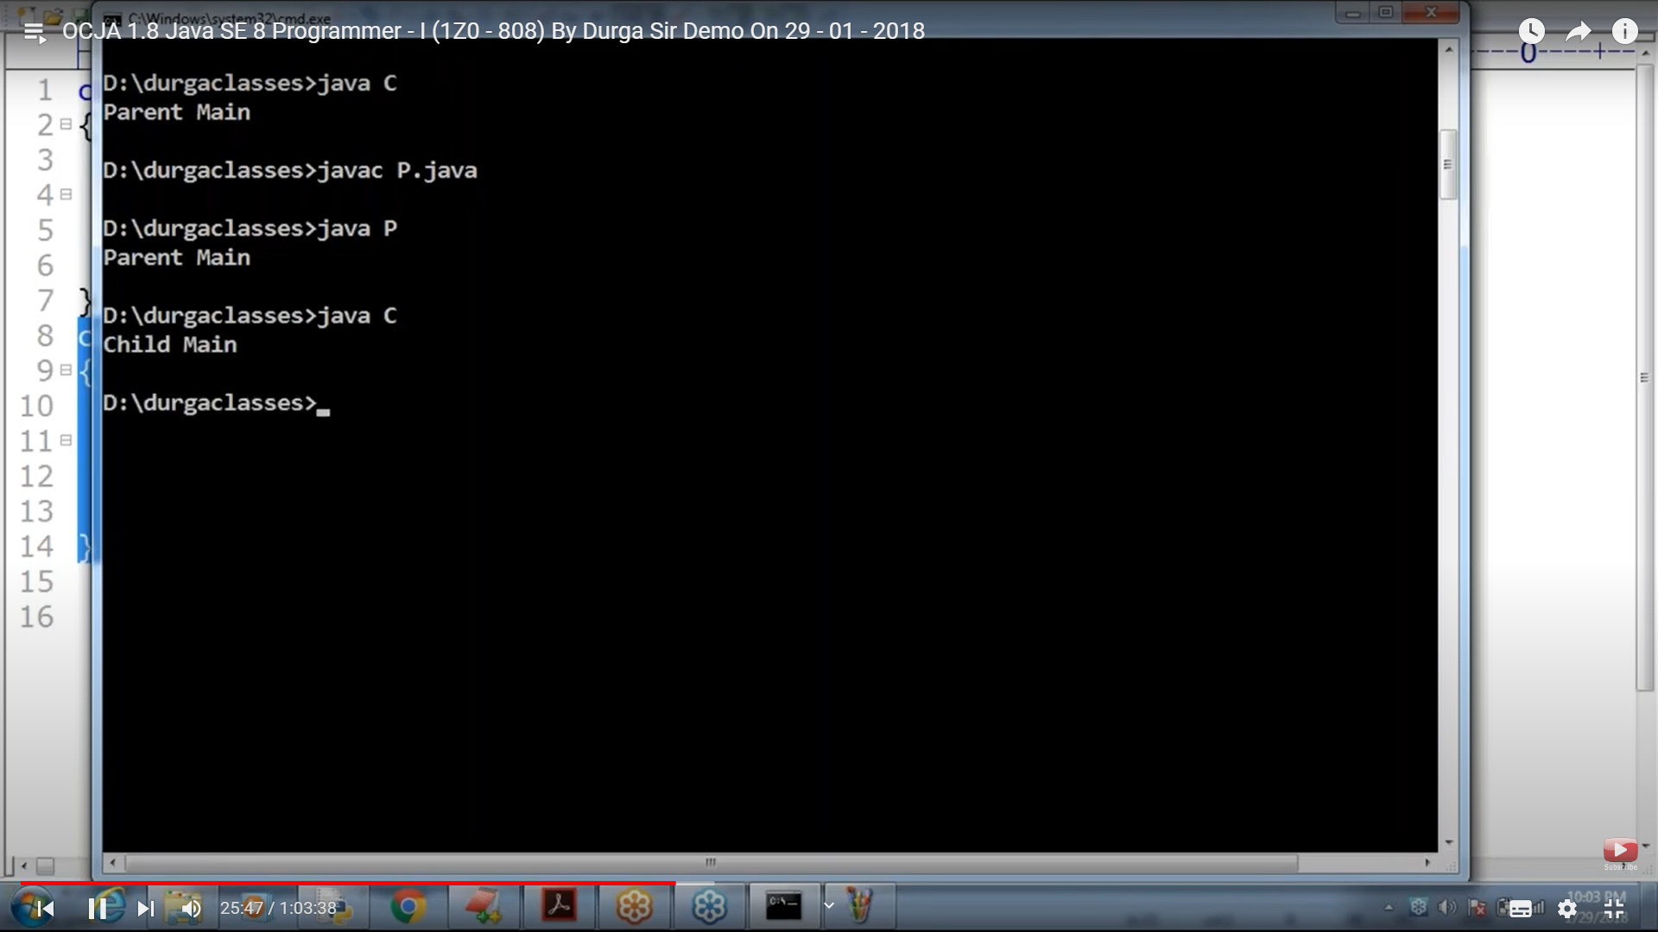

After 1.7 only the below error

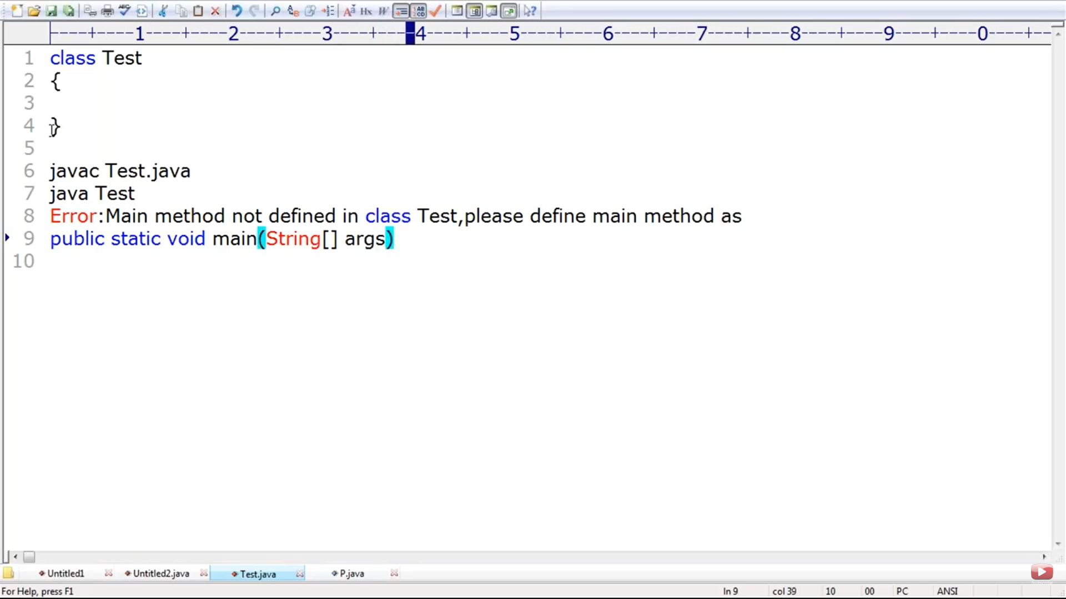

Before – No Such method found error

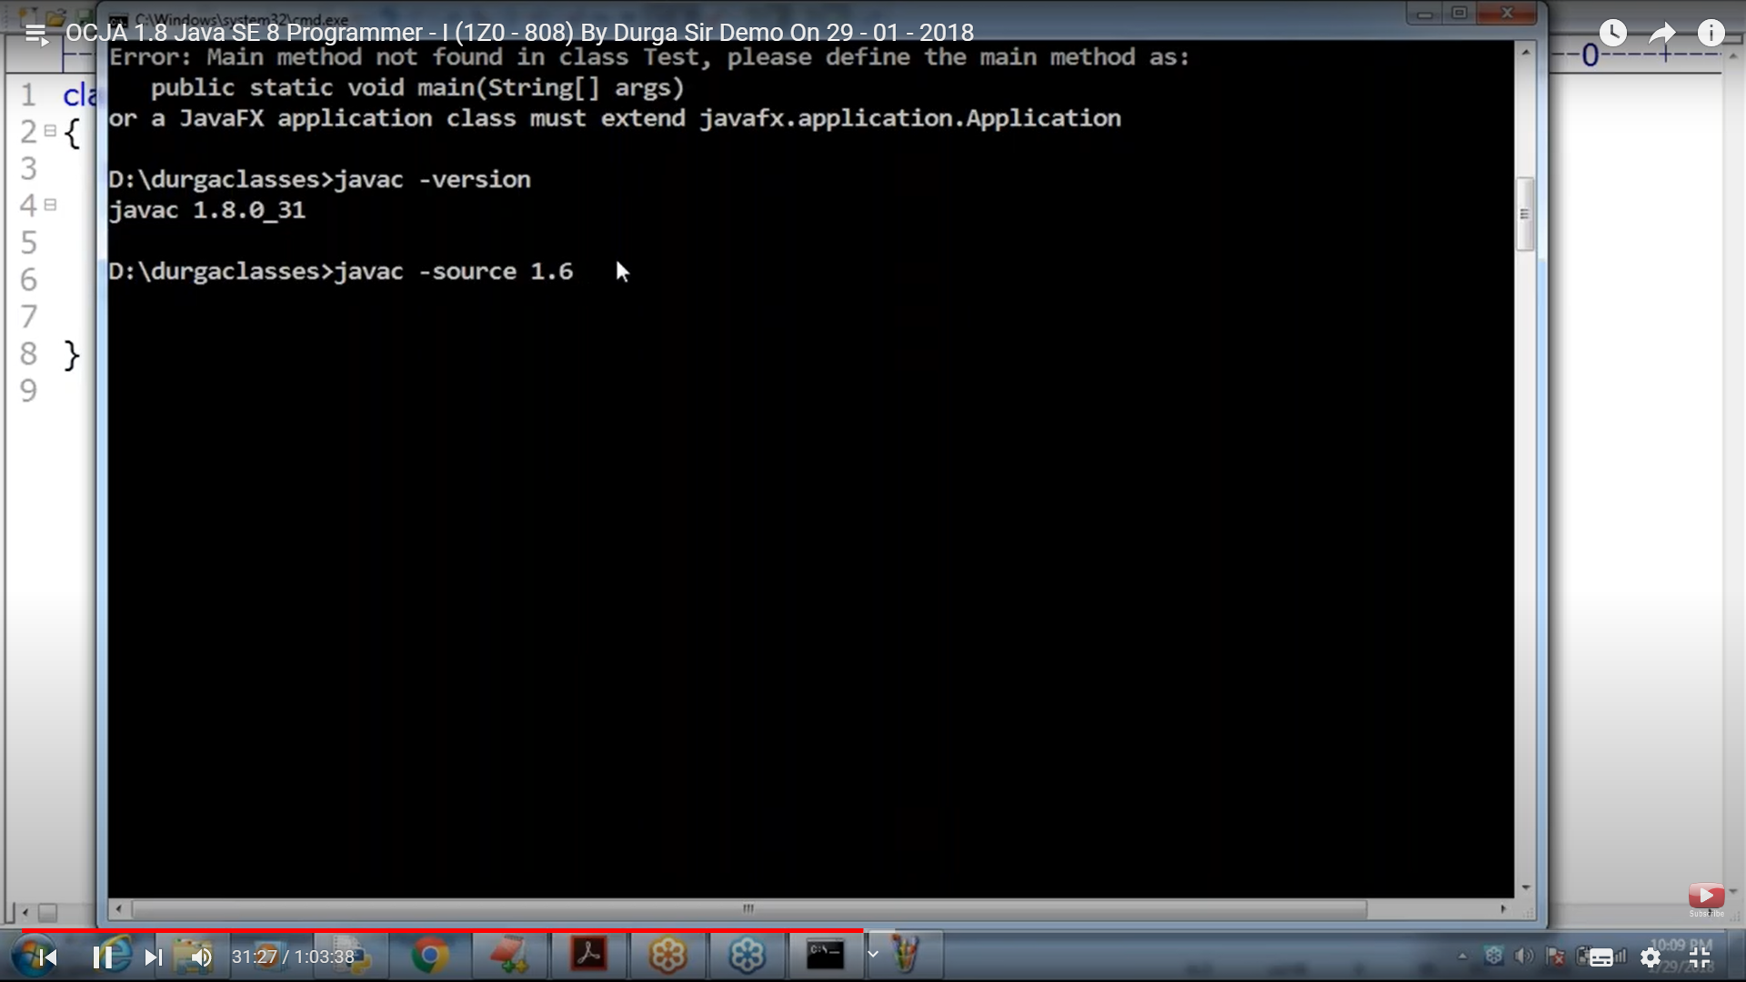

Until 1.6- Static block will execute first then main method

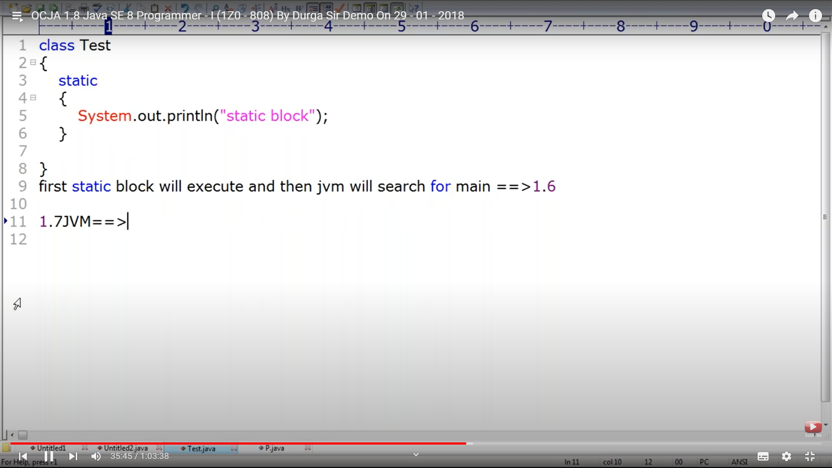

From 1.7 it would check if main method is there or not, will throw an error if main method is not available. If available, it executes the static block first and then the main method. Whereas before 1.7 until 1.6 JVM executes the static block and throws a run time error saying No such Method found

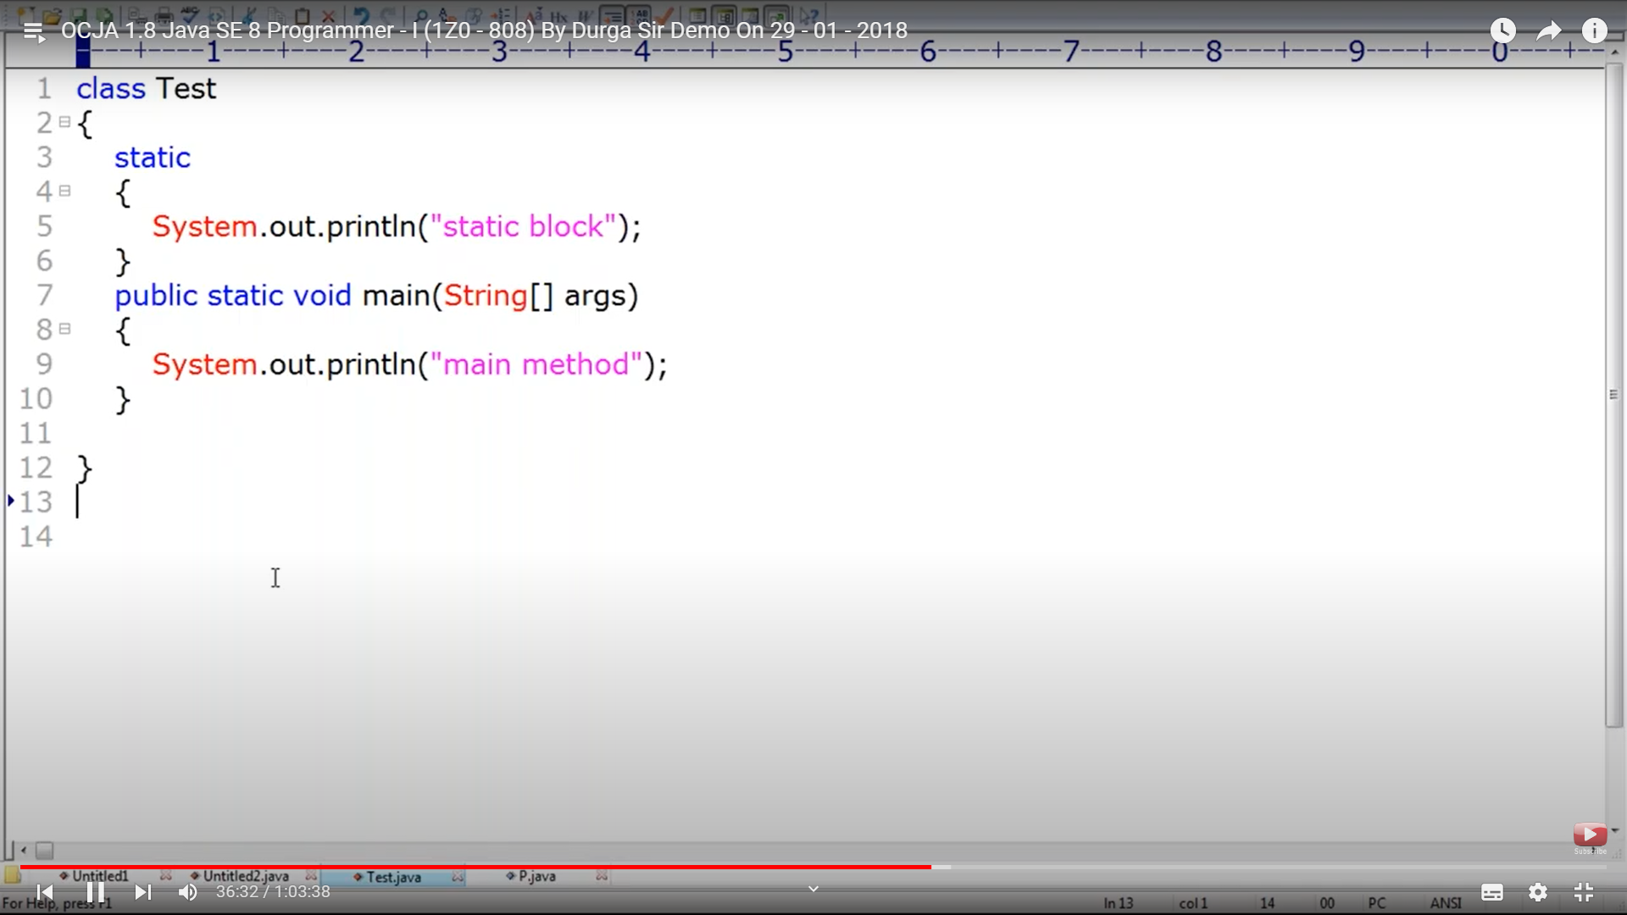

s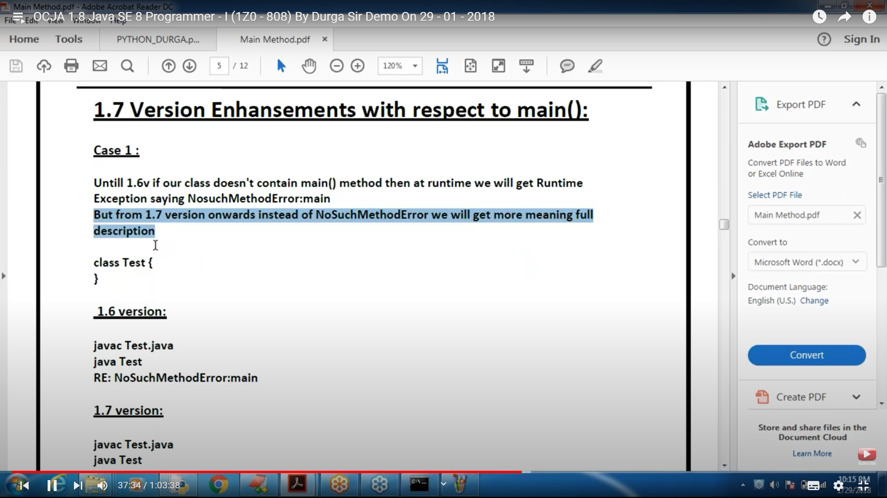

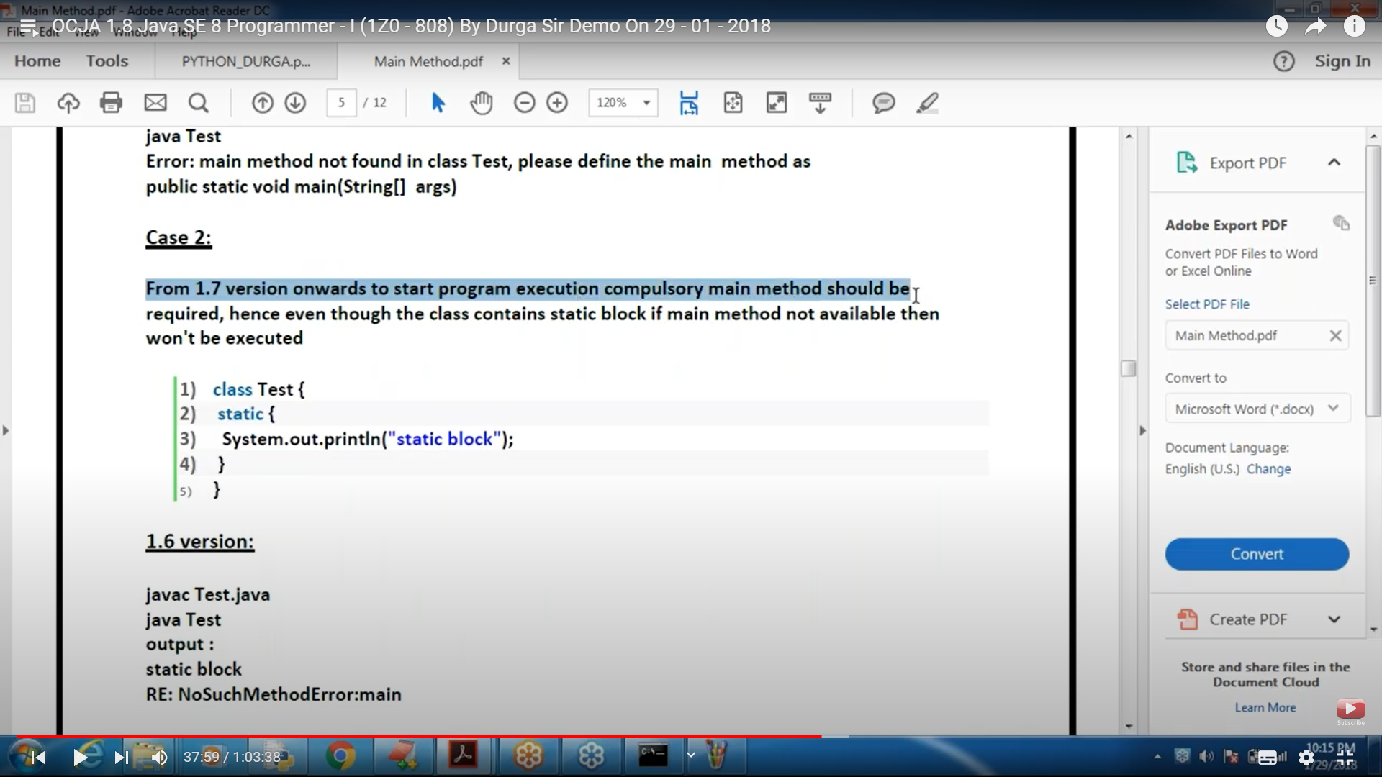

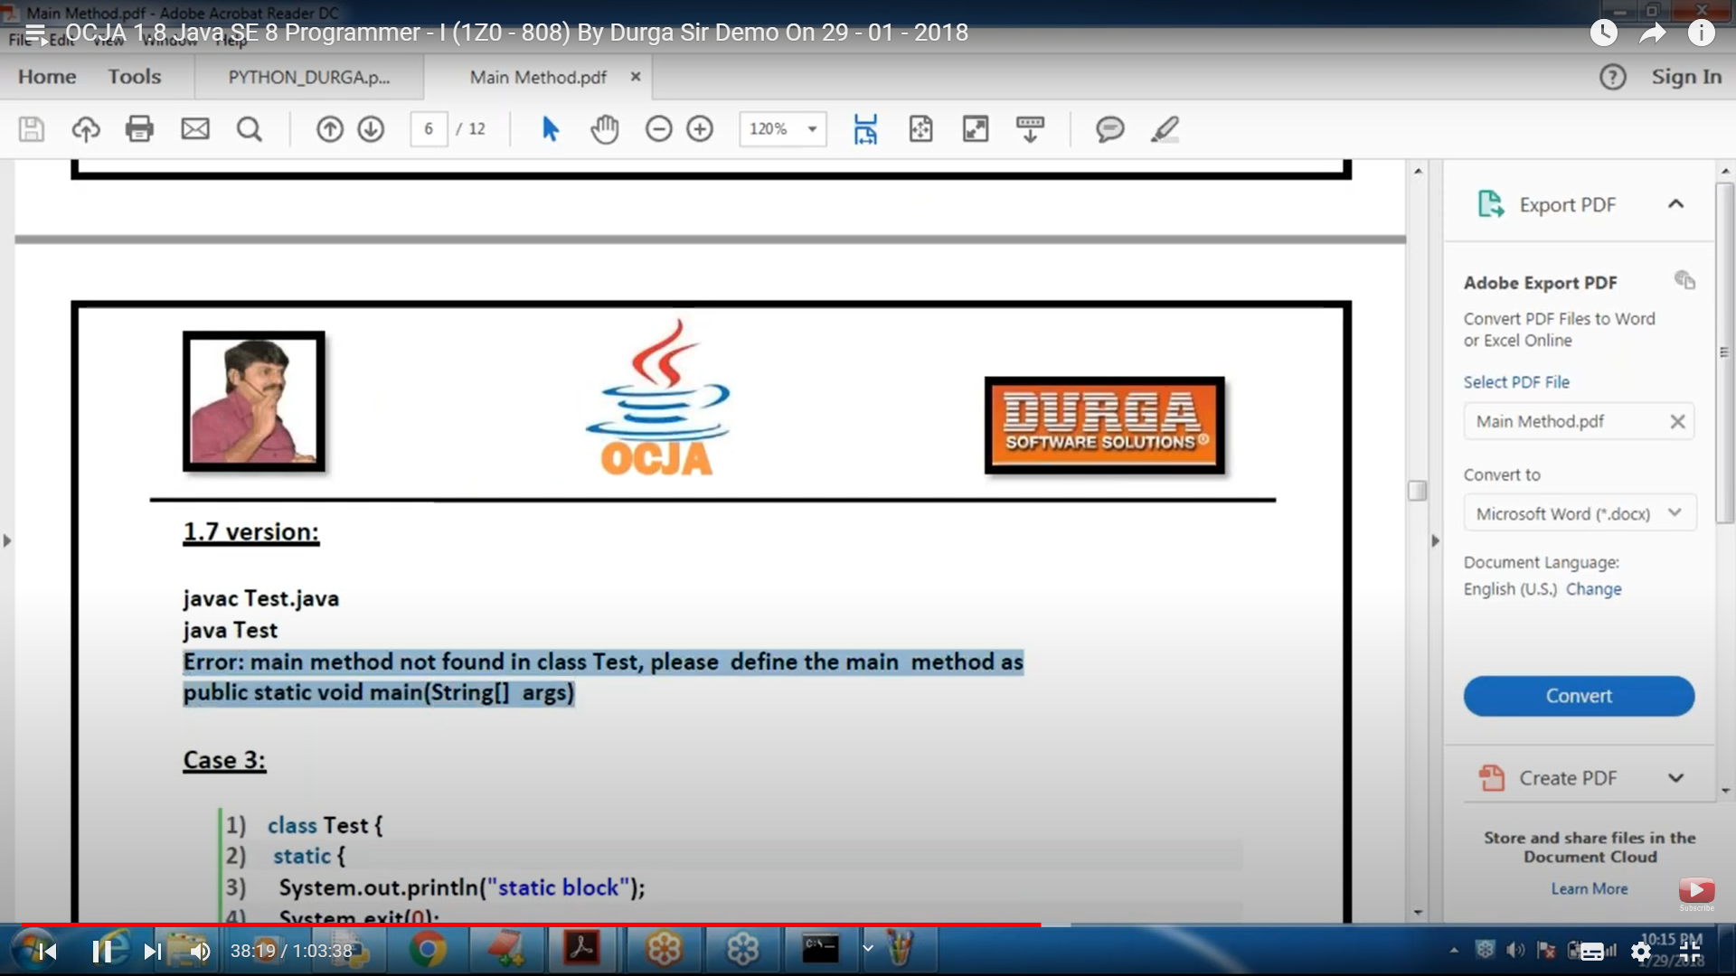

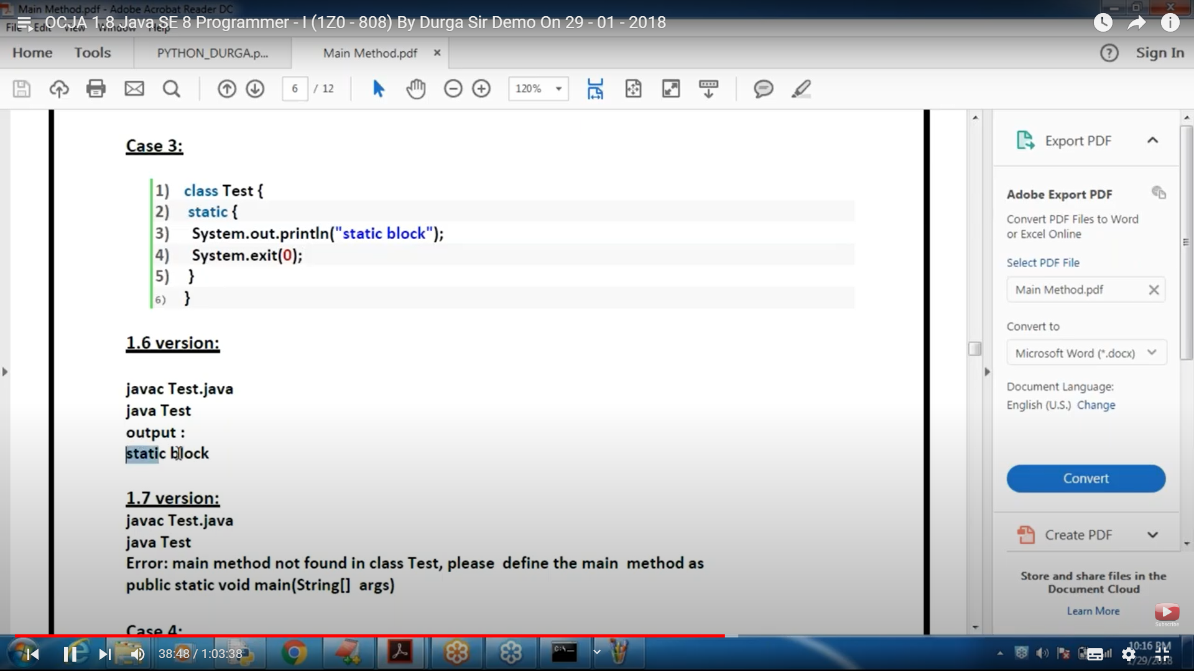

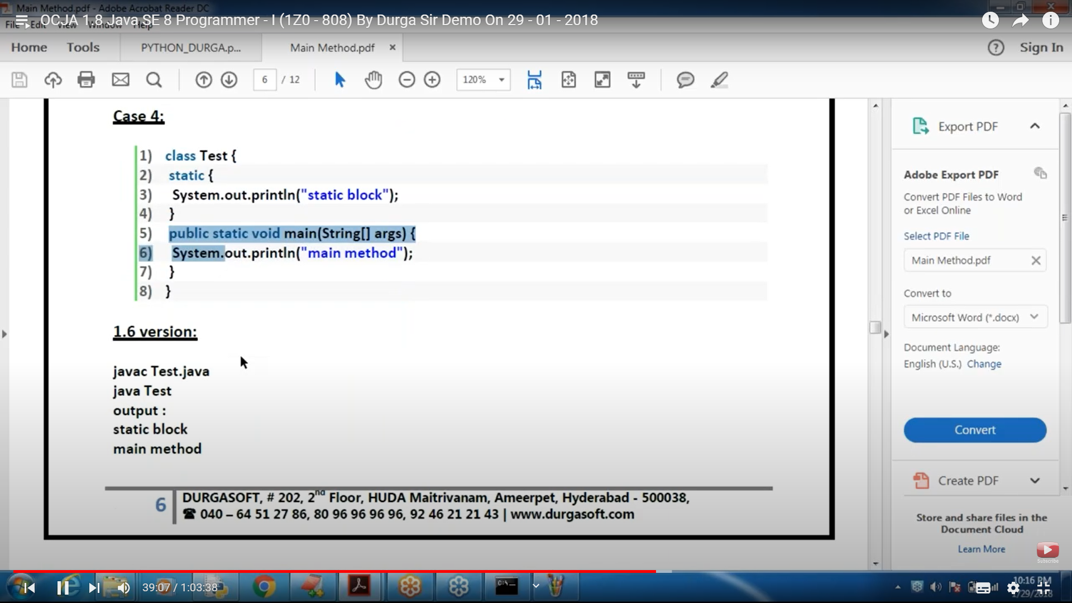

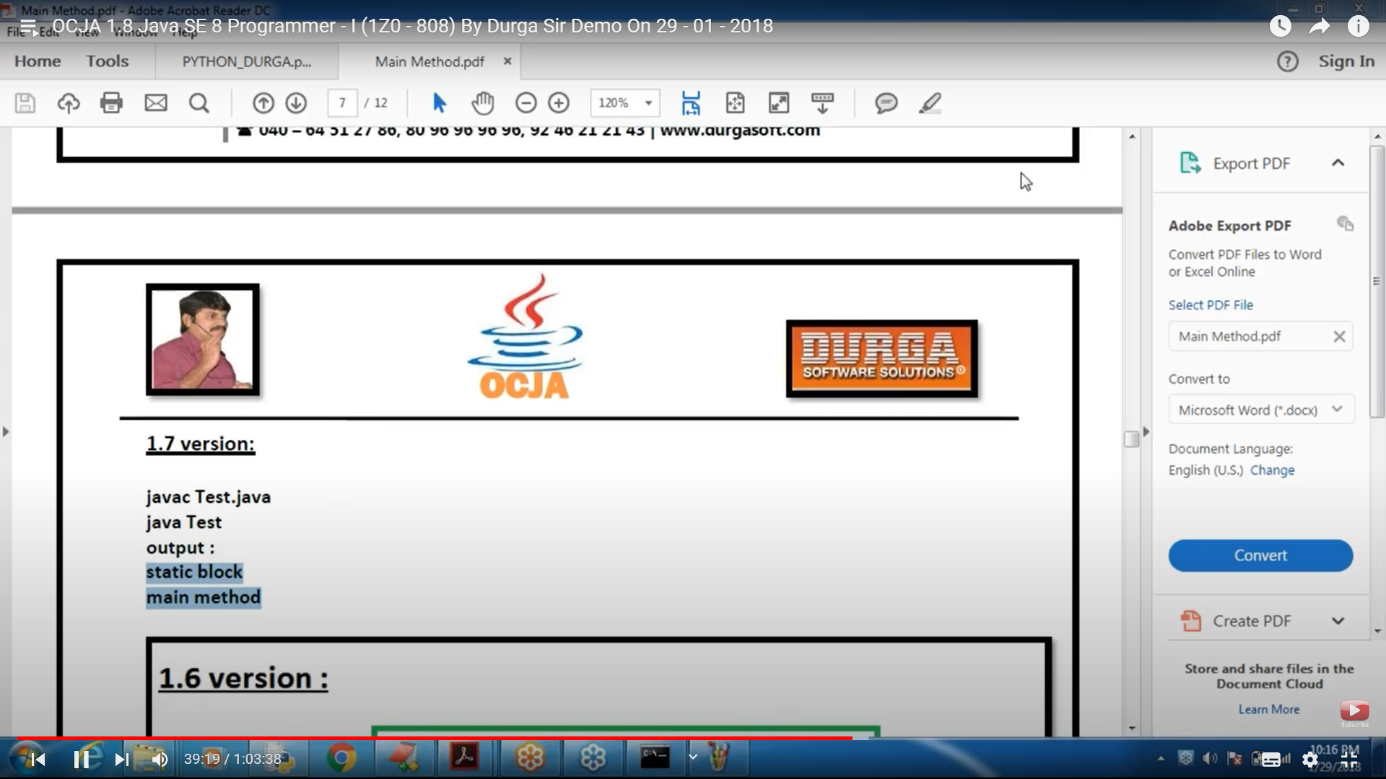

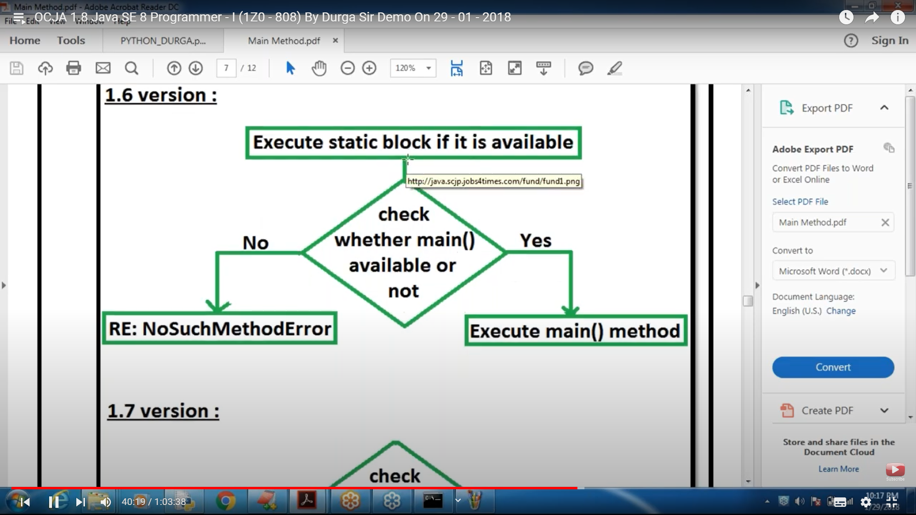

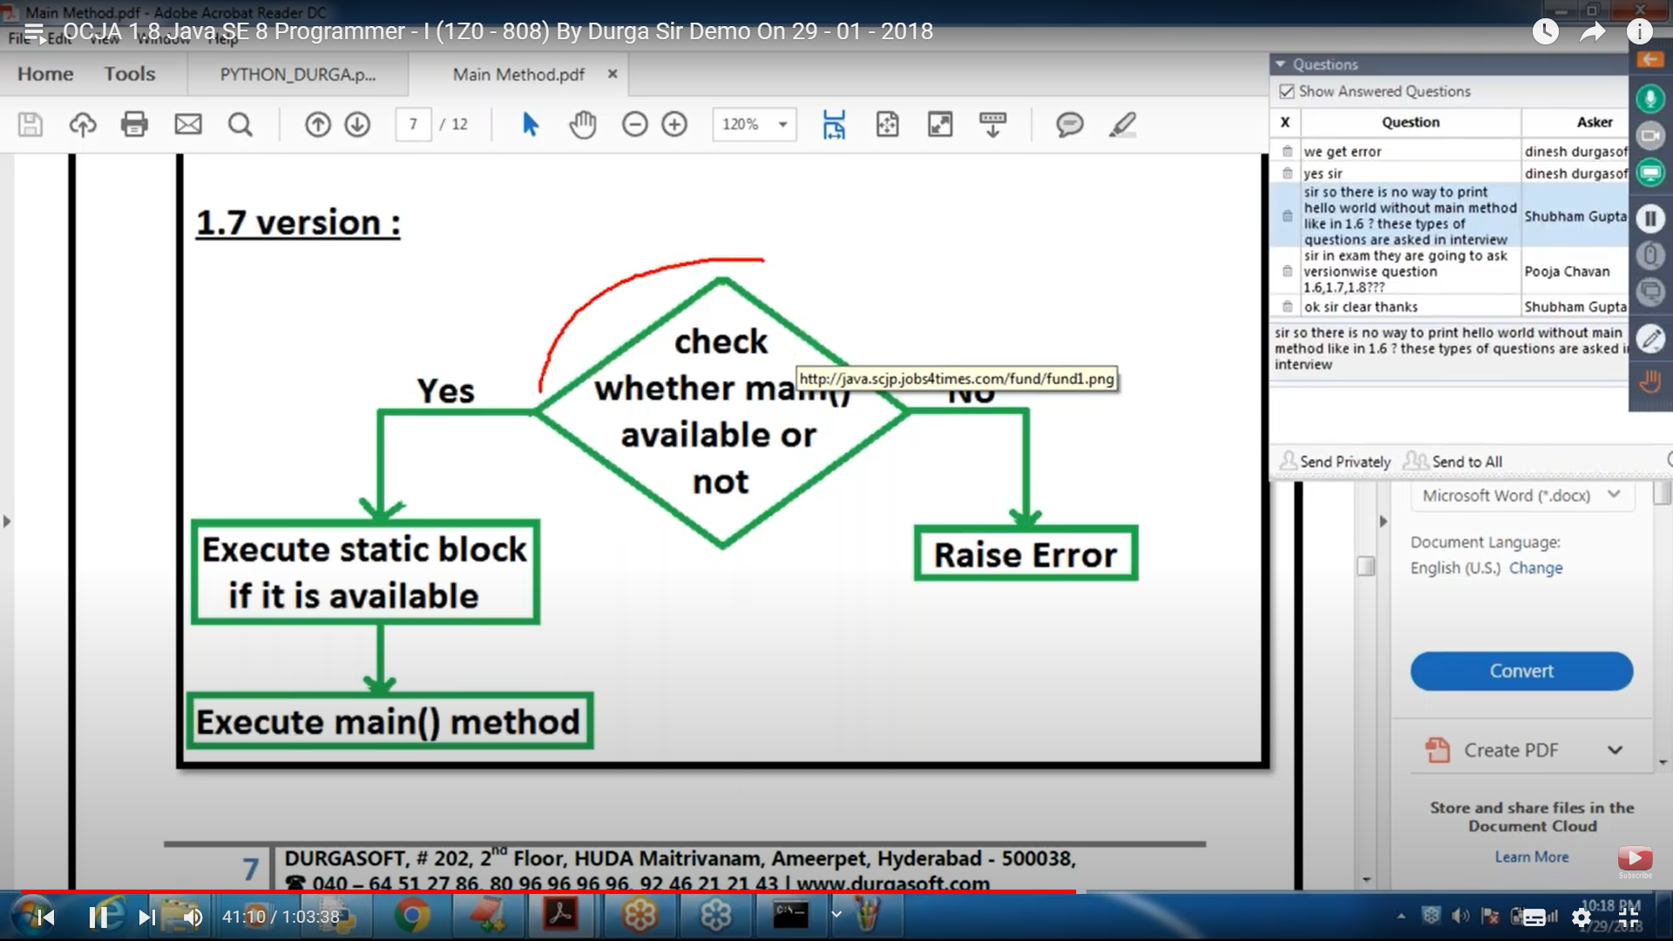

Command line Args

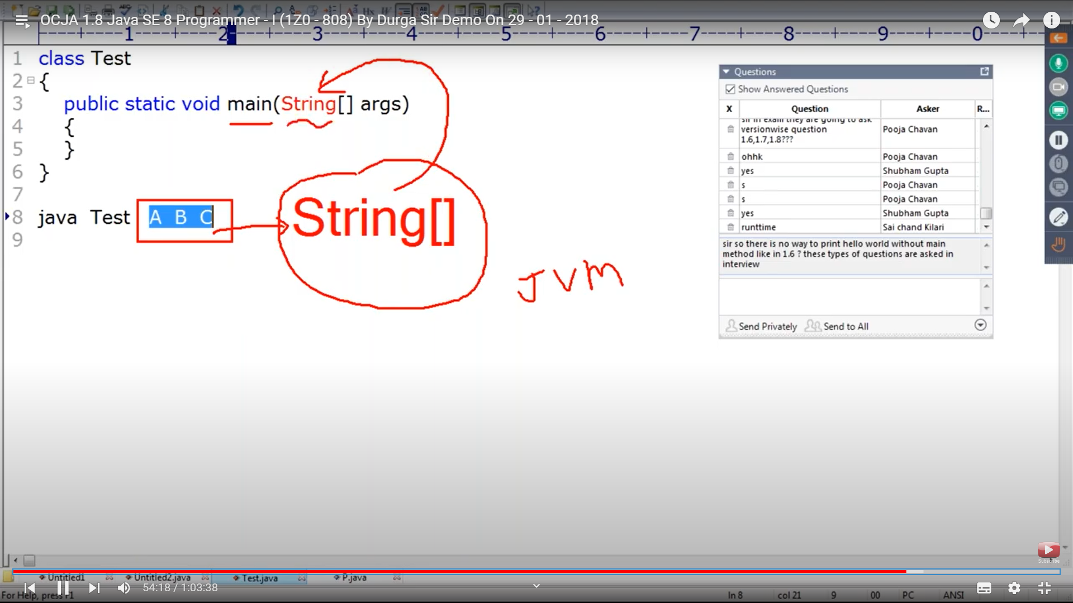

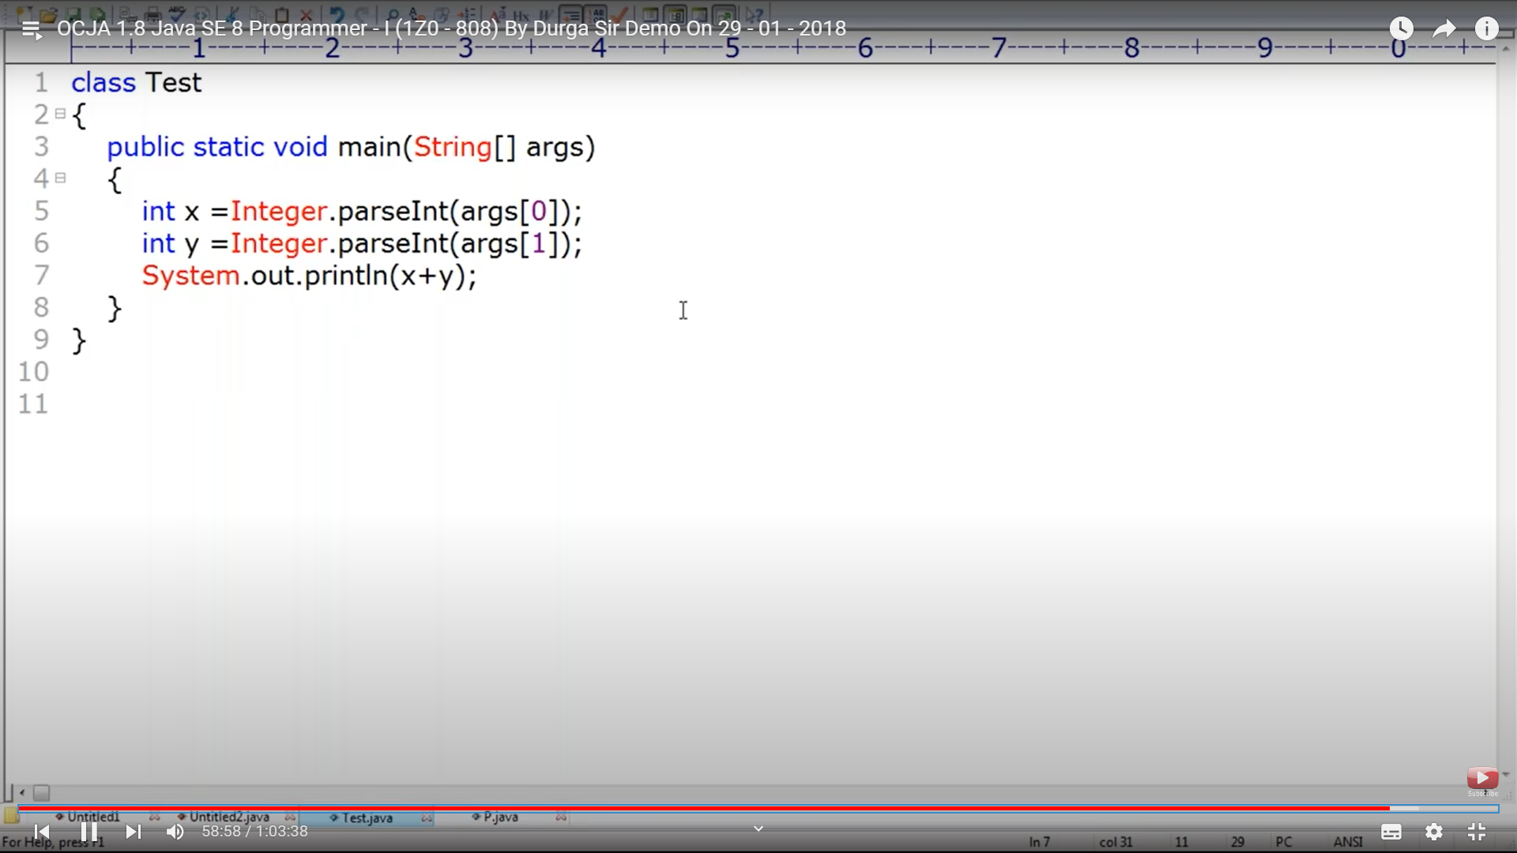

C. is the correct answer

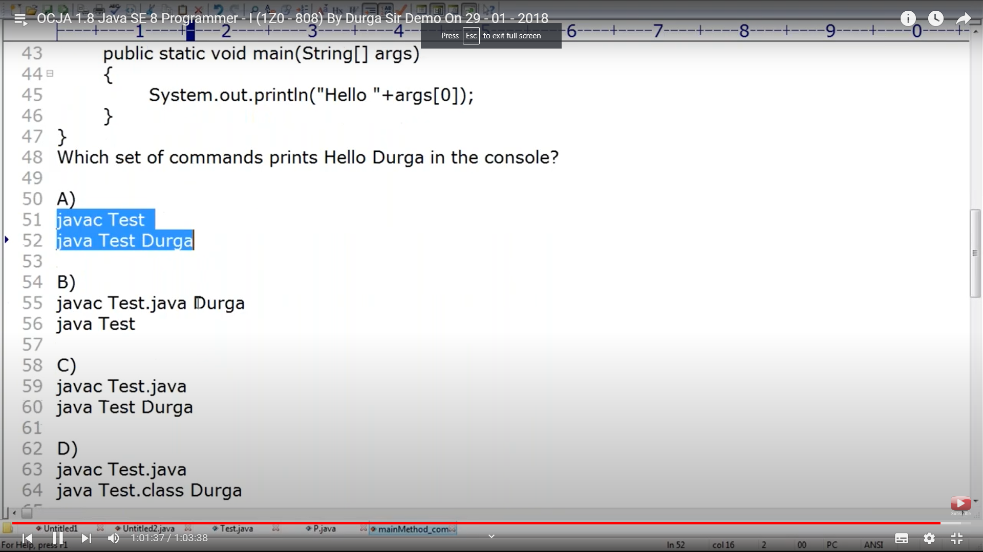

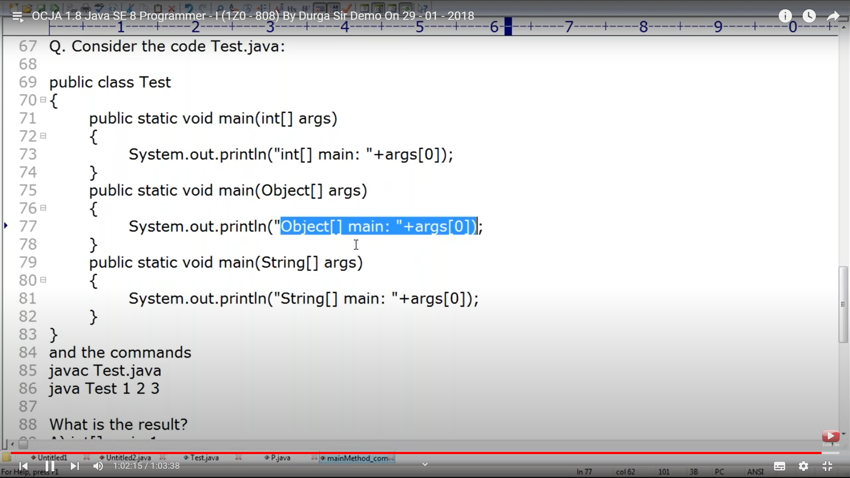

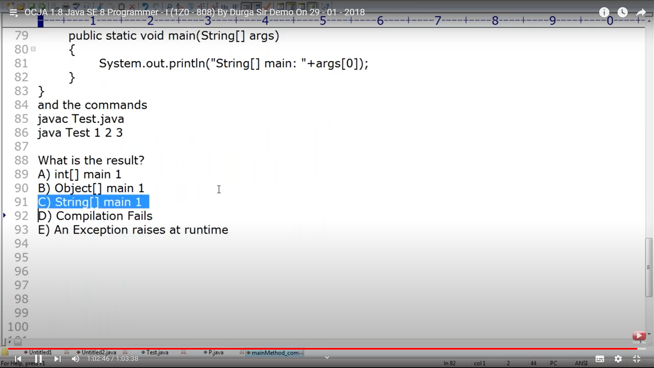

Next Topic very imp

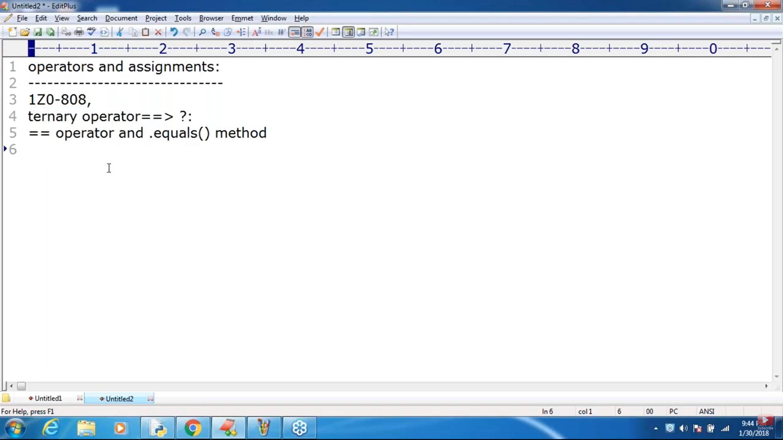

PreIncreement and Post increment. Pre Decrement and Post Dec

Y =++x; First increments and assign x to you.

Y=x++; first assigns x to y and then increments x

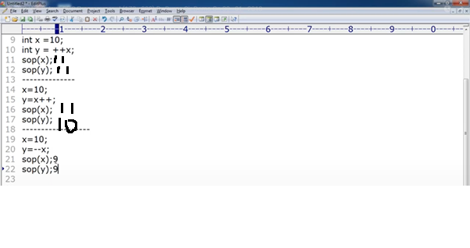

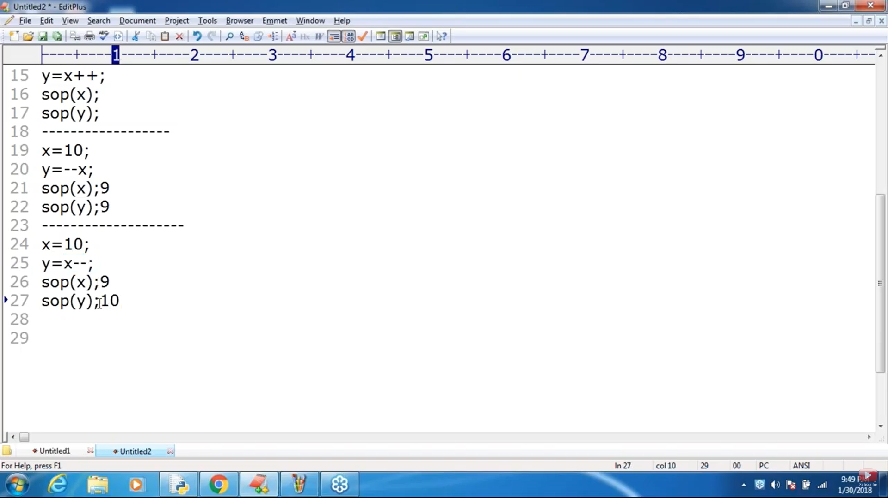

Incremet and dec are not appilcable for values- Unexpected type ++10. Required variable. Applicable only for available

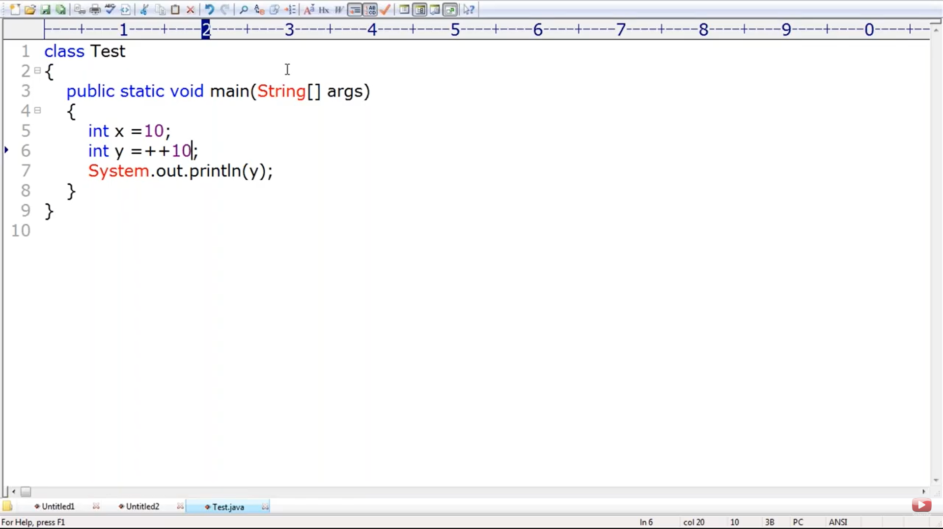

Compile time error. ++x is 11 . it’s a value not variable applying ++11 throws error . above

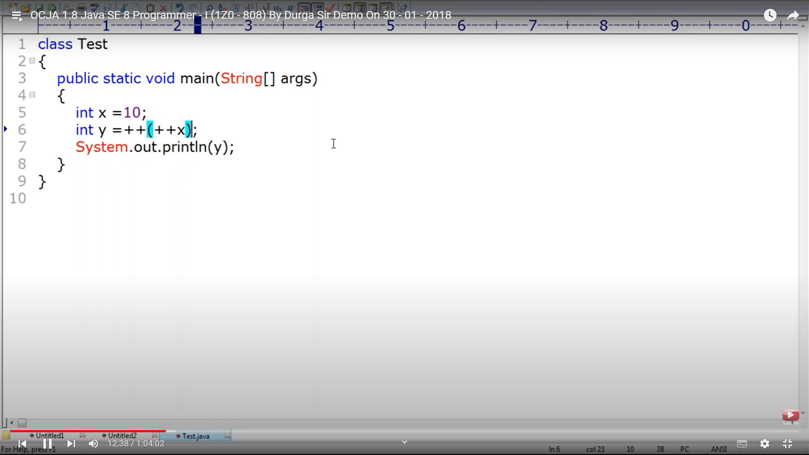

In Increment and decrement operation reassign is gonna to happen. So it reassigns , final variable cant be reassigned.

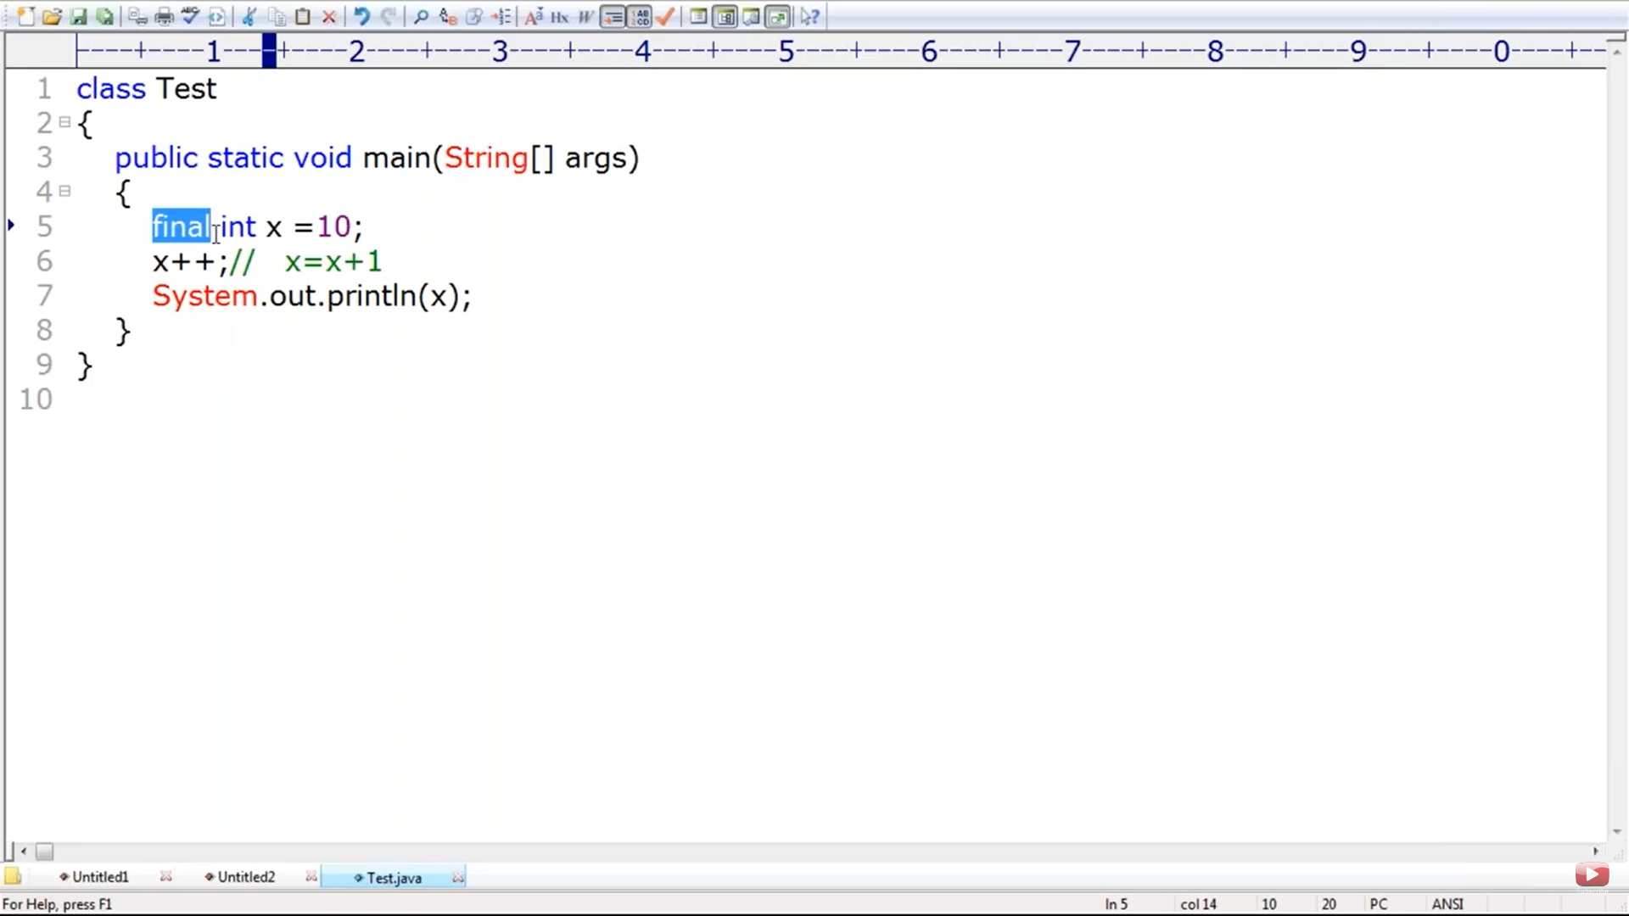

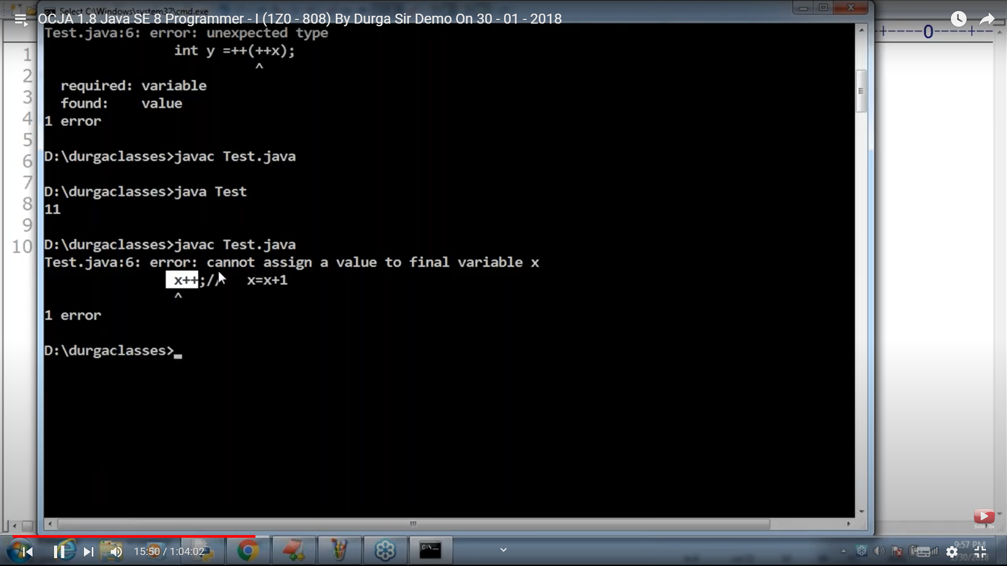

Increment and dec is applicable for all primitives except boolean

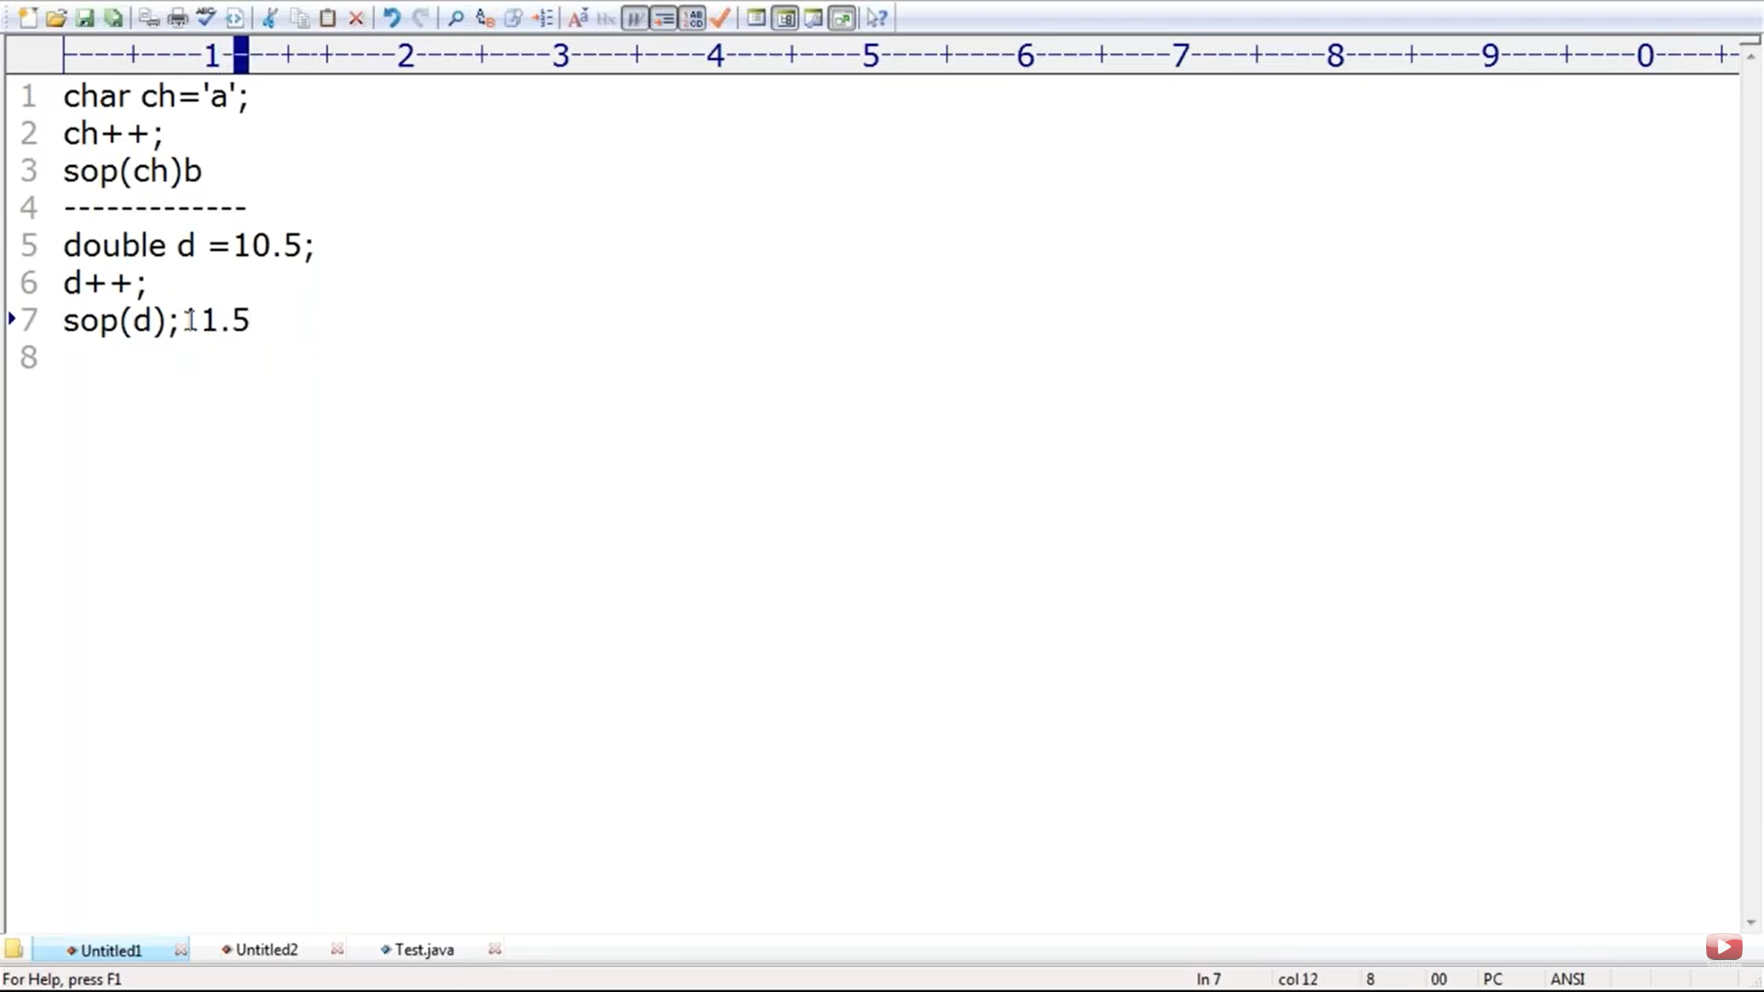

Increment and dec , implicit typecasting will be performed and the value will always be in the range only

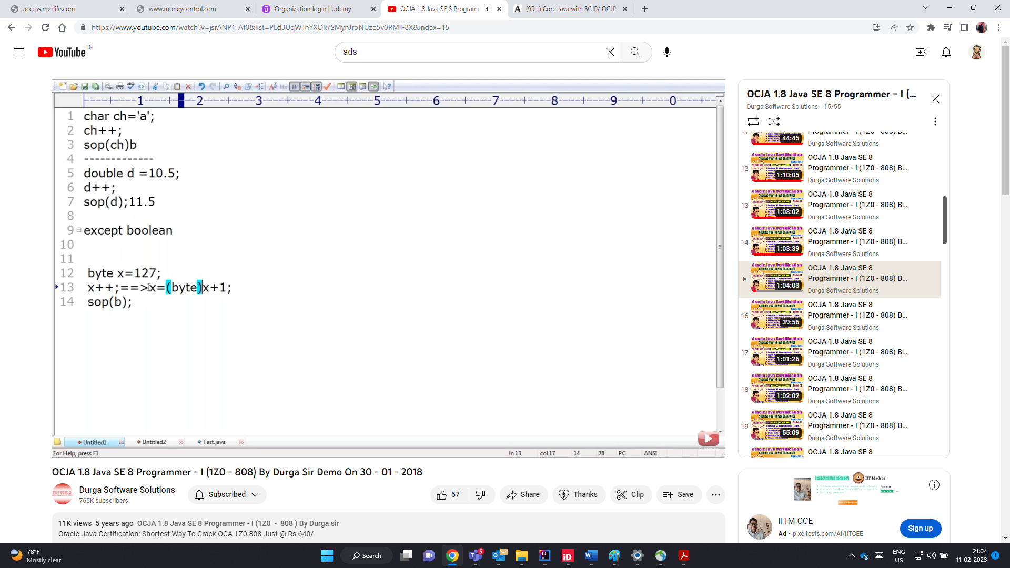

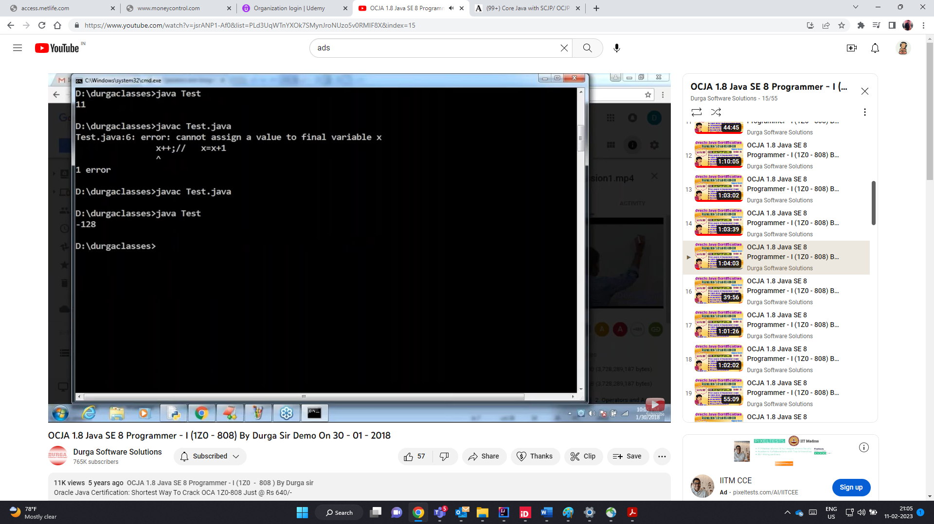

The below will never end, infinite loop

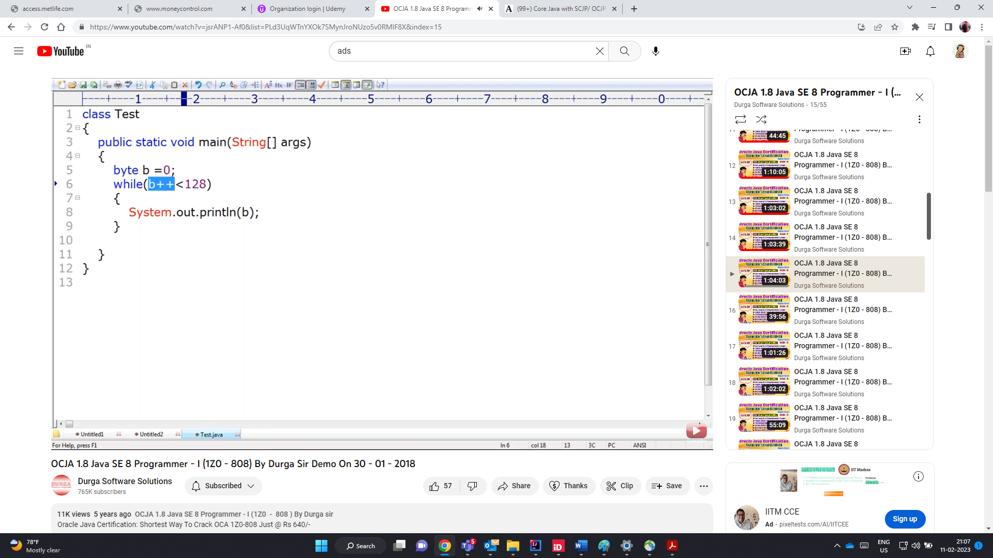

Arithmetic operator

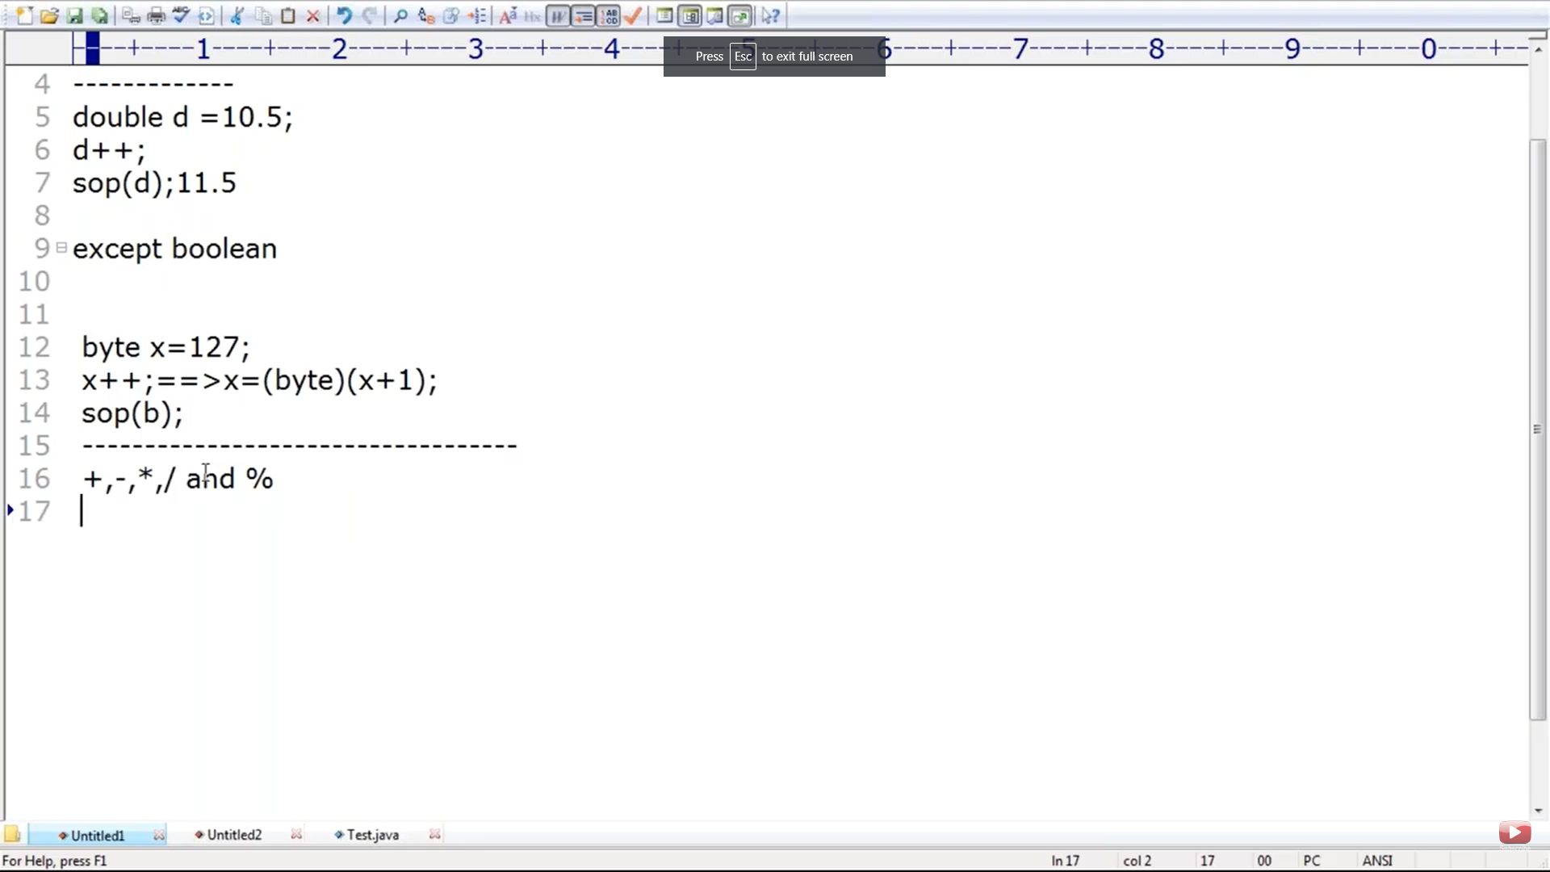

Systematically the below is correct. Any arithemetic

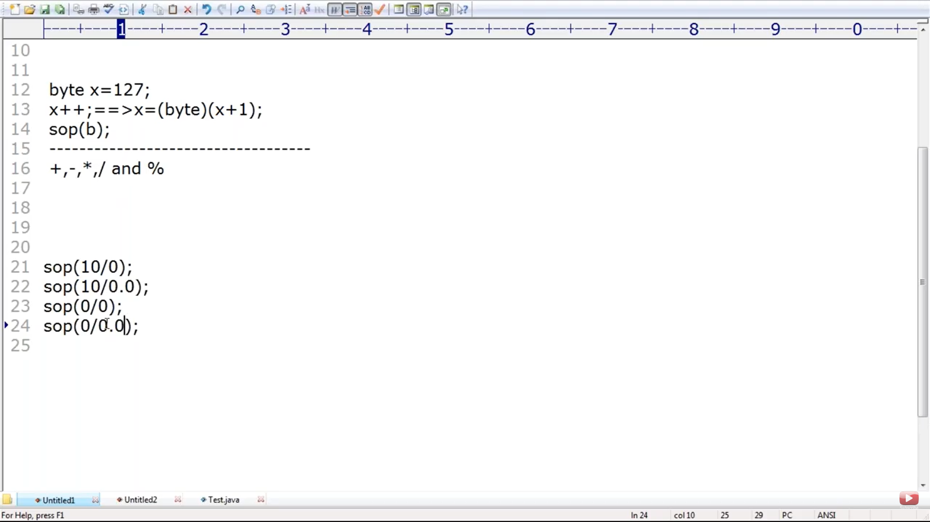

Result type for any arithmetic operation the result type is

=Max(int, type(a),type(b))

1. Max(int,int,int) -🡪 int
2. Maz(int, int, double) -> double
3. Max(int,int,int) -🡪 int
4. Maz(int, int, double) -> double

In integral rep there is no way to represent infinity so in 1 case , which is int when we divide a no by 0 , which is infity throws arithmetic exception. Whereas in case 4 double has a way to rep infinity so it will not throw arithmetic exception

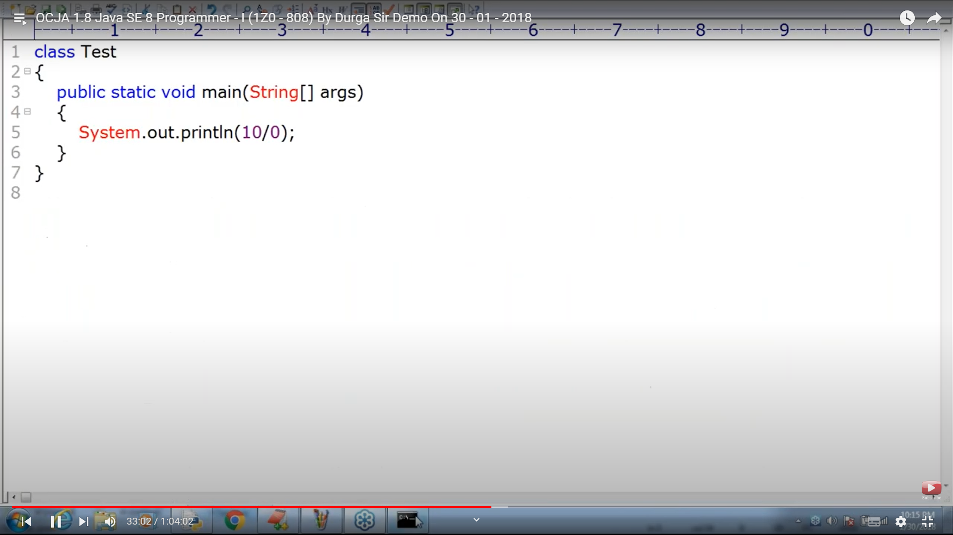

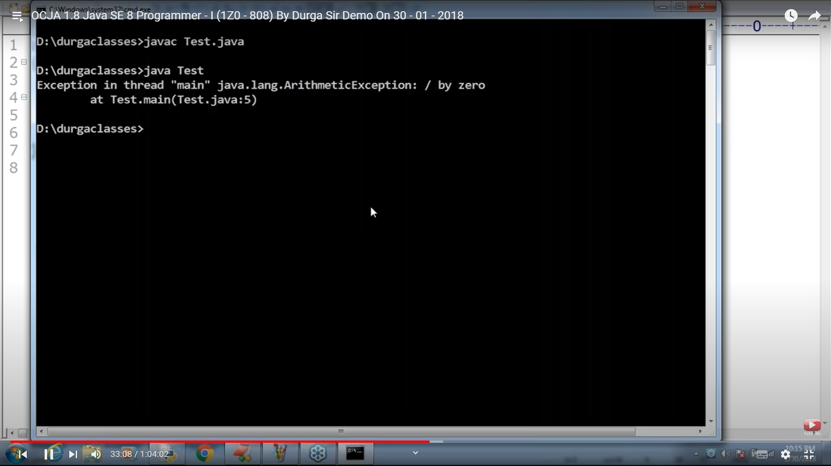

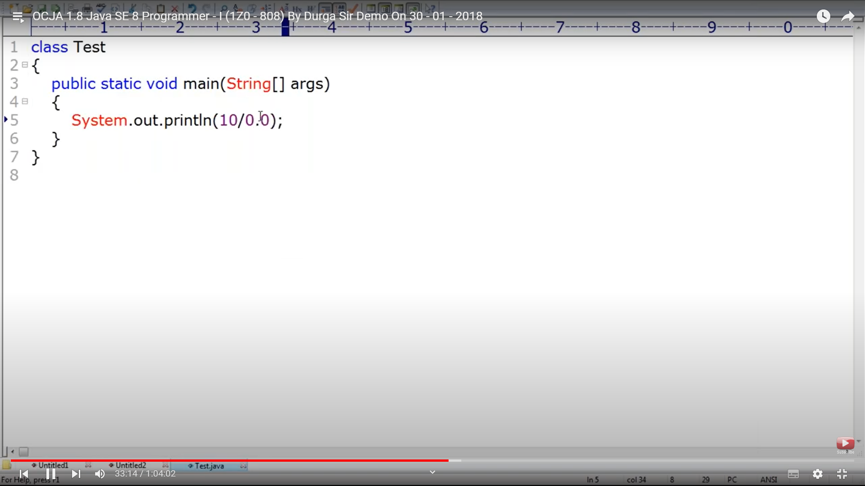

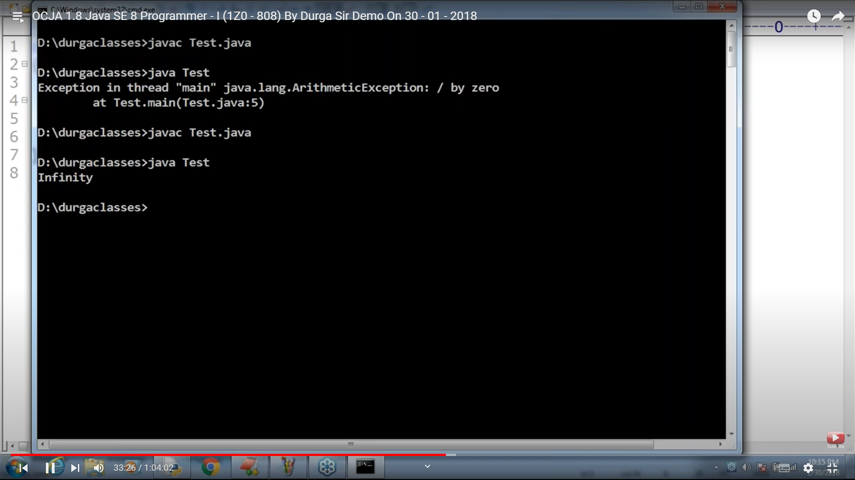

In general math 0/0 is undefined. So integral rep there is no way to define undefined values. So it throws Arithmetic Exception. Case 2

Whereas Floating point rep has a way to rep undefined values which is **NaN** case 4

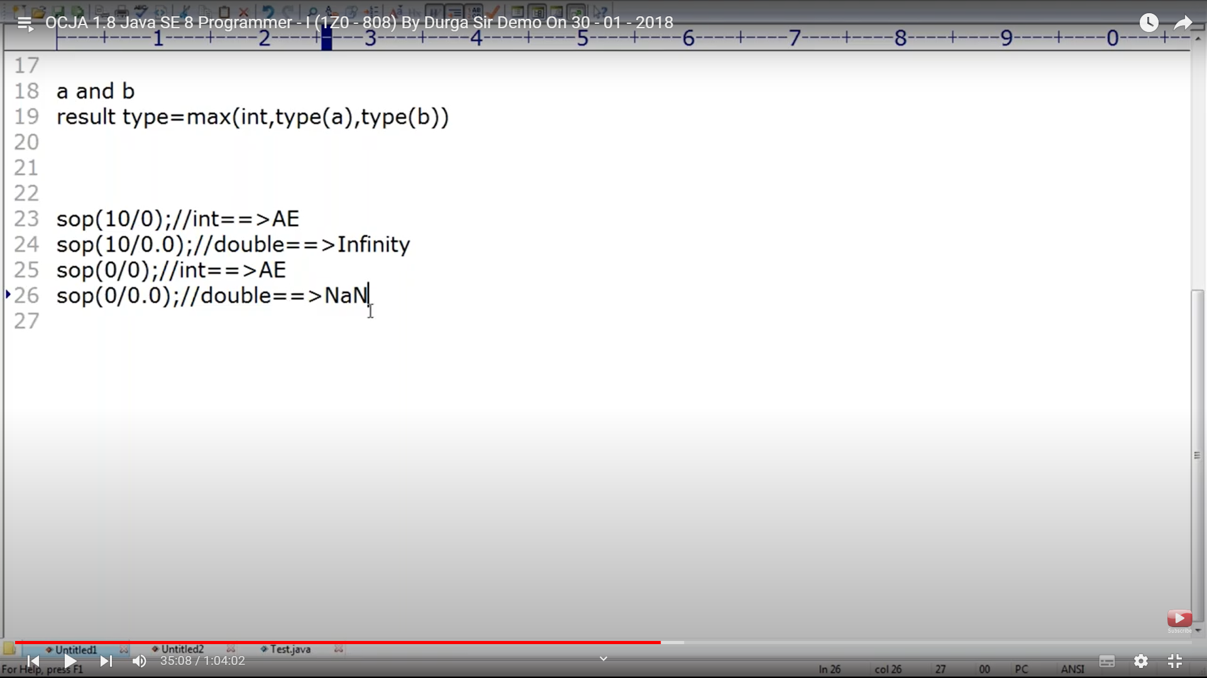

/ and % operation alone will cause arithmetic exception. Run Time exception AE

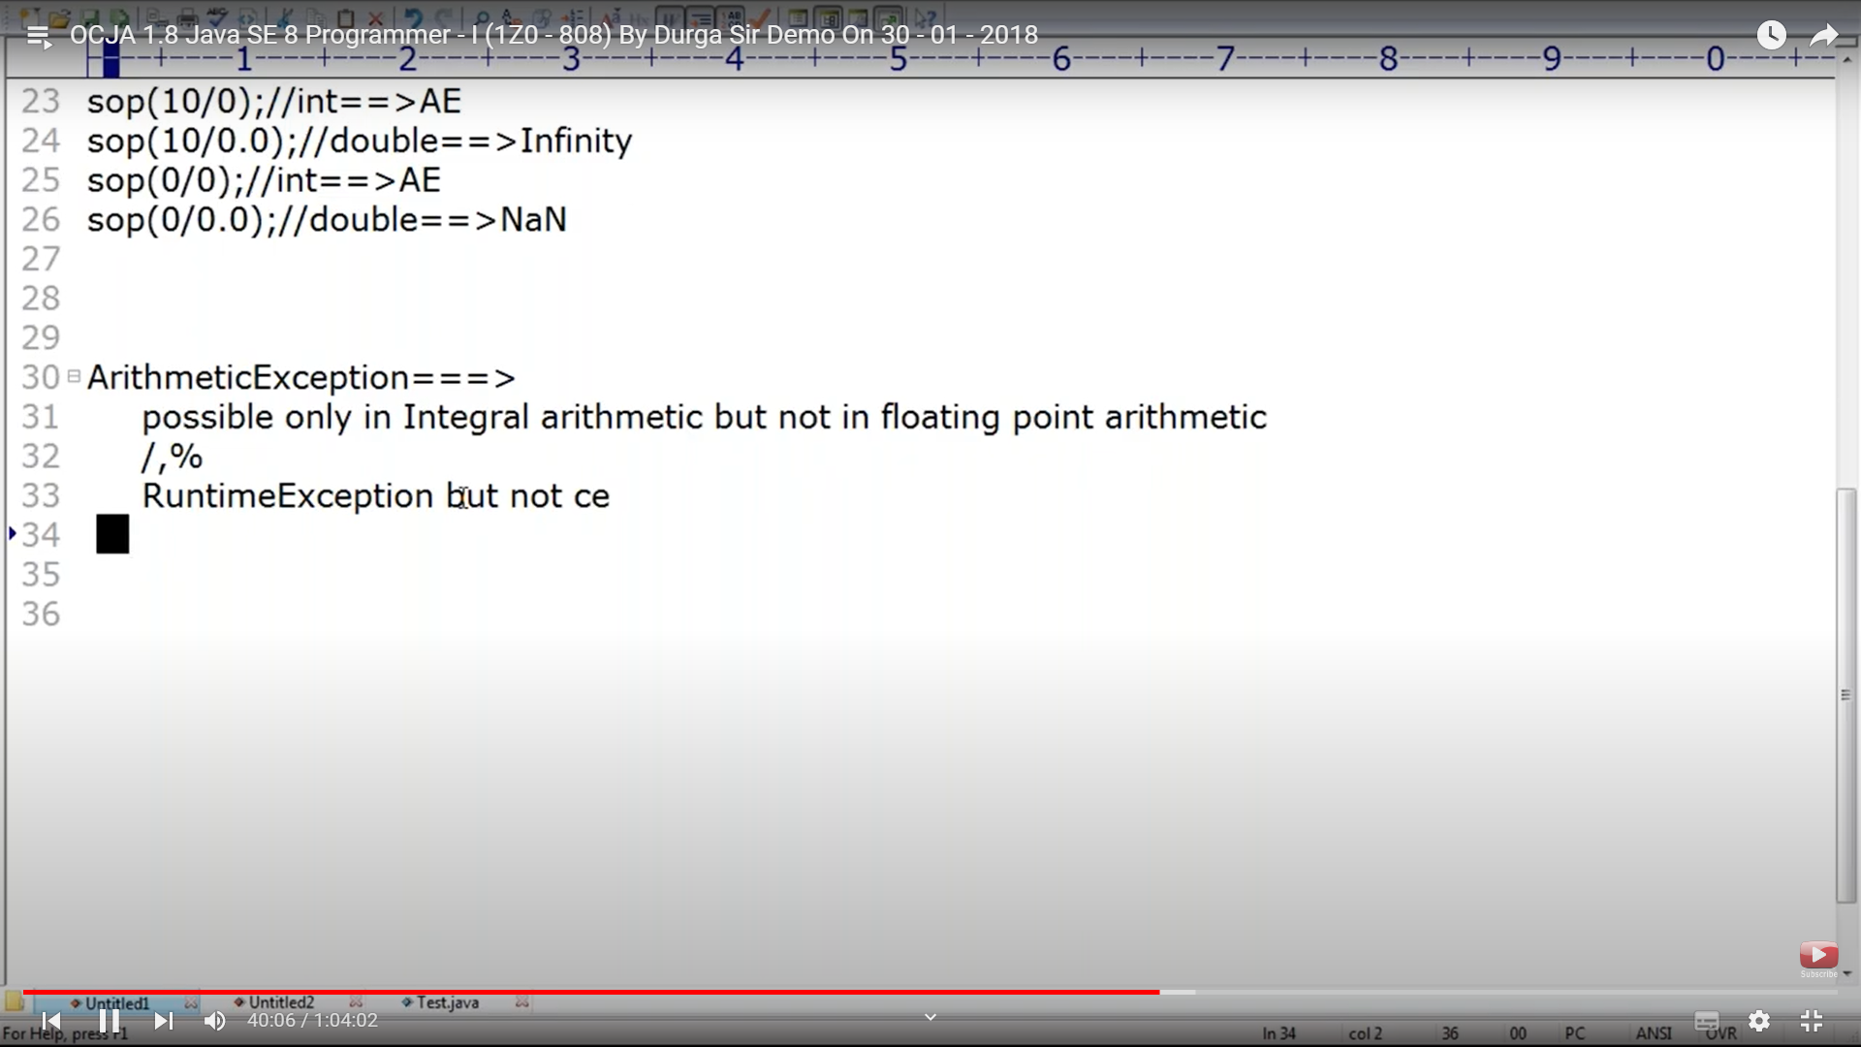

+ acts as arithmetic operator and as concatenation in string. + operator alone supports operator overloading. Since + operator supports operatior overloading we cant say java as a whole supports operator overloading

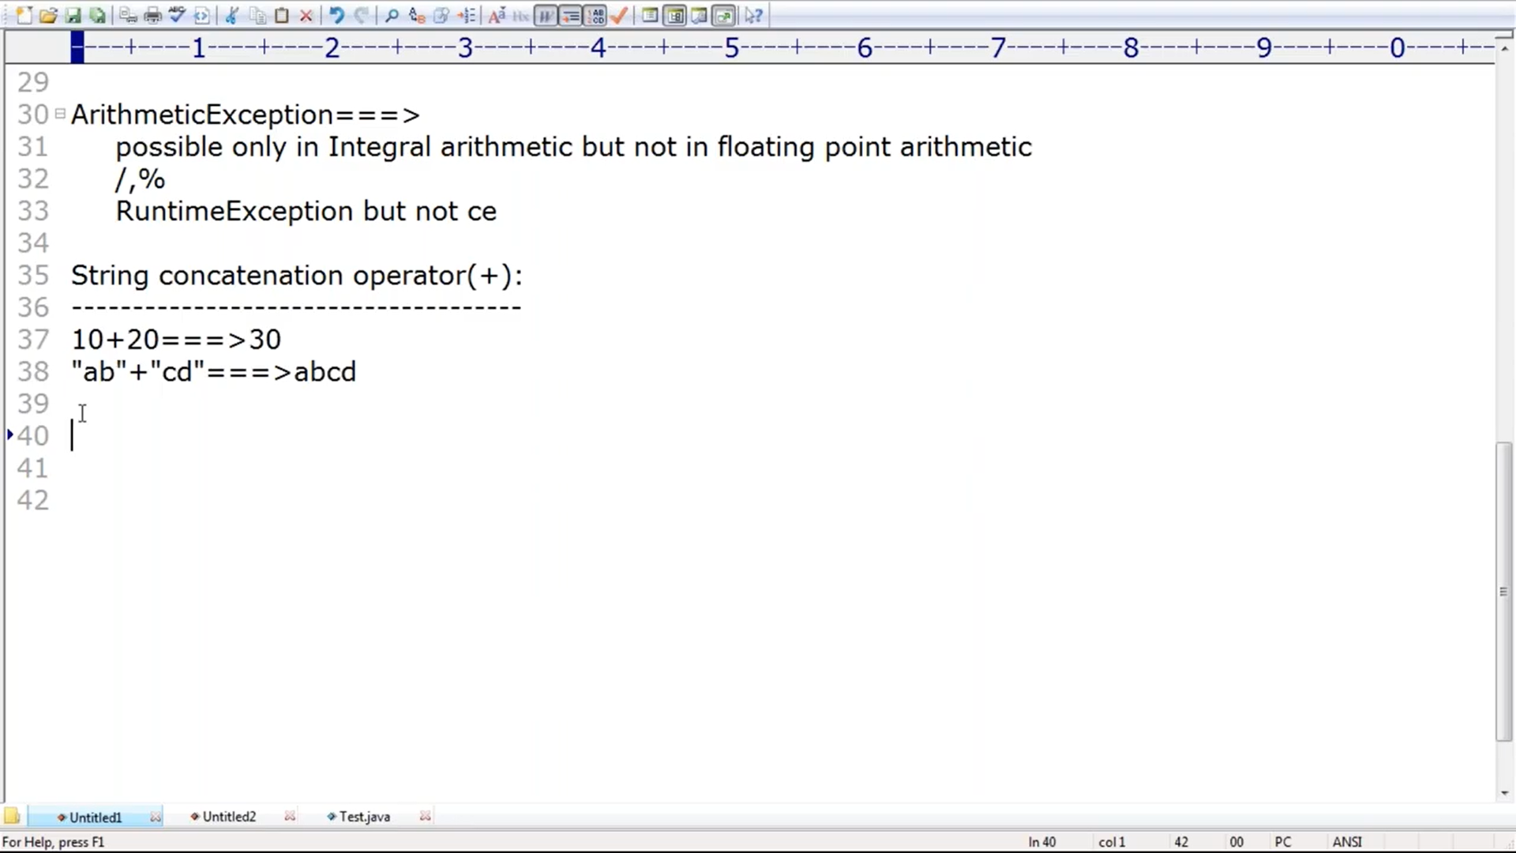

String + no – String , String+no -> String

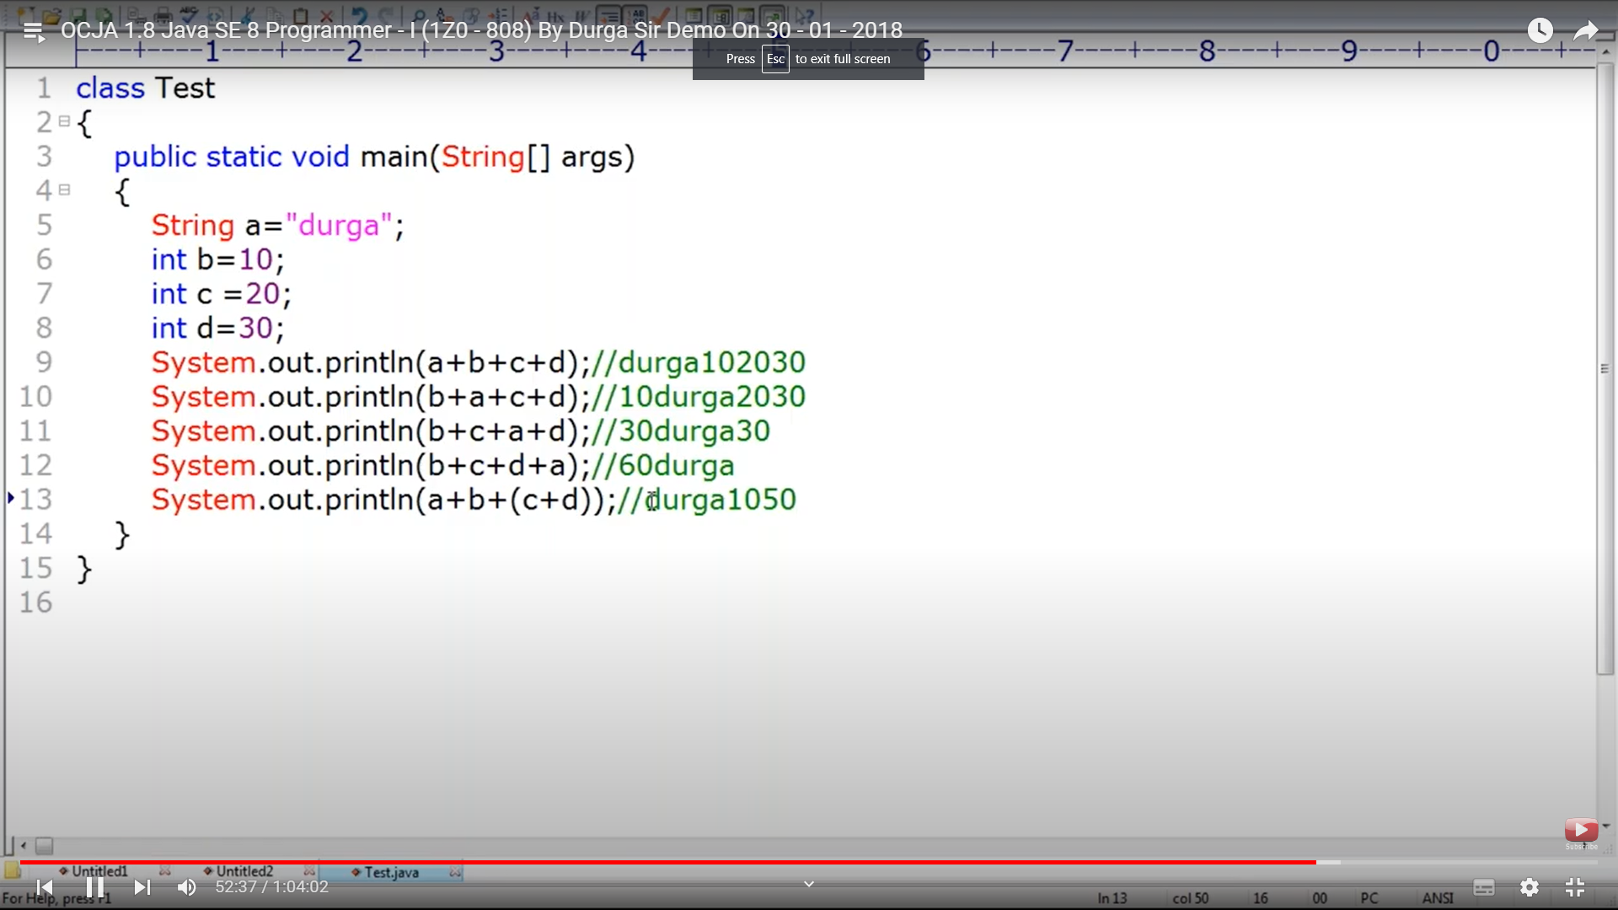

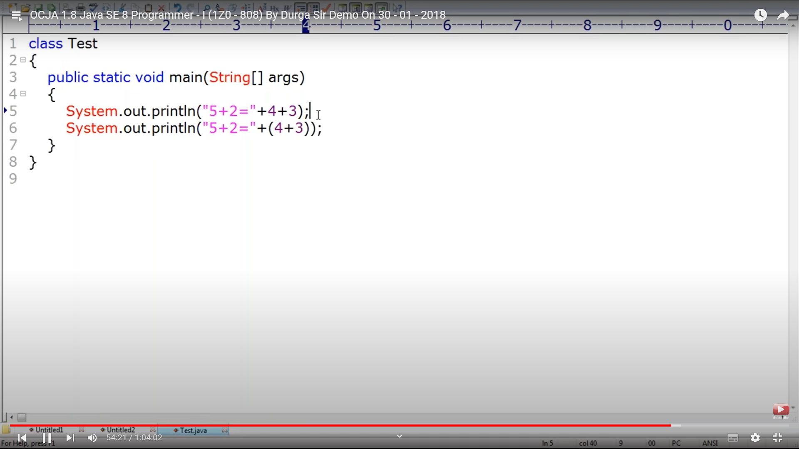

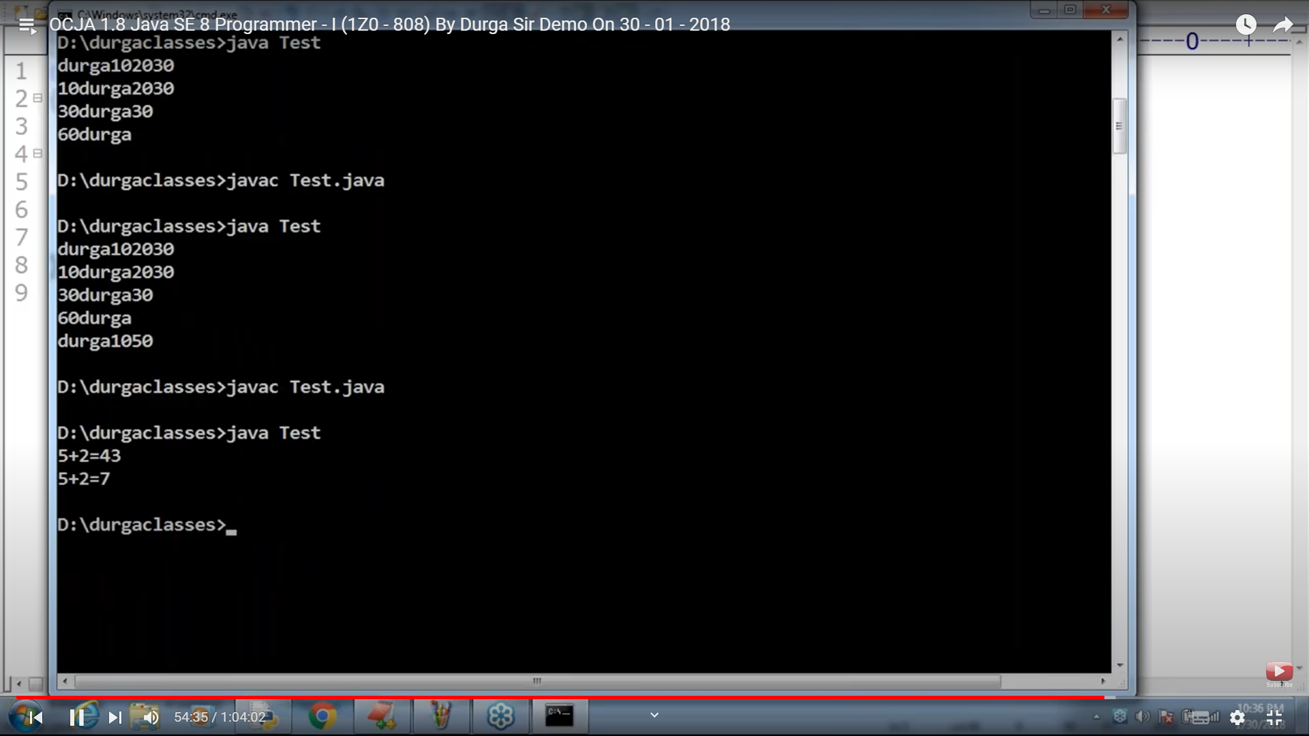

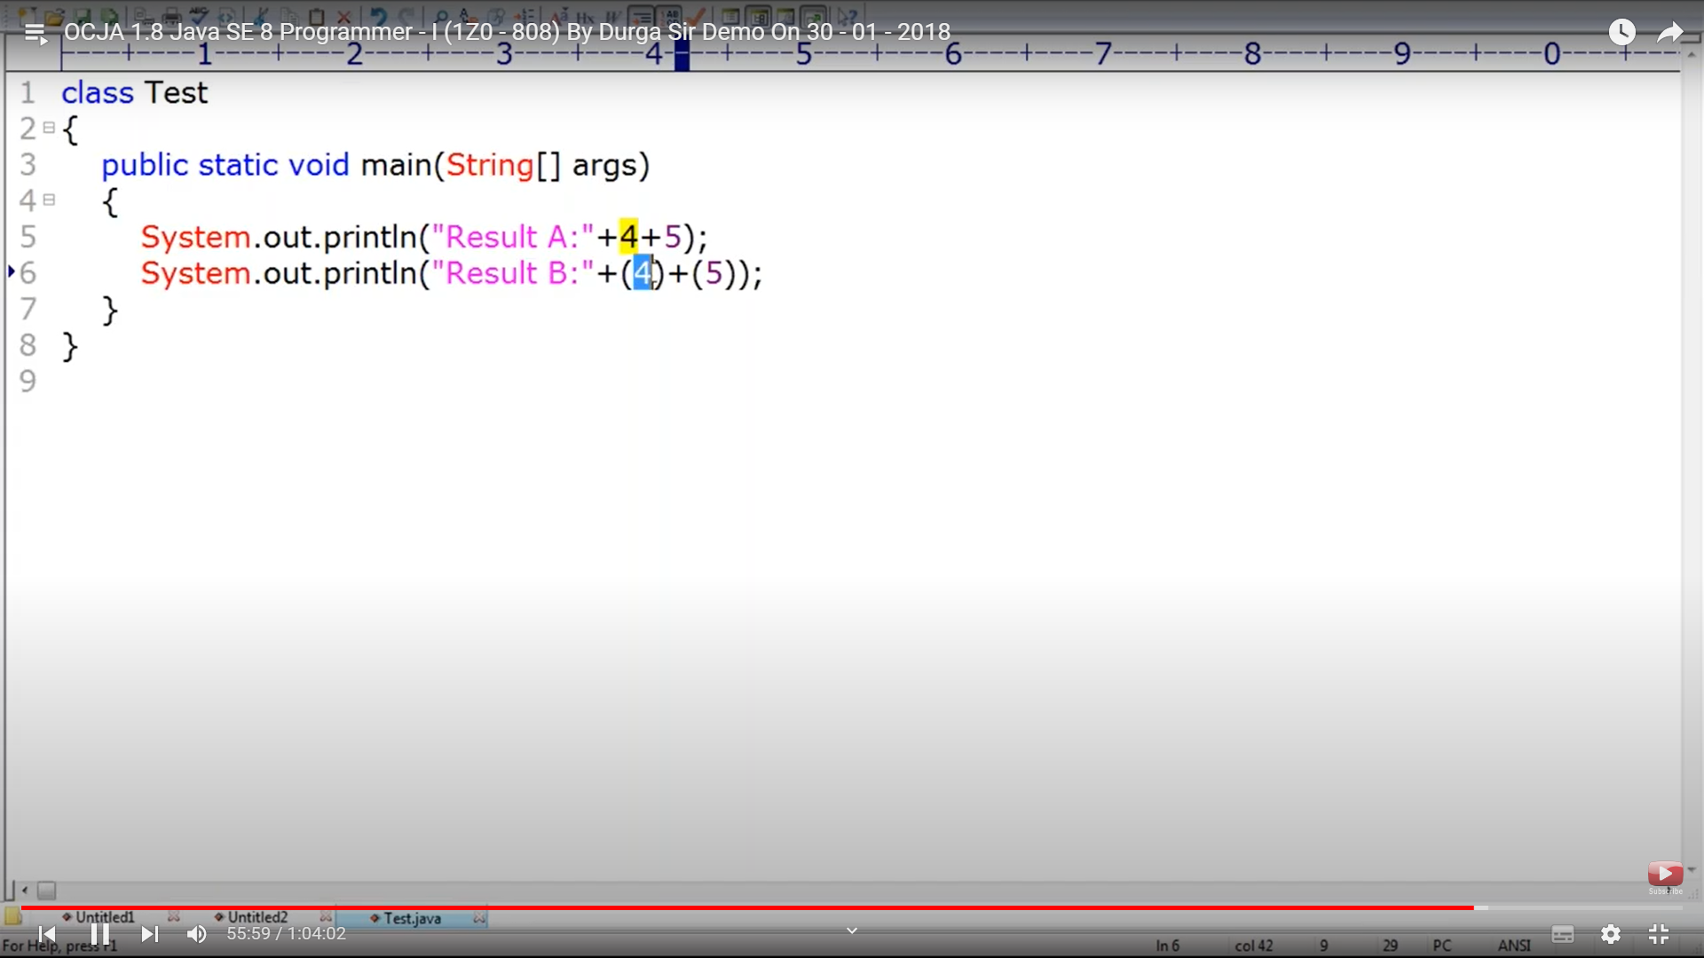

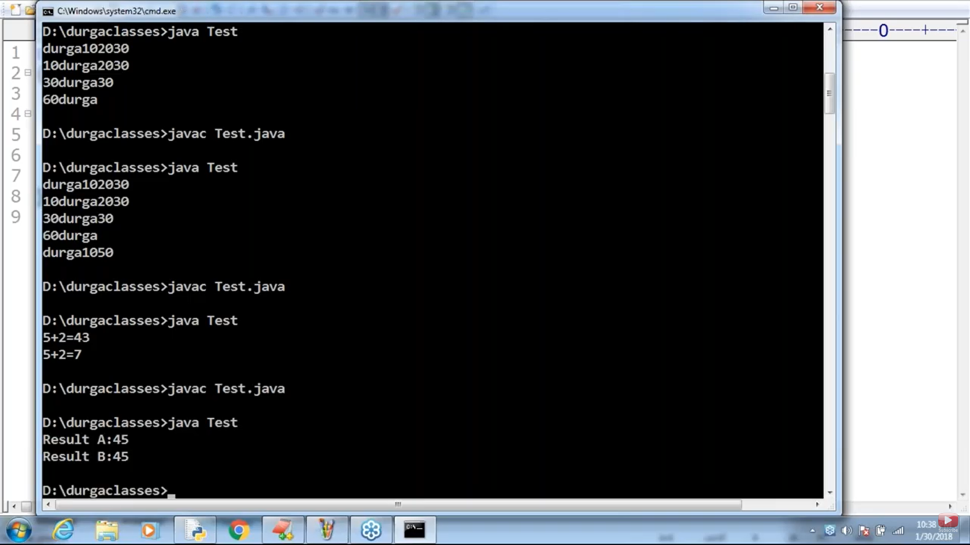

You can apply relational operators on any type other than Boolean. For Boolean and objects relational ops throw compile time error. Line 45 throws error

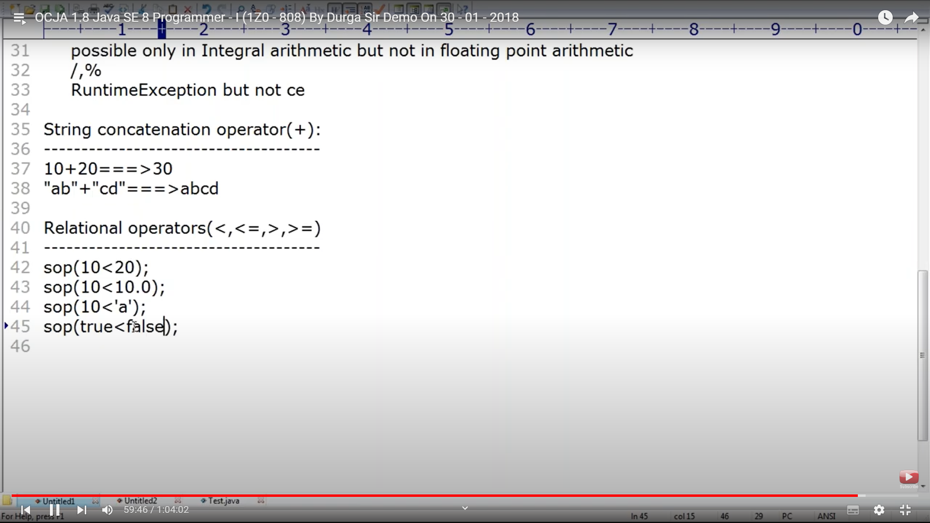

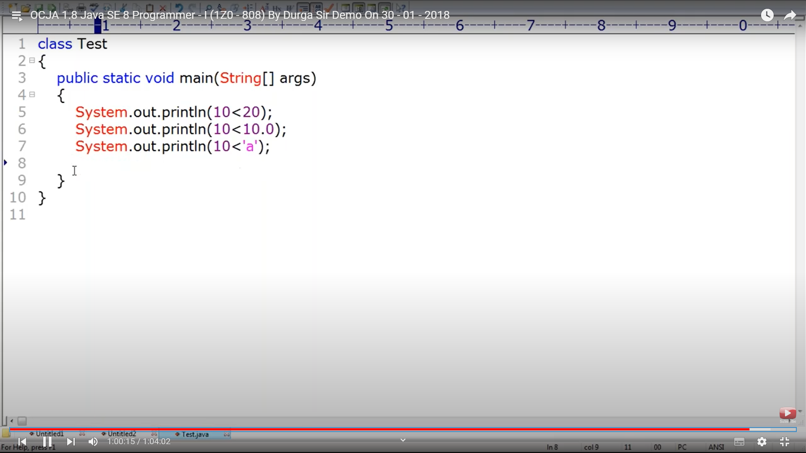

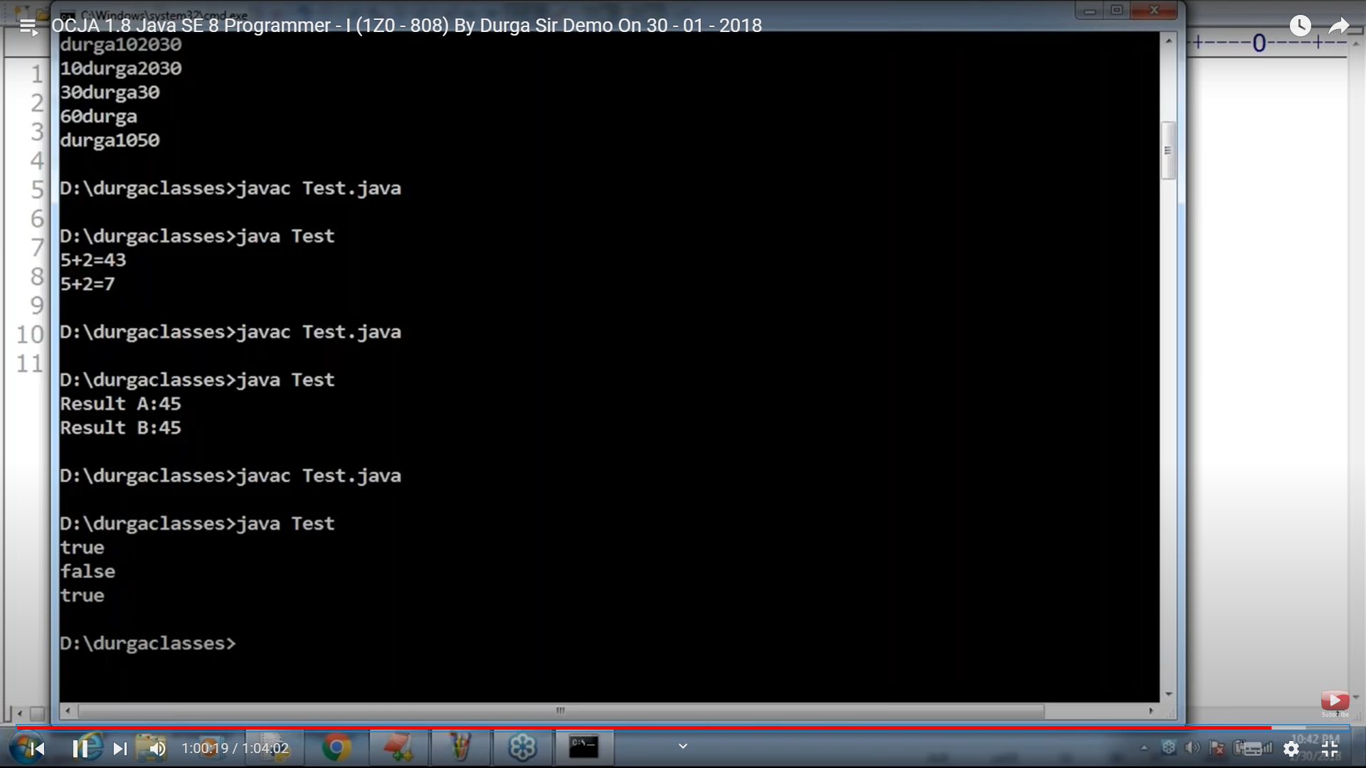

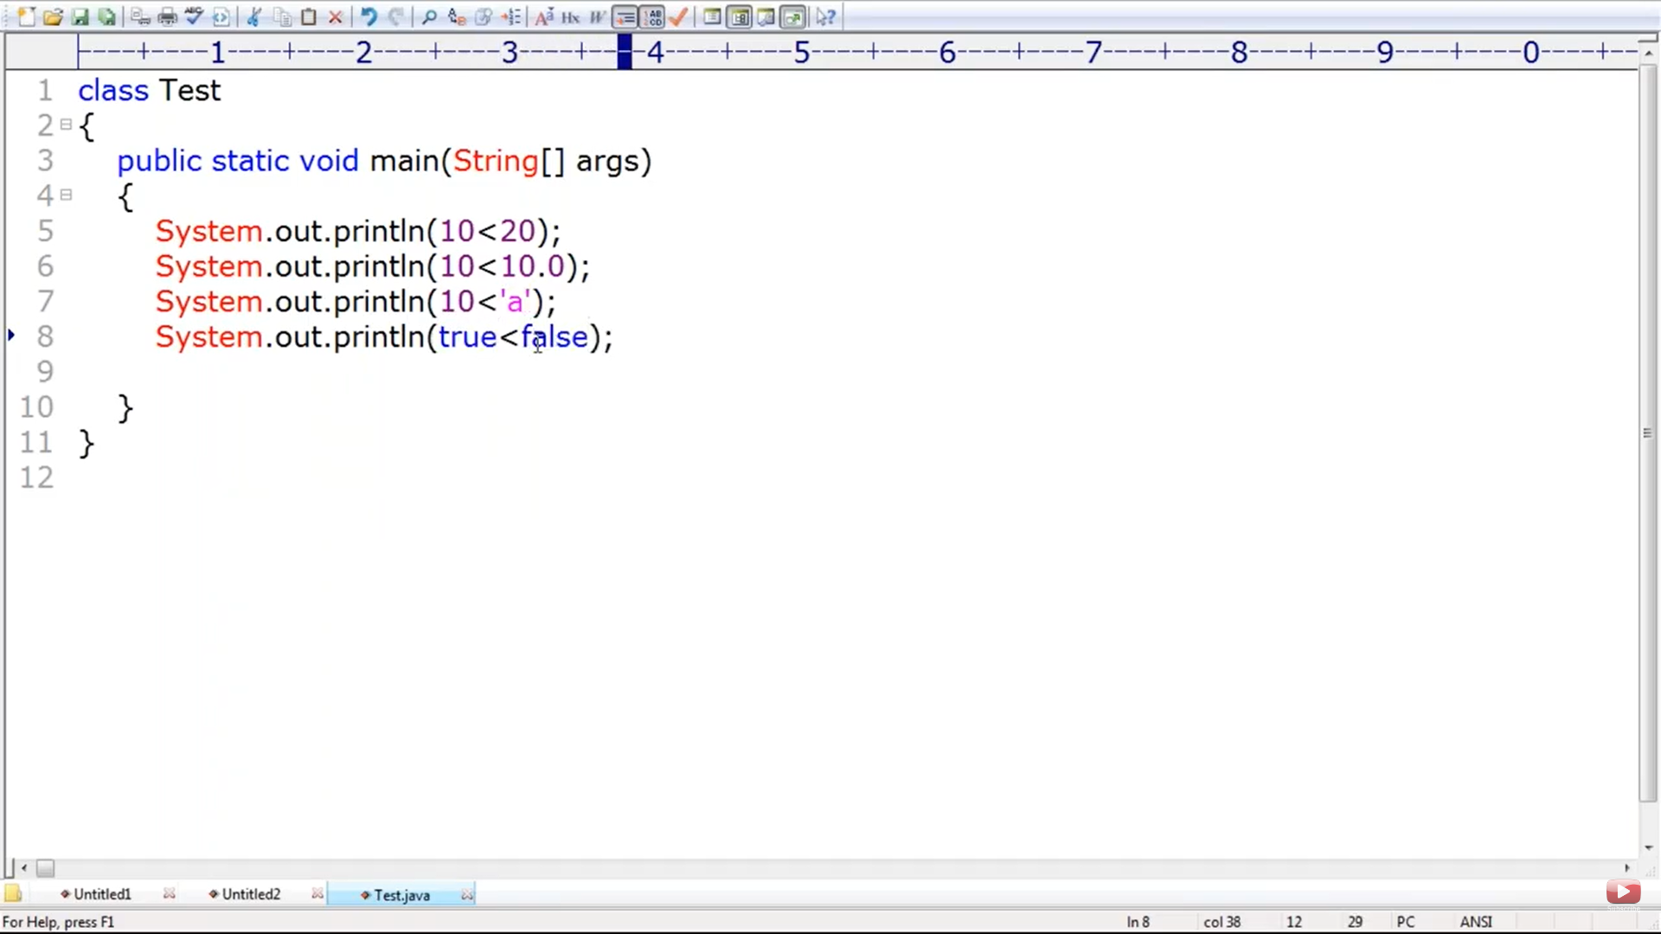

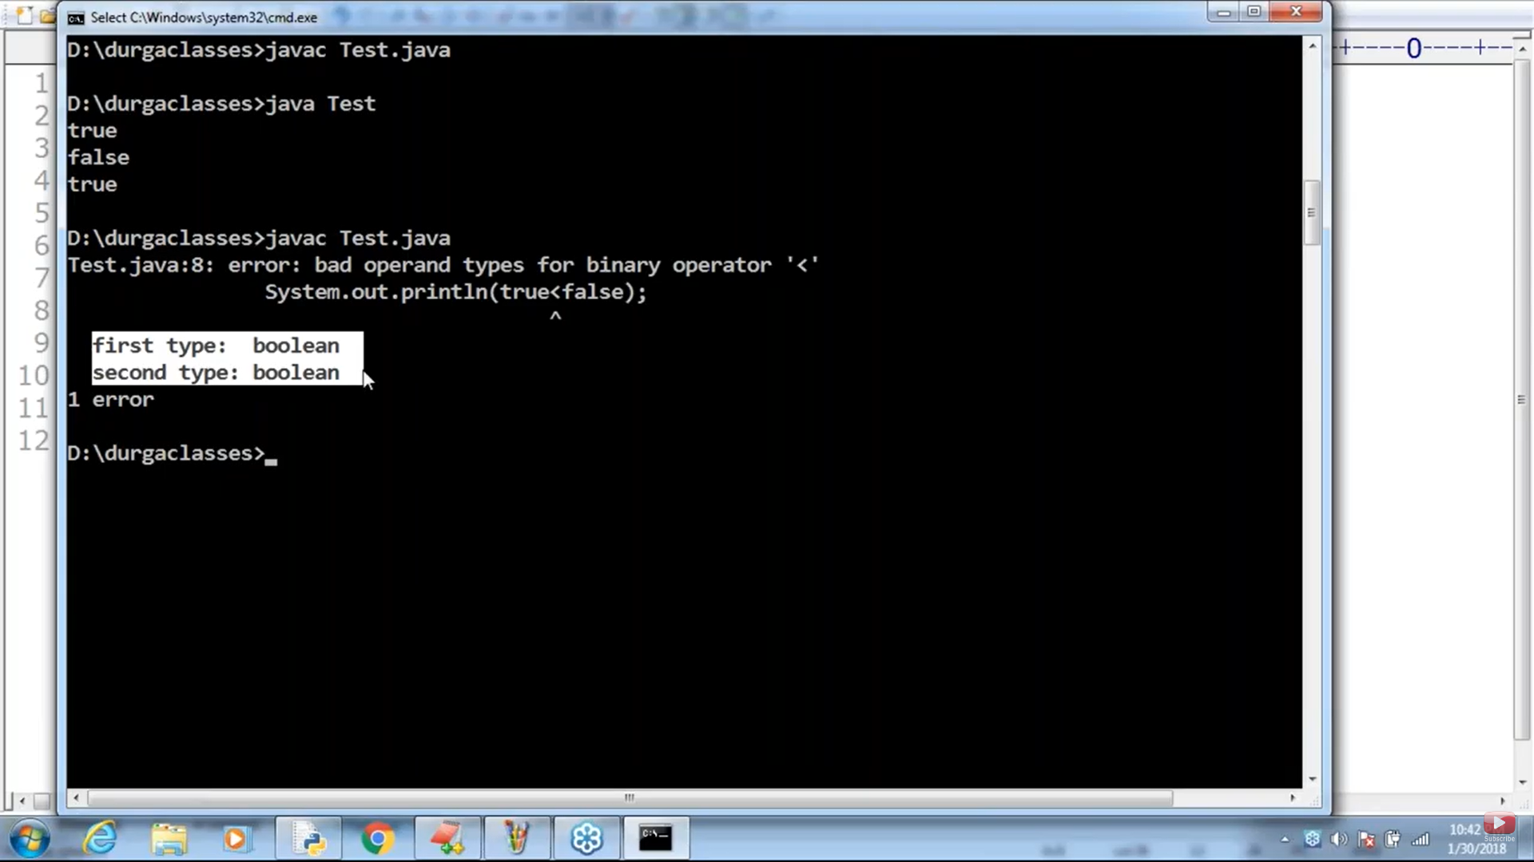

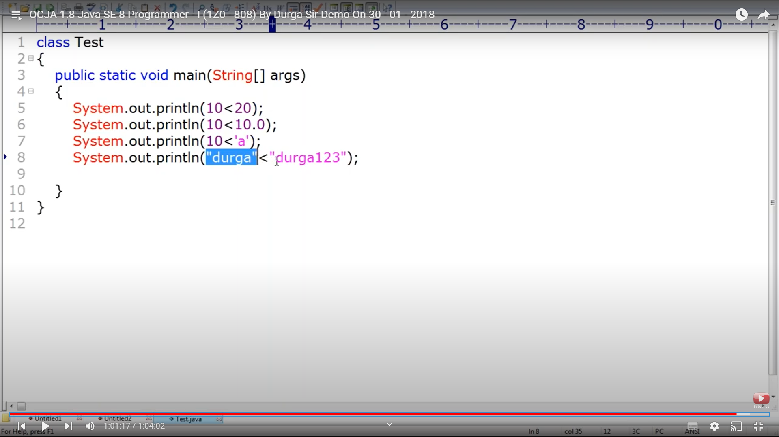

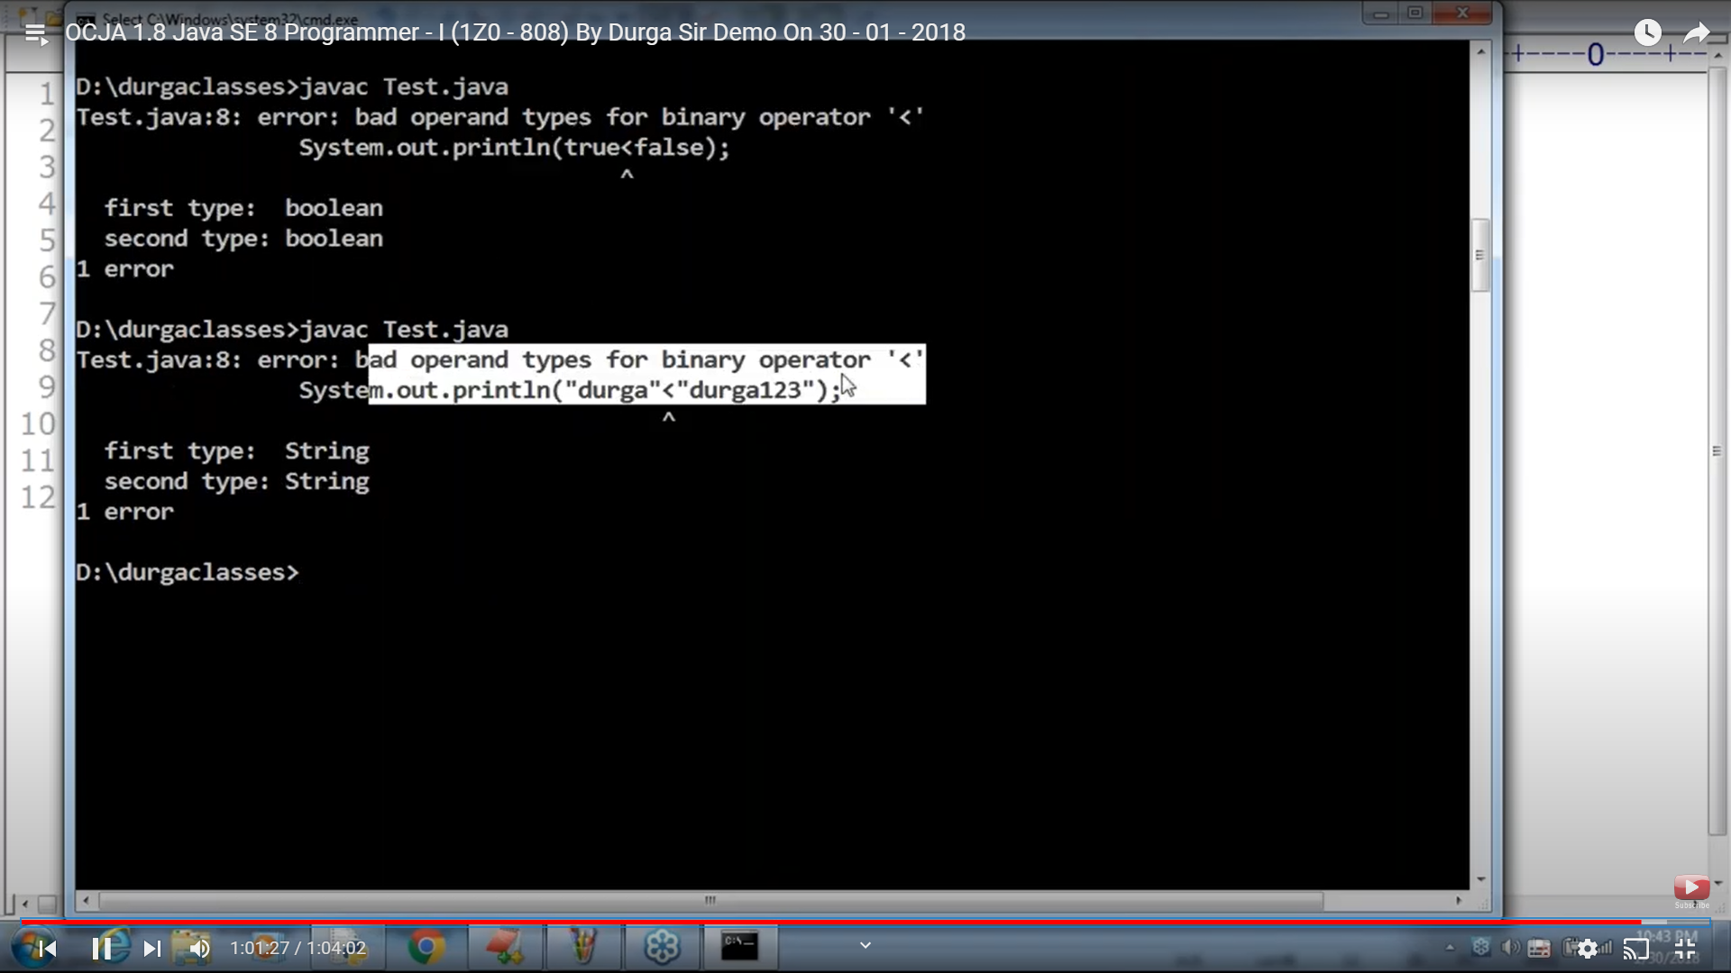

10>20 – true: True<30 , boolan on relational throws compile time error. Nesting of relational operator throws error

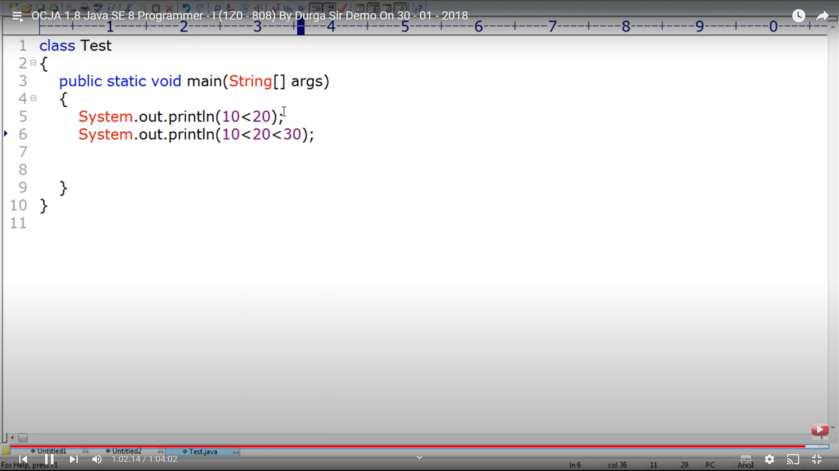

Equality Operator:

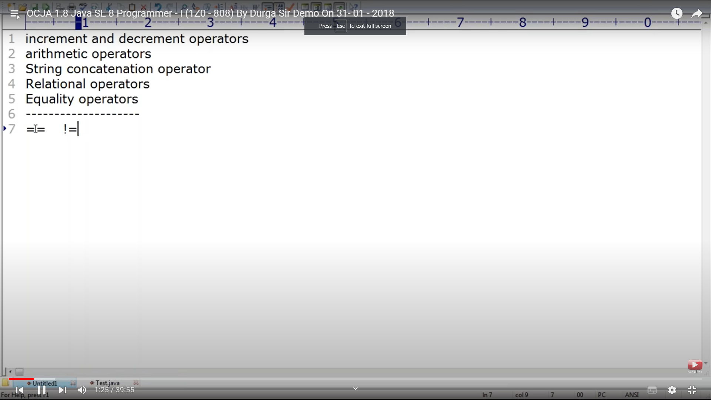

Equality op can be use for any primitive type. Line 12 , int gets promoted to bigger data type double so would return true. Can apply equality to boolean as well.

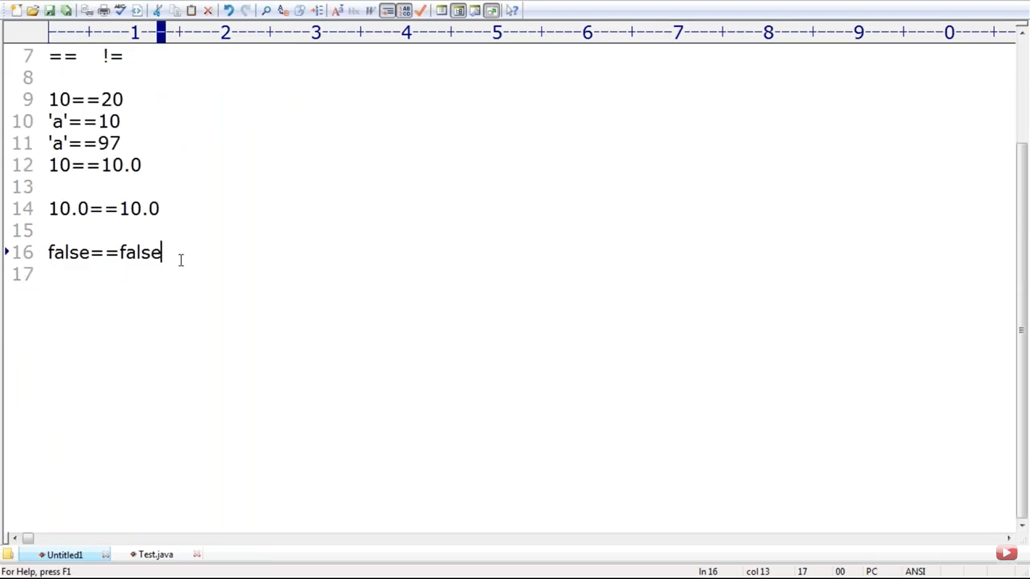

Equality op can be applied to object types as well if both ref points to same object. == ops are use to compare ref value or add value

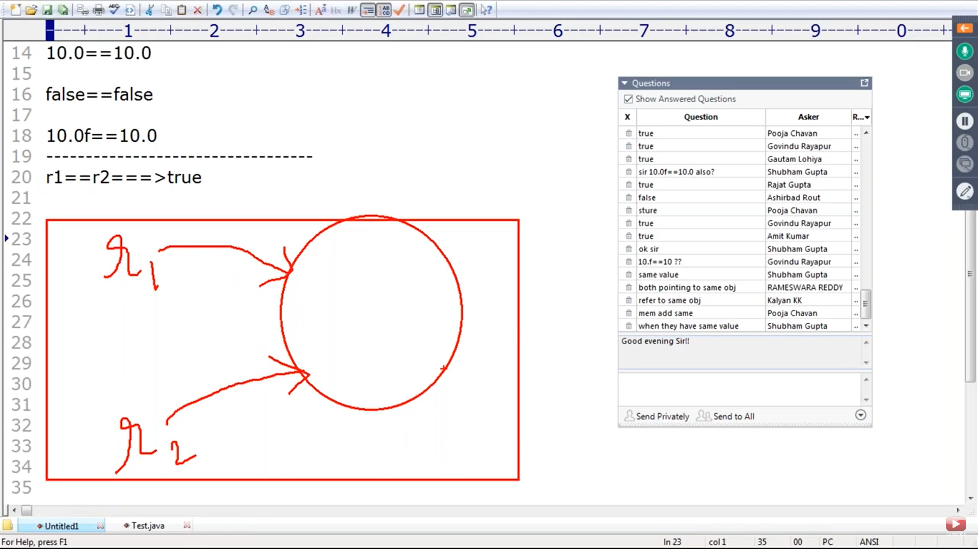

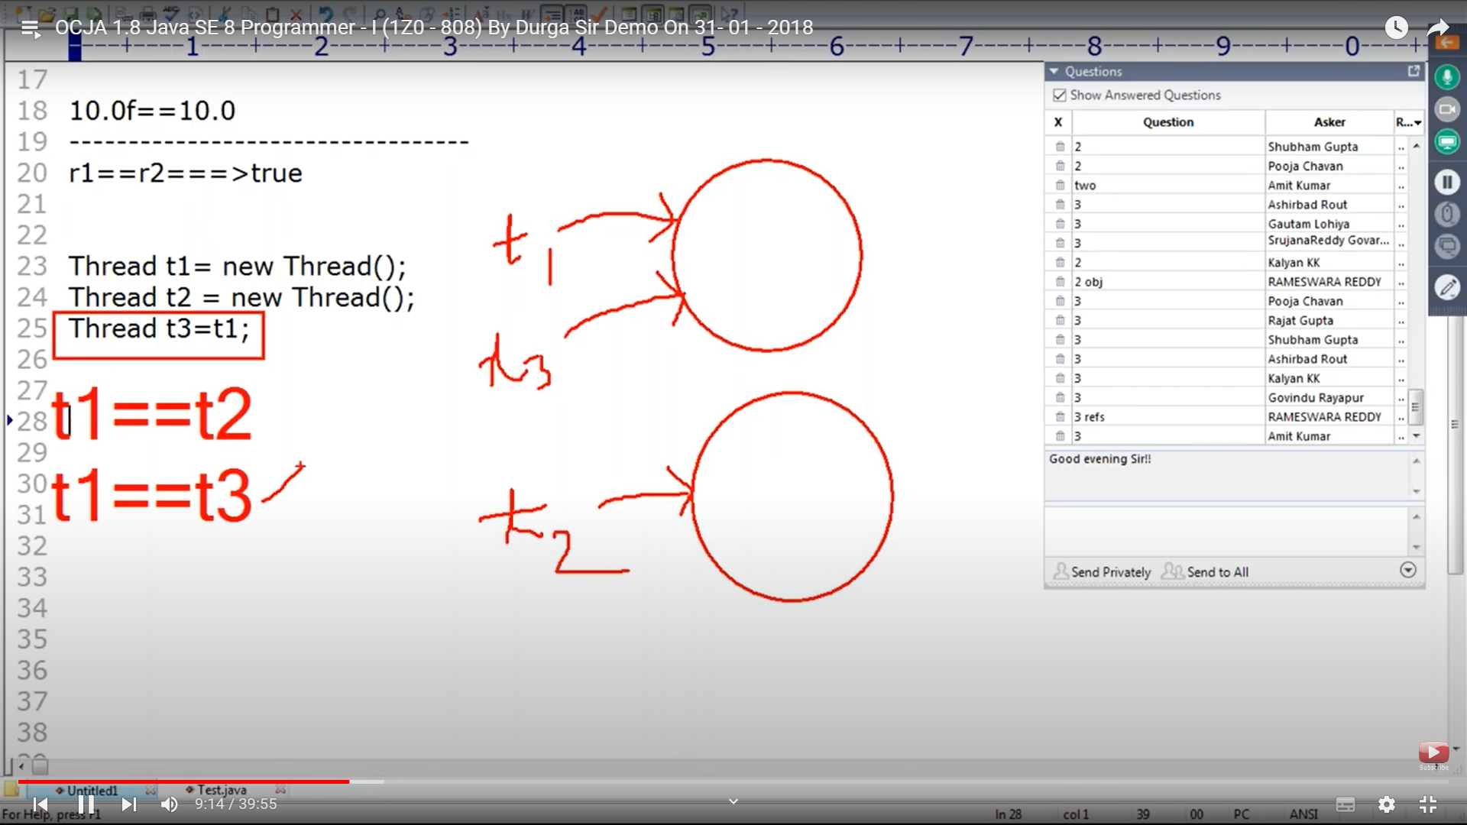

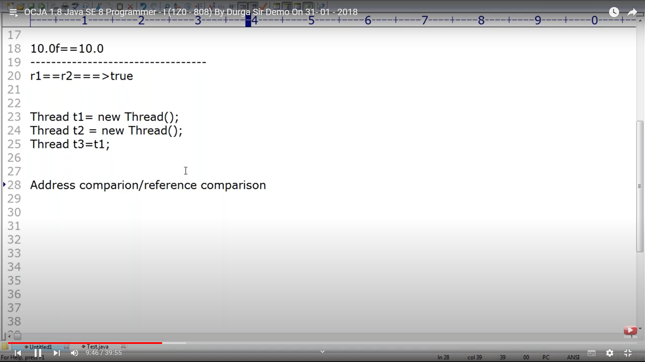

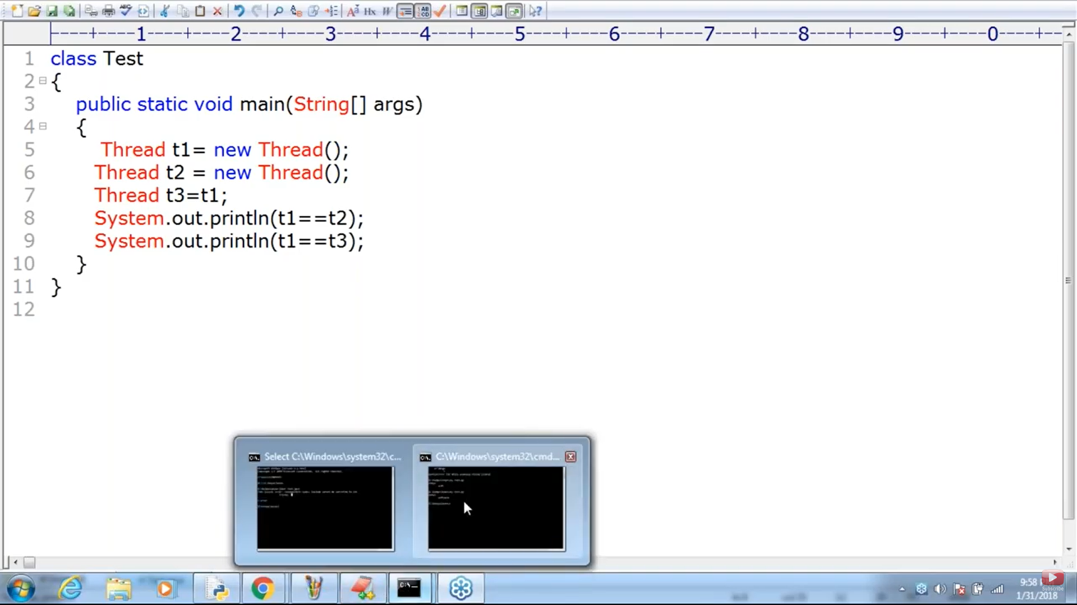

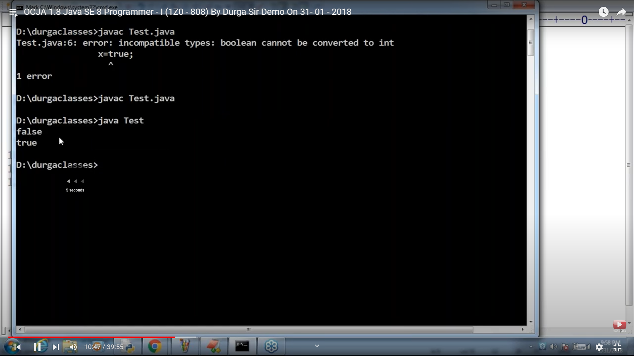

Below is false as new creates a new object and the add ref are diff

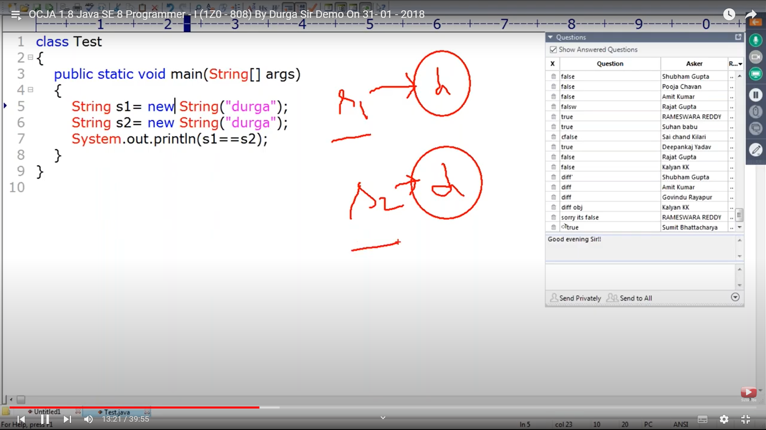

These are two diff object types and returns false but,

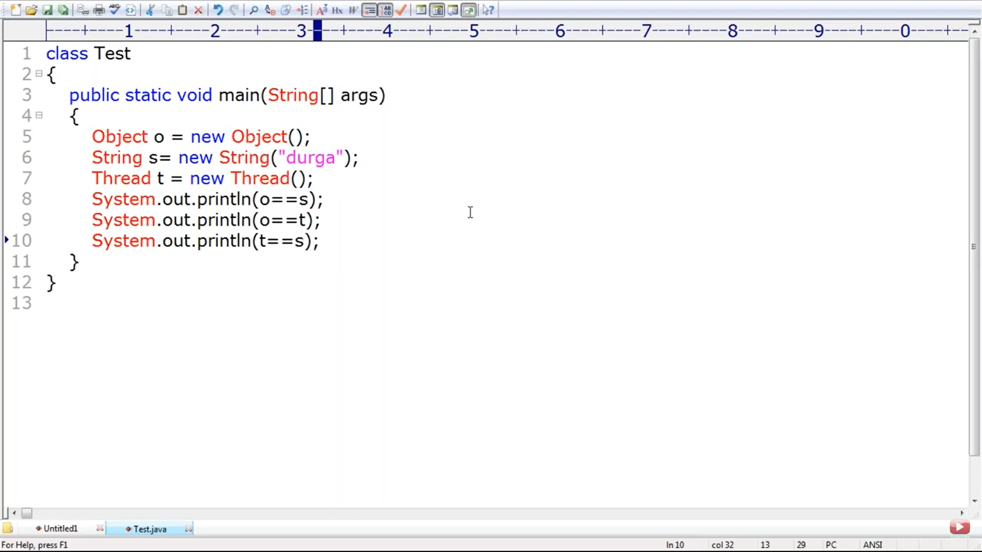

There is a relation between Object -> String and Object -> Thread . But there is no relation btw Thread and String , u cant apply equality operator on objects with no relation.So compile time error on line 10. There should be relation btw argument types

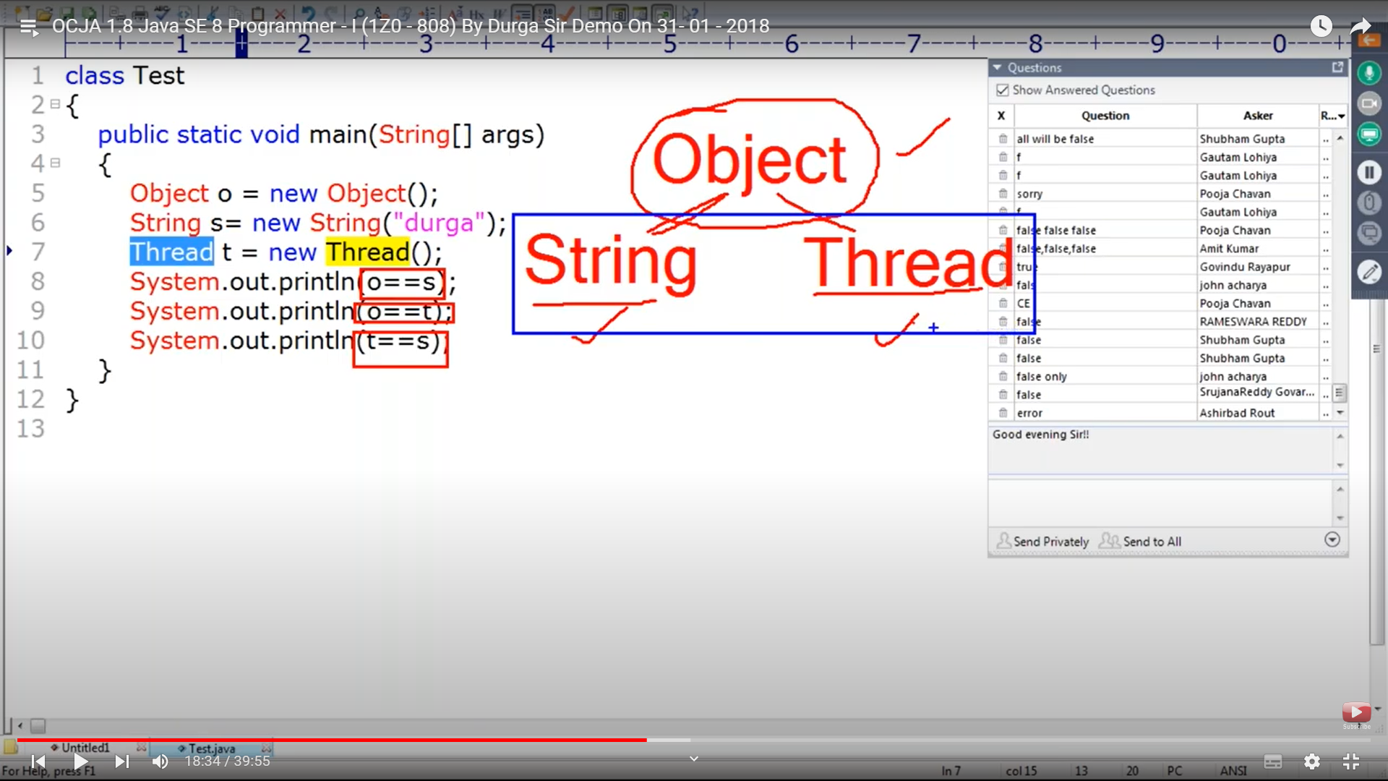

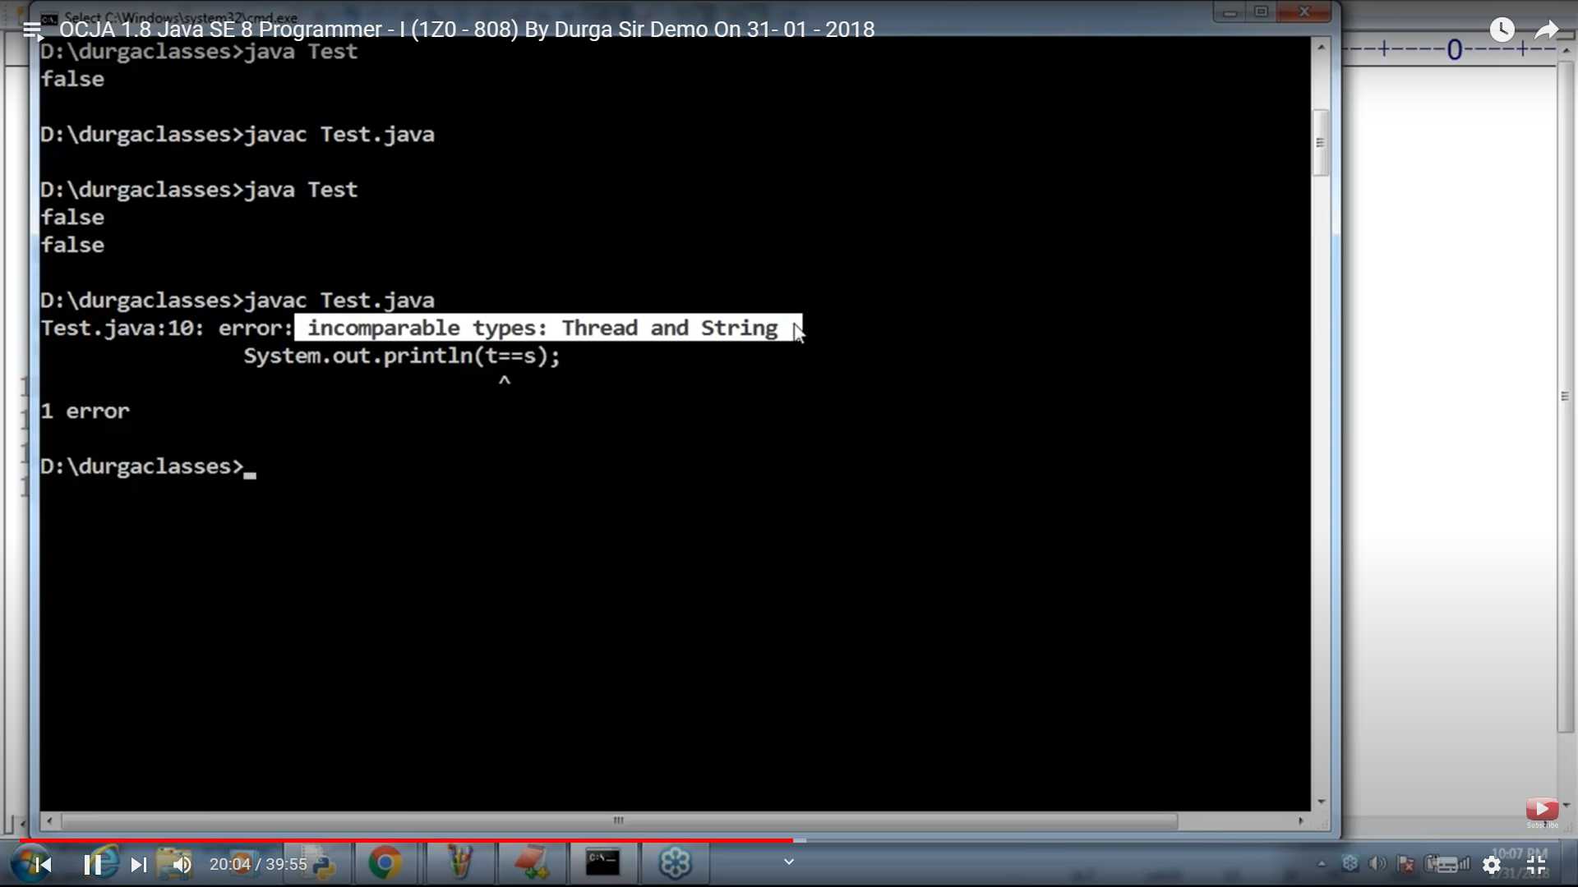

Exam equals specific to String only not other objects

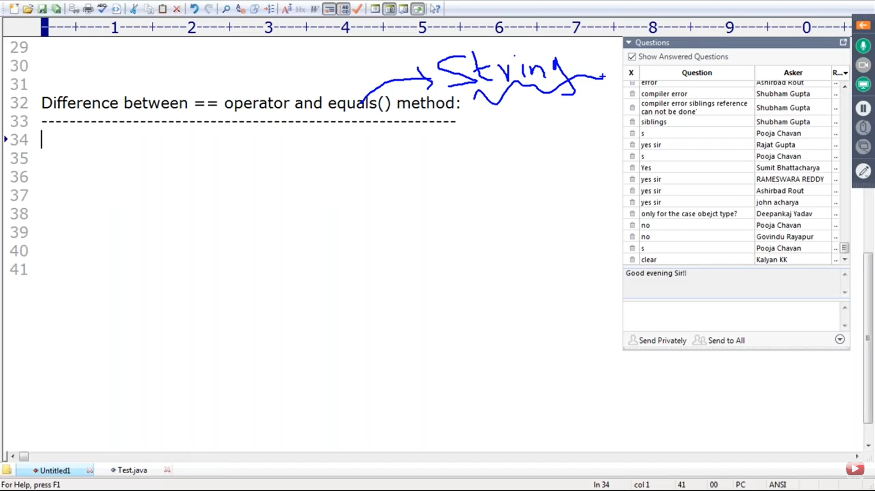

Even if object is diff if content is same equals() returns true

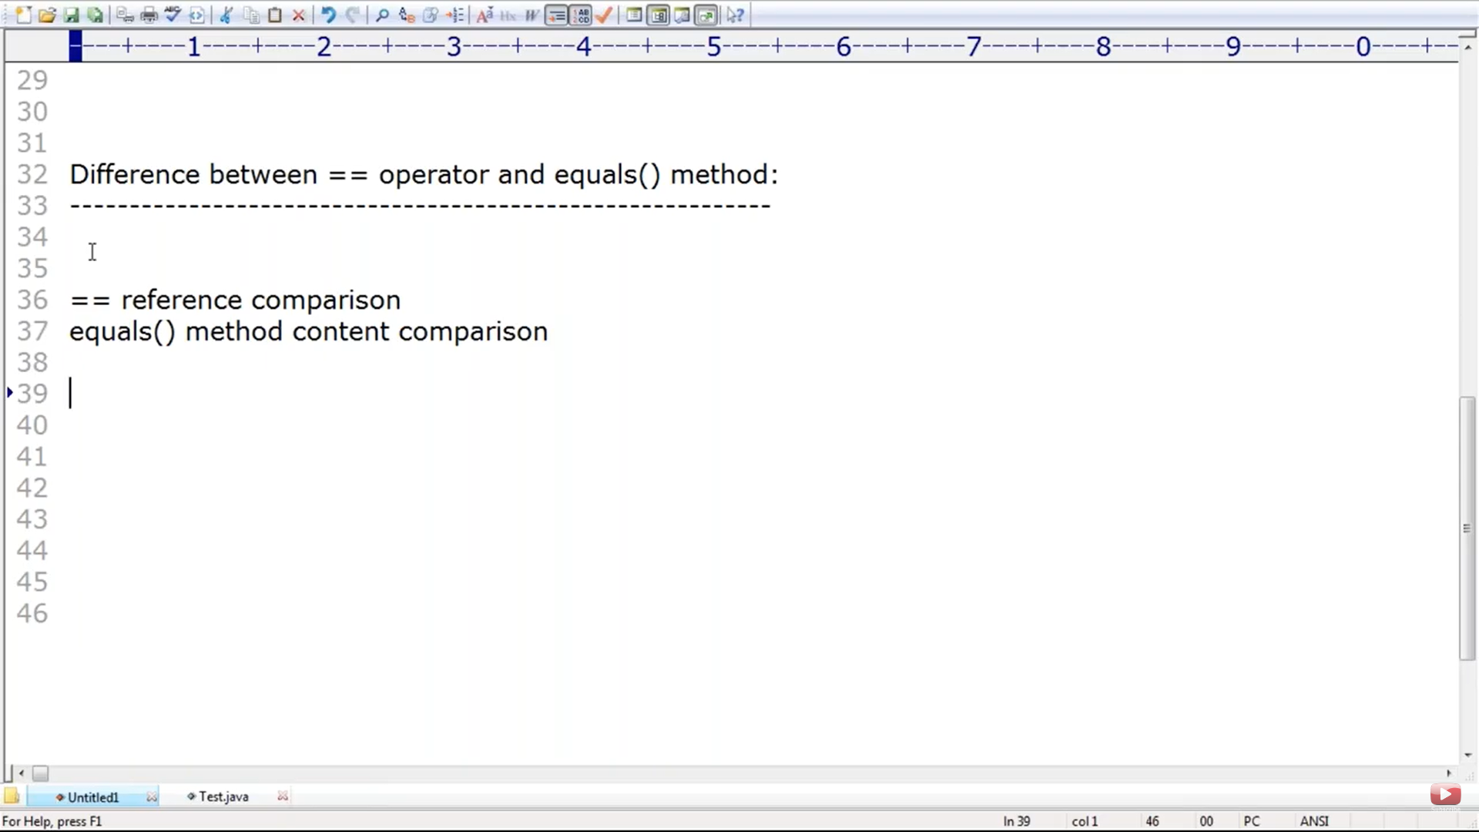

Line 7 is false and Line 8 true

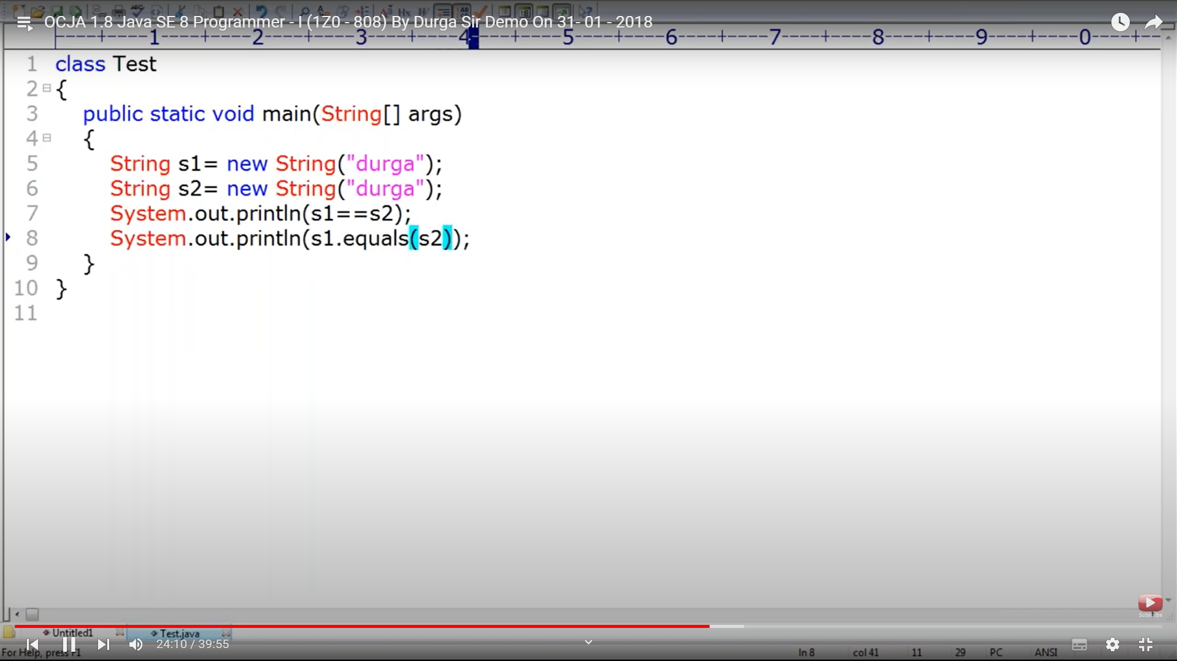

Compile time error no relation btw string and String buffer

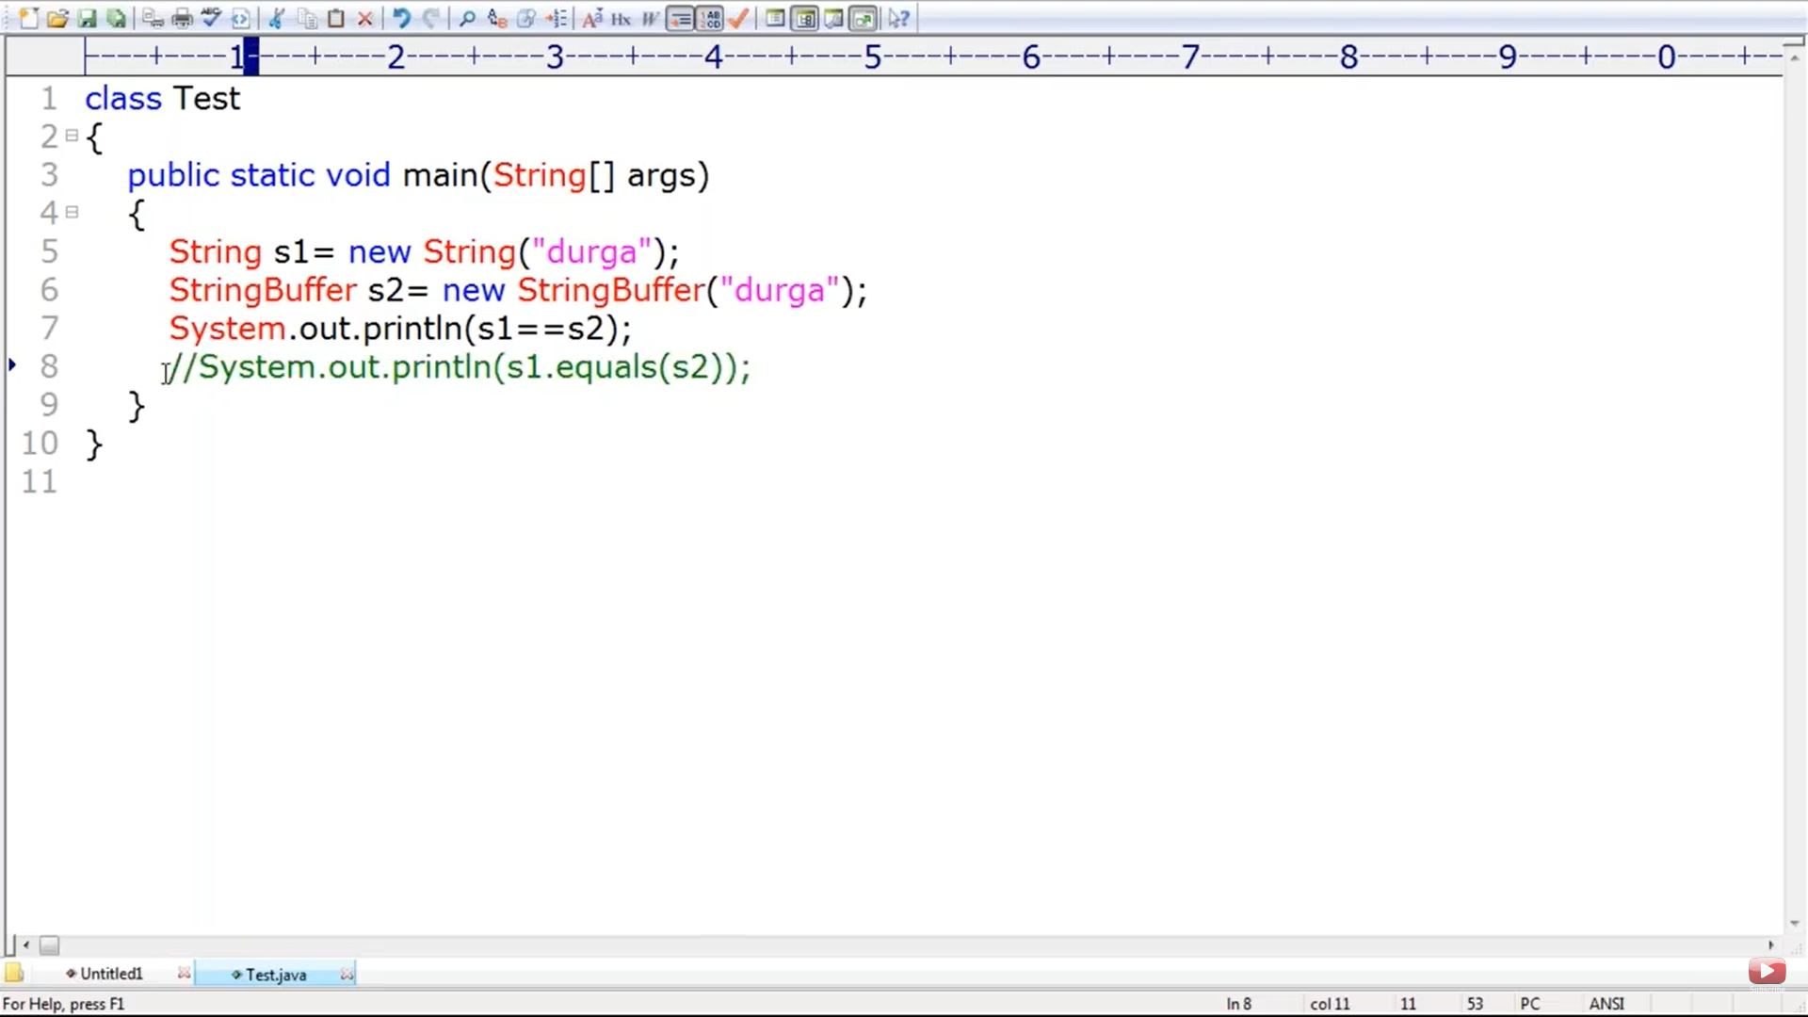

Equals method does not check for relation but if the object is different, it returns false

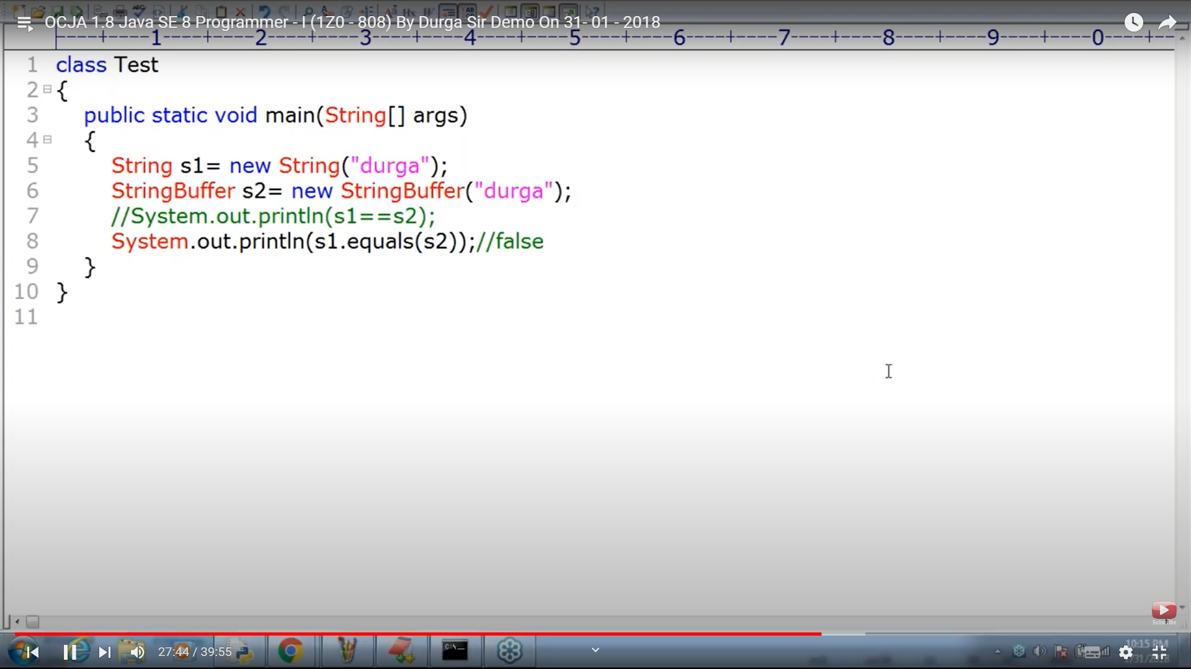

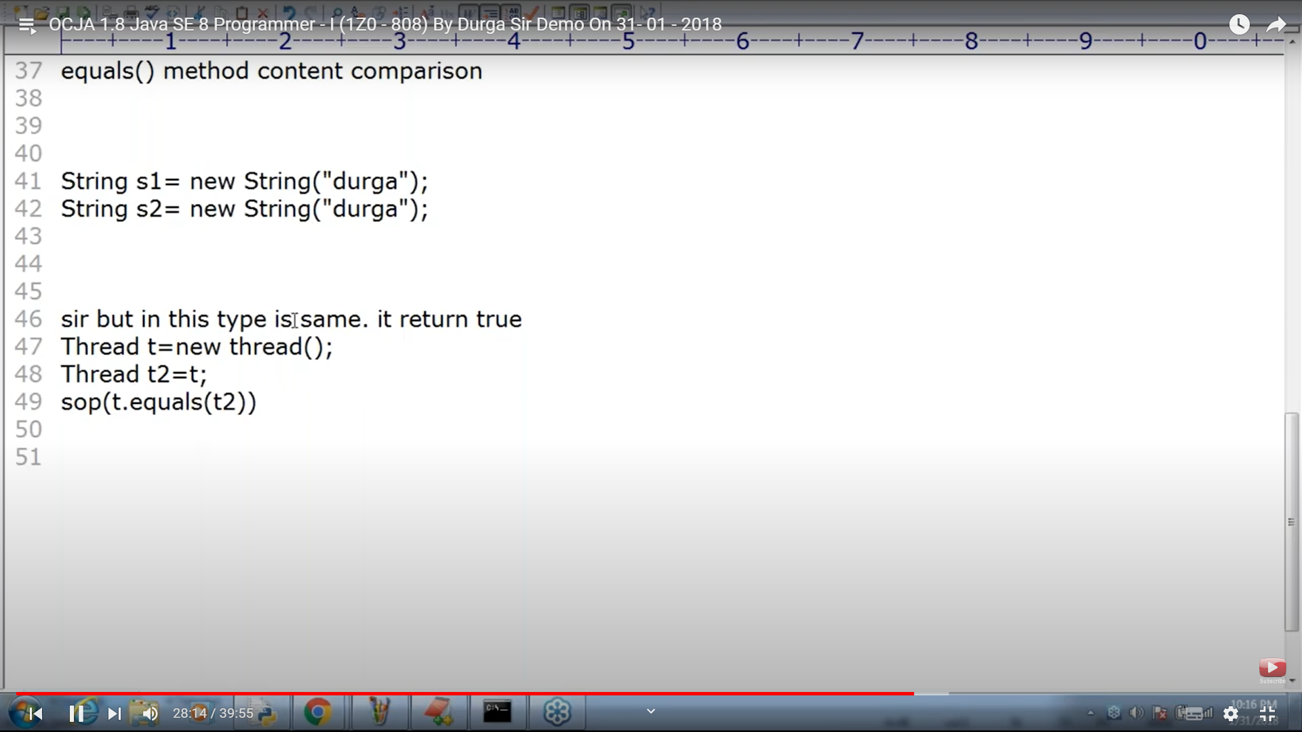

T1 and T2 content are the same, since they point to same object

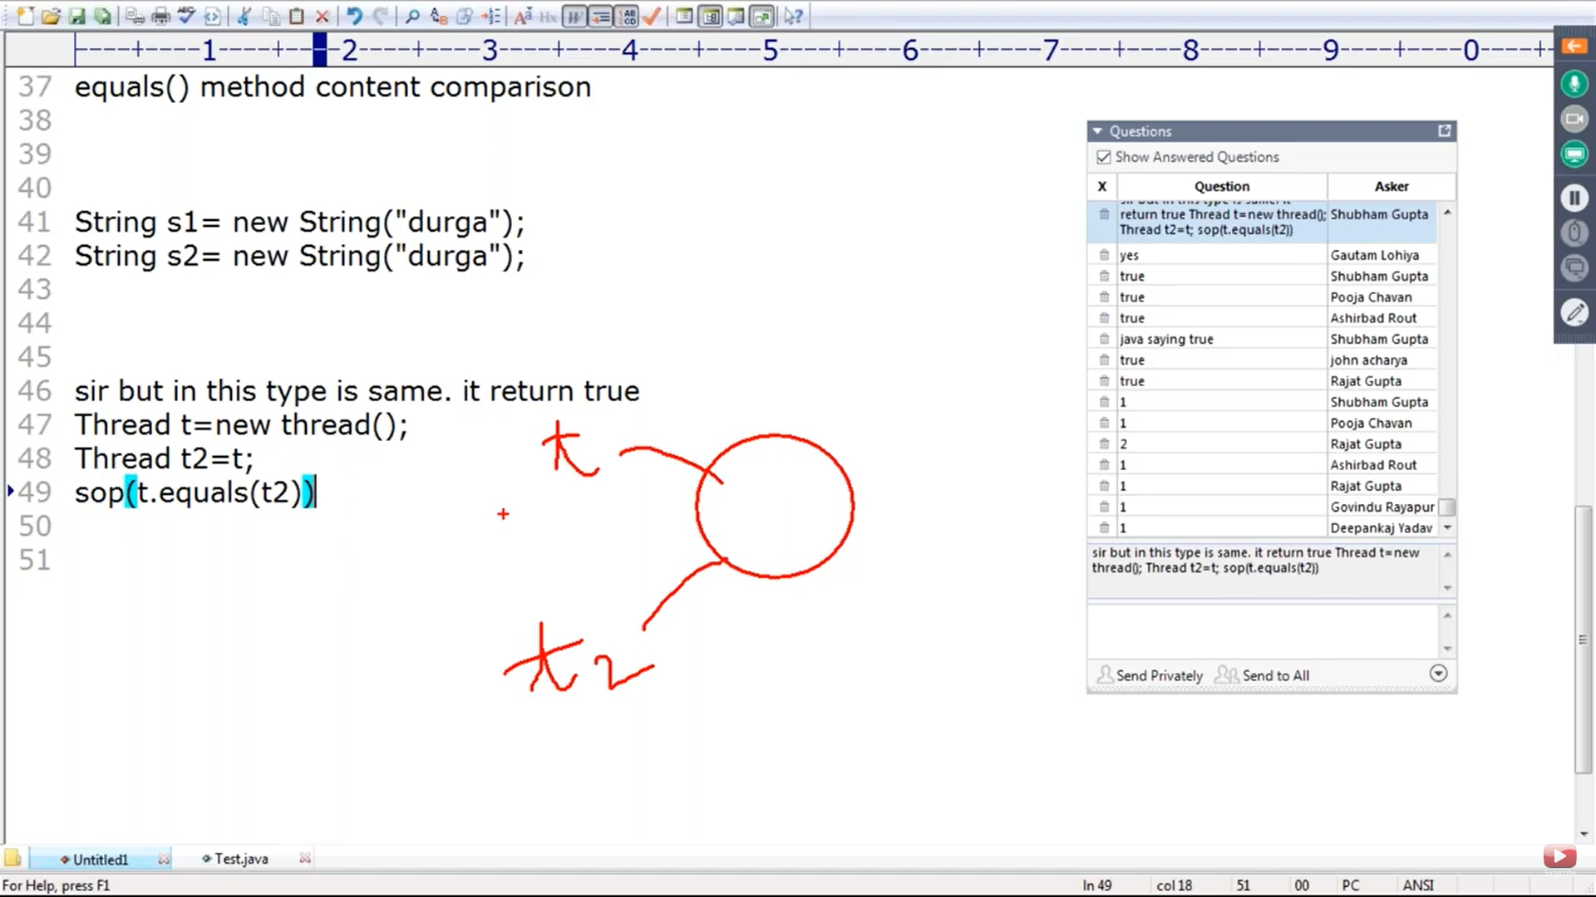

**Instanceof operator – instanceof is a reserved word and operator should be lower case . reserved words are lower case**

All true

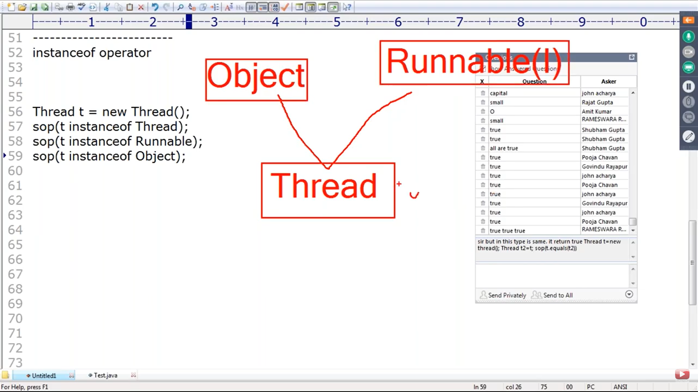

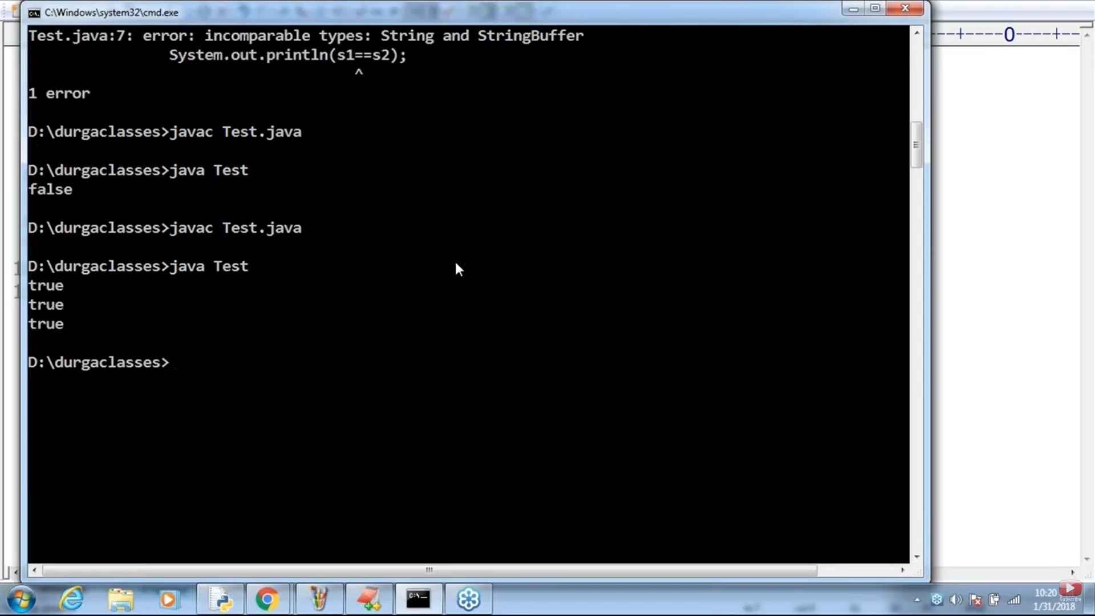

If you want to use instanceof operator ther should be some relation. Else it will throw

Inconvertible types; cannot cast 'java.lang.String' to 'java.lang.Thread'

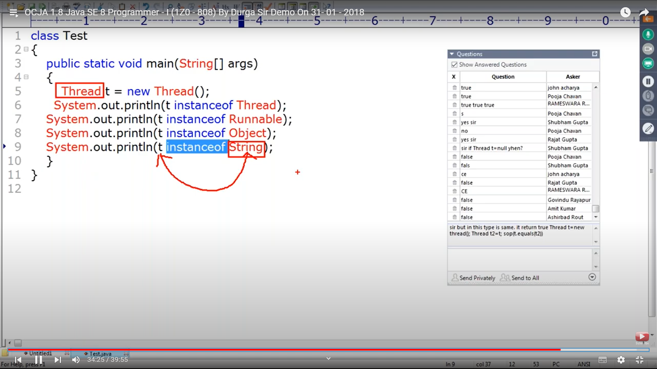

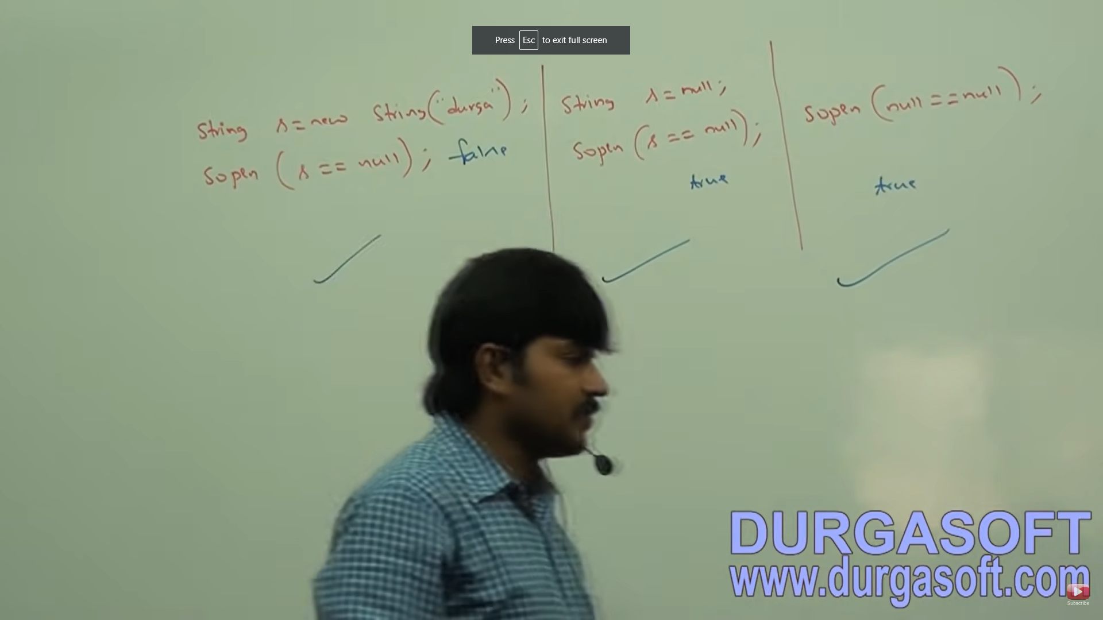

ArrayList can be of anytype

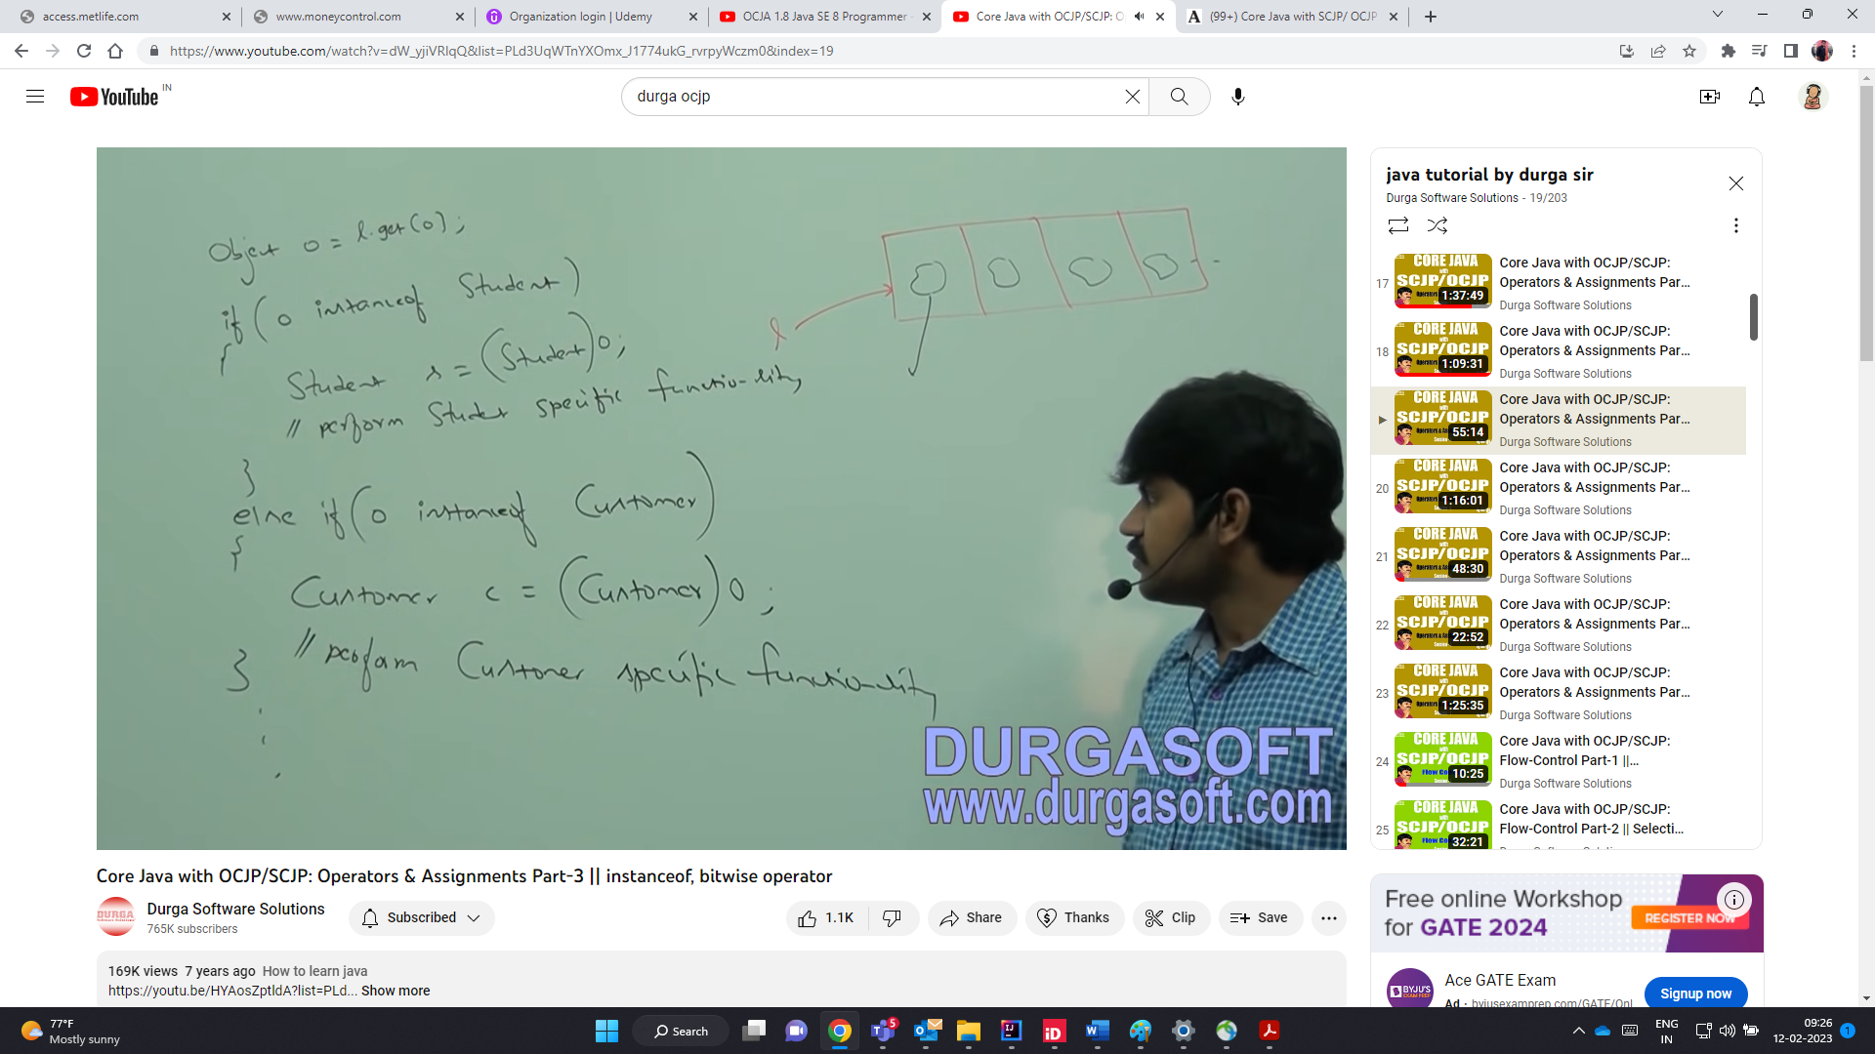



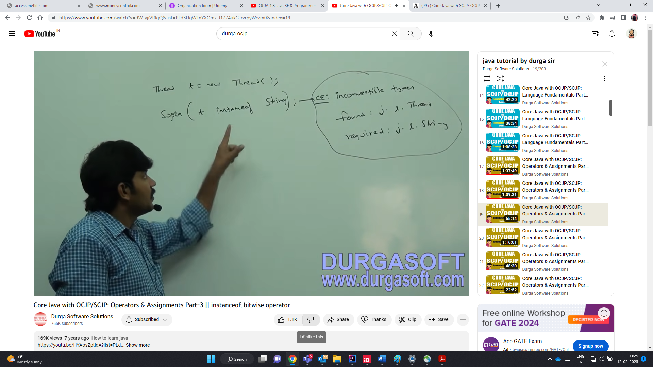

For any class or interface x -> null instance of x , is always false

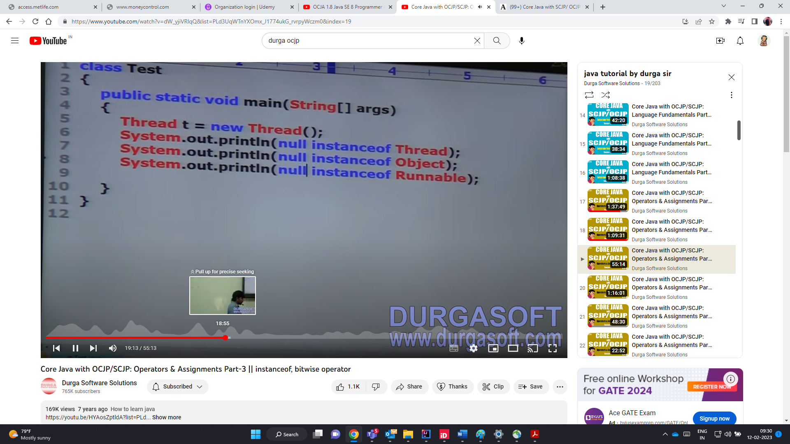

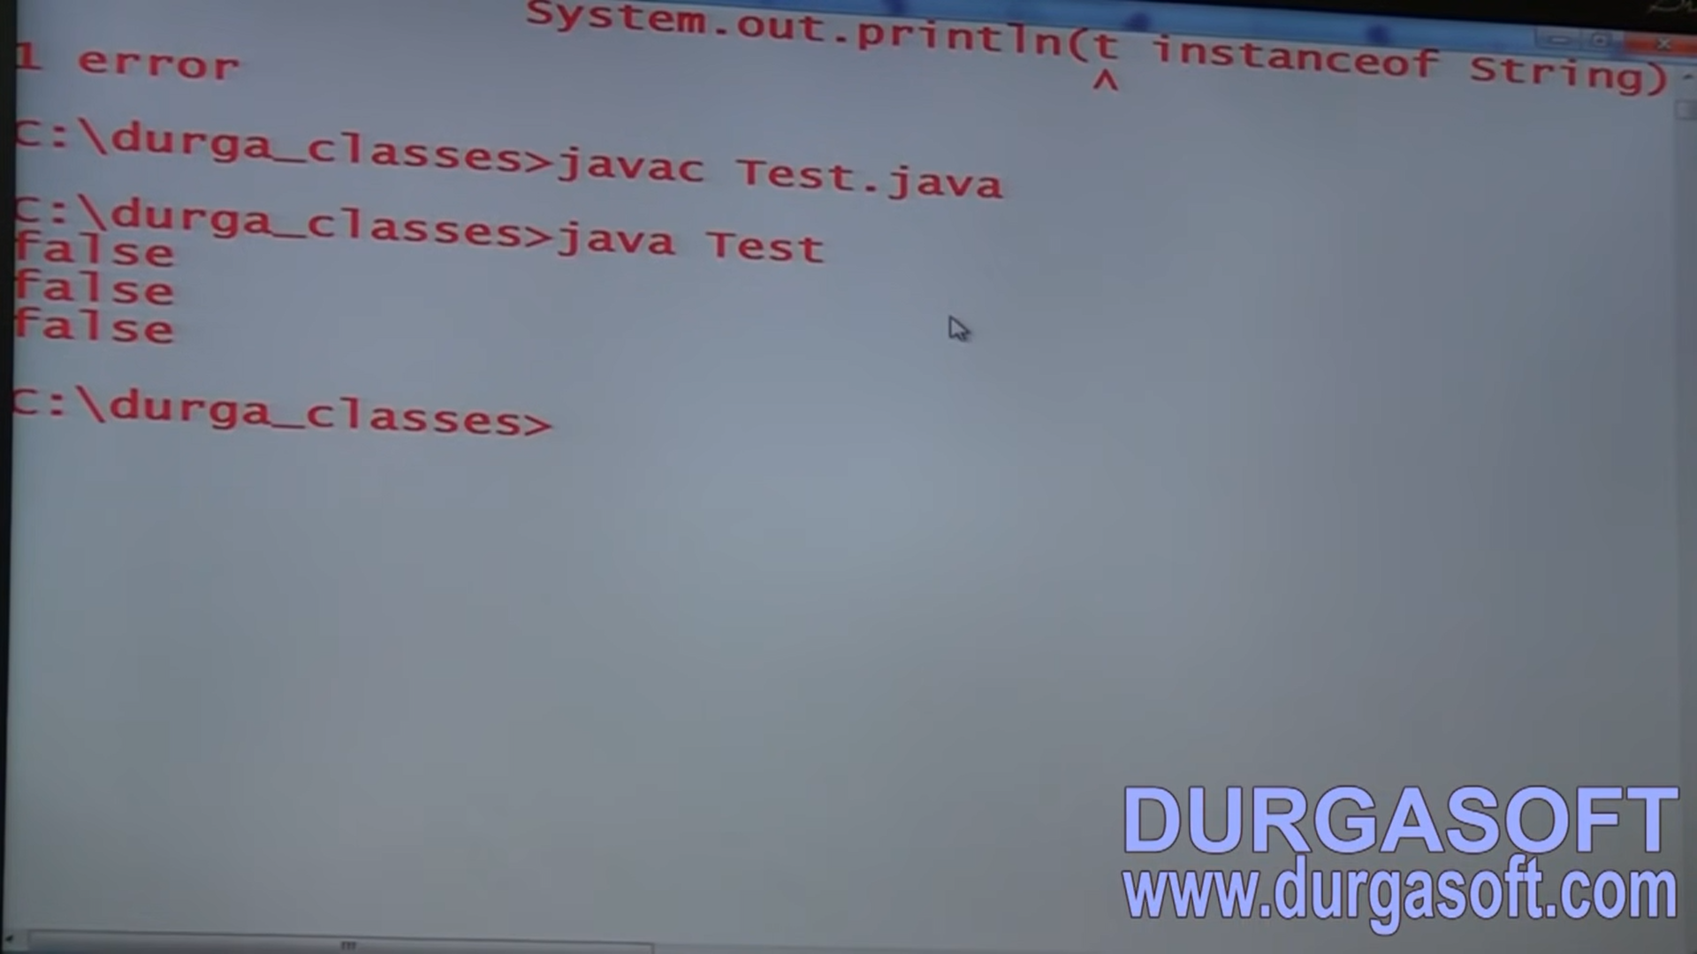

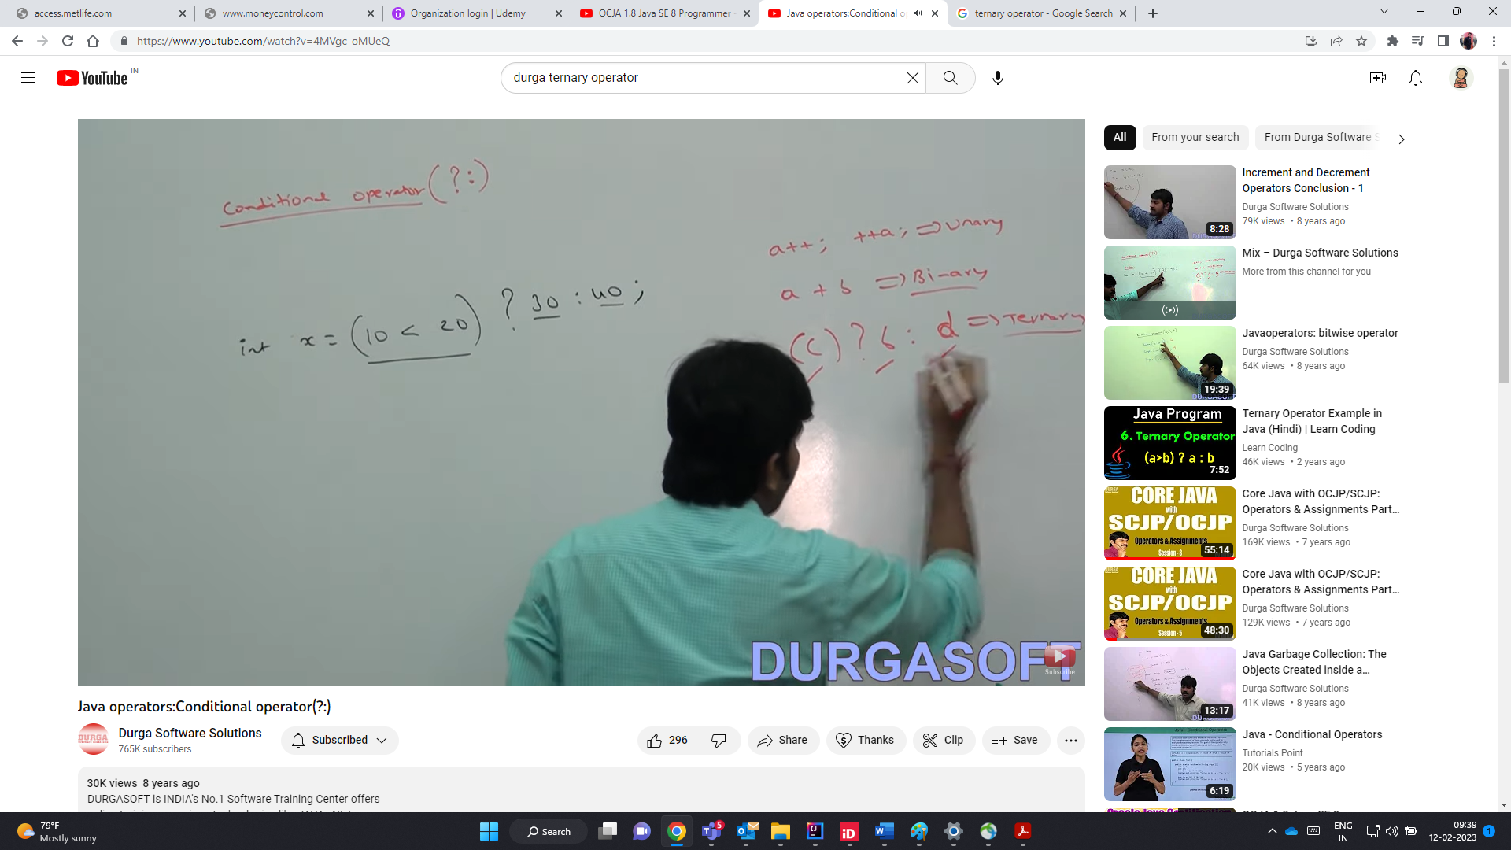

Nesting of conditional operator ternary operator is possible

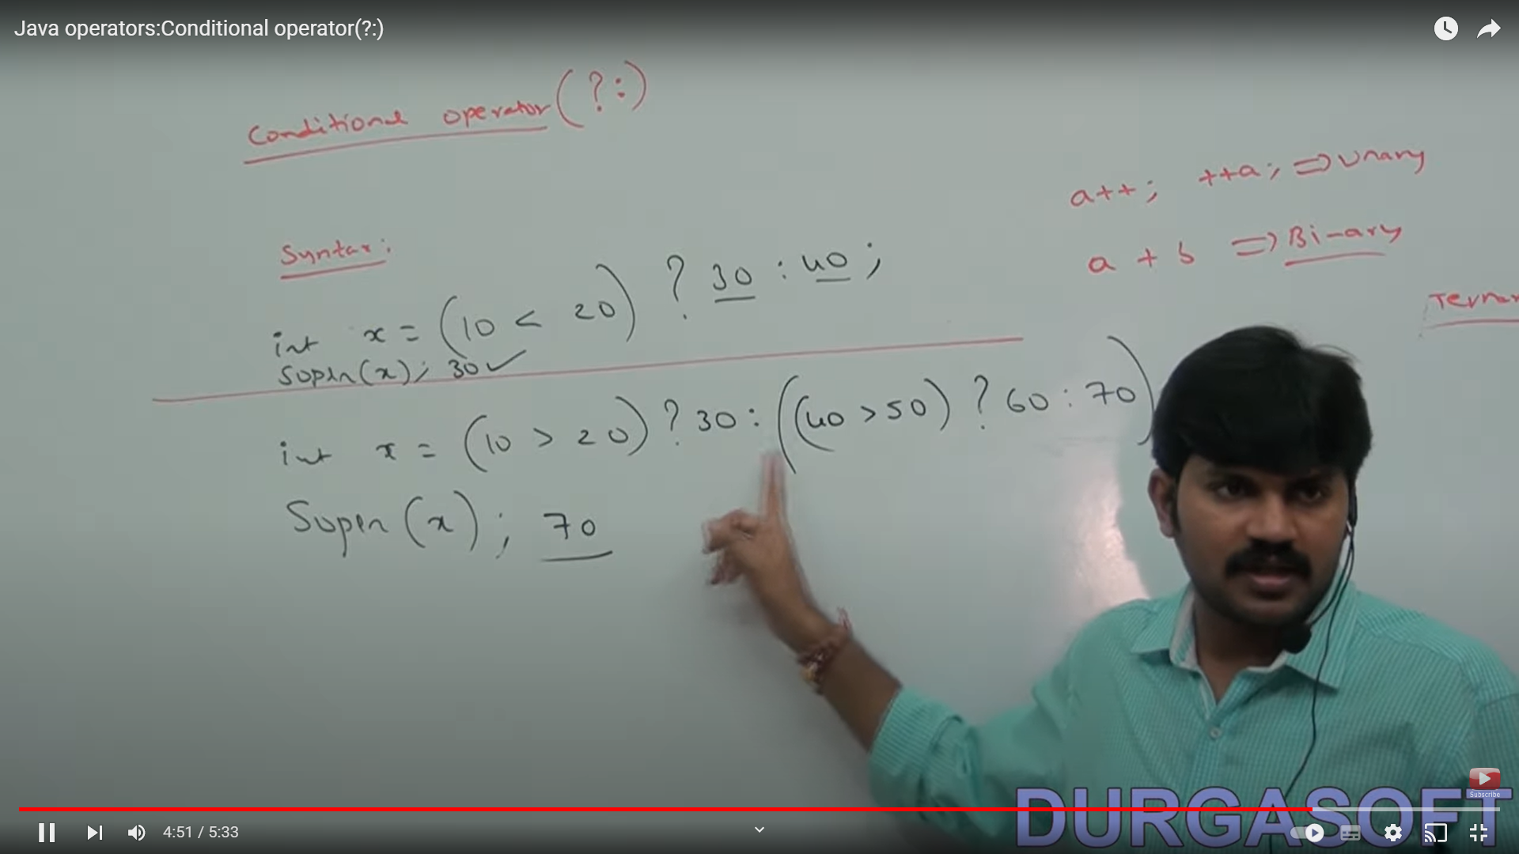

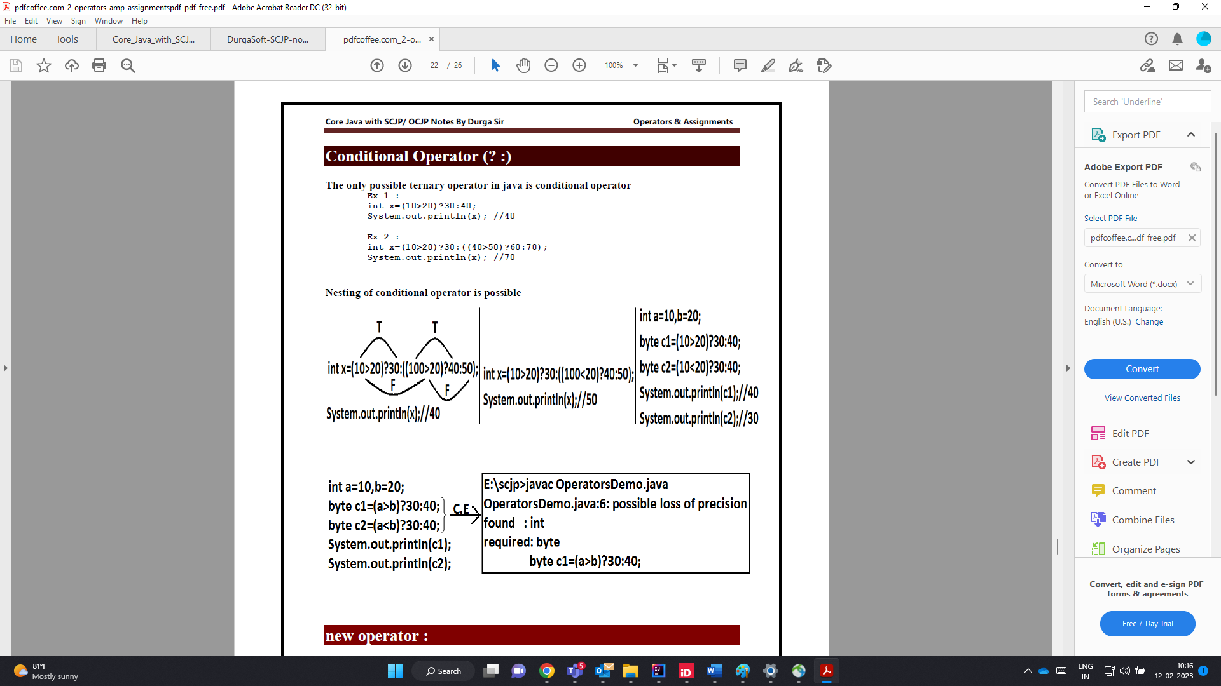

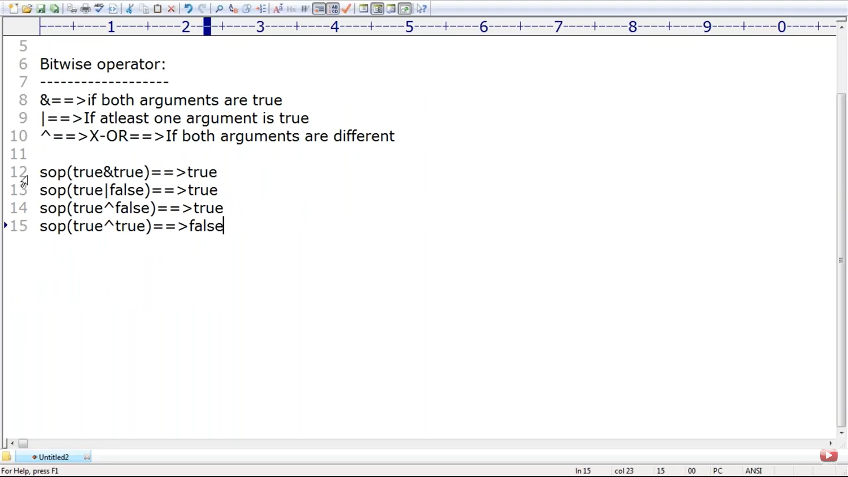

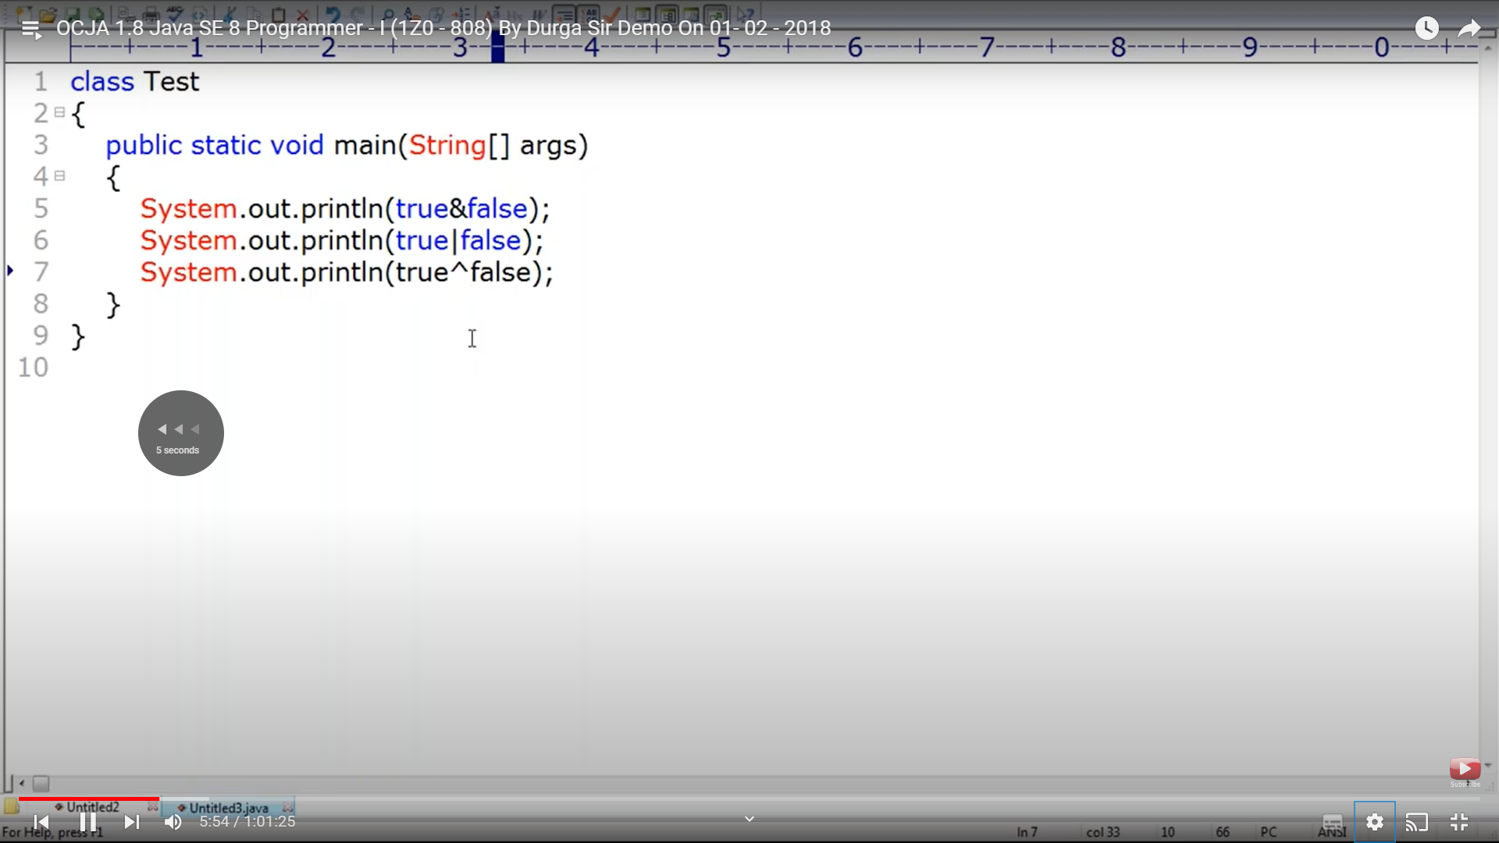

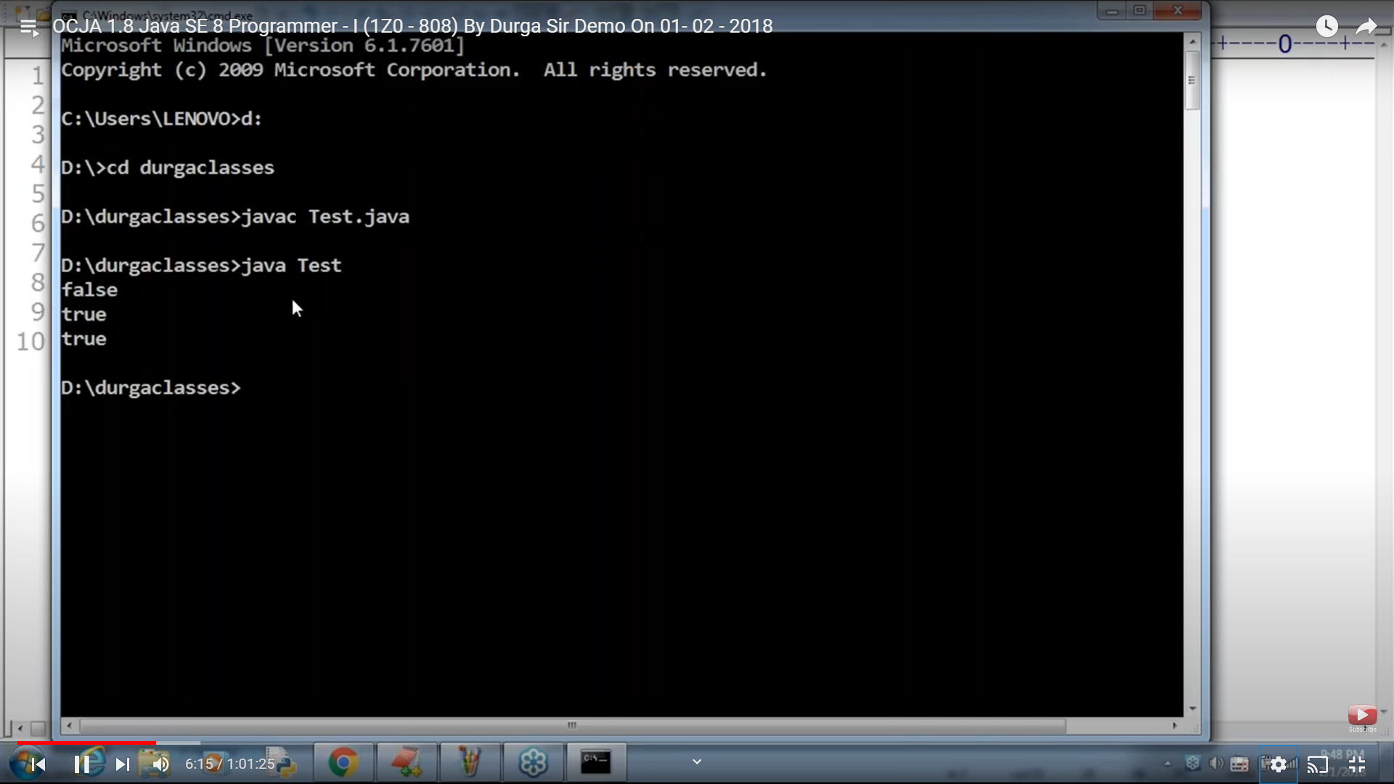

If we apply bitwise operator on nos, the operation is performed bitwise and returns a number.

Bitwise operator cant be applied only on Boolean and itegrals not floating pt

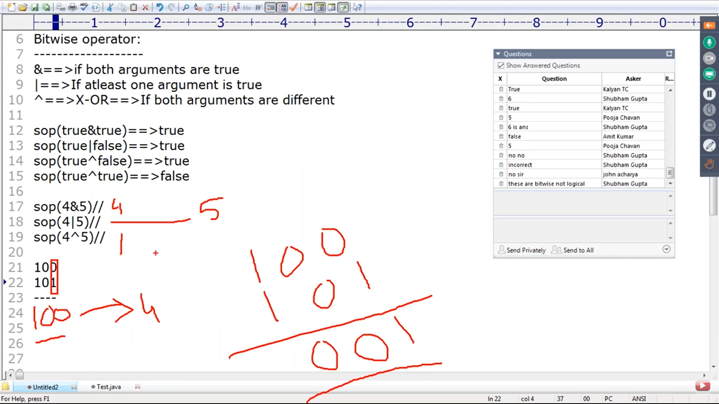

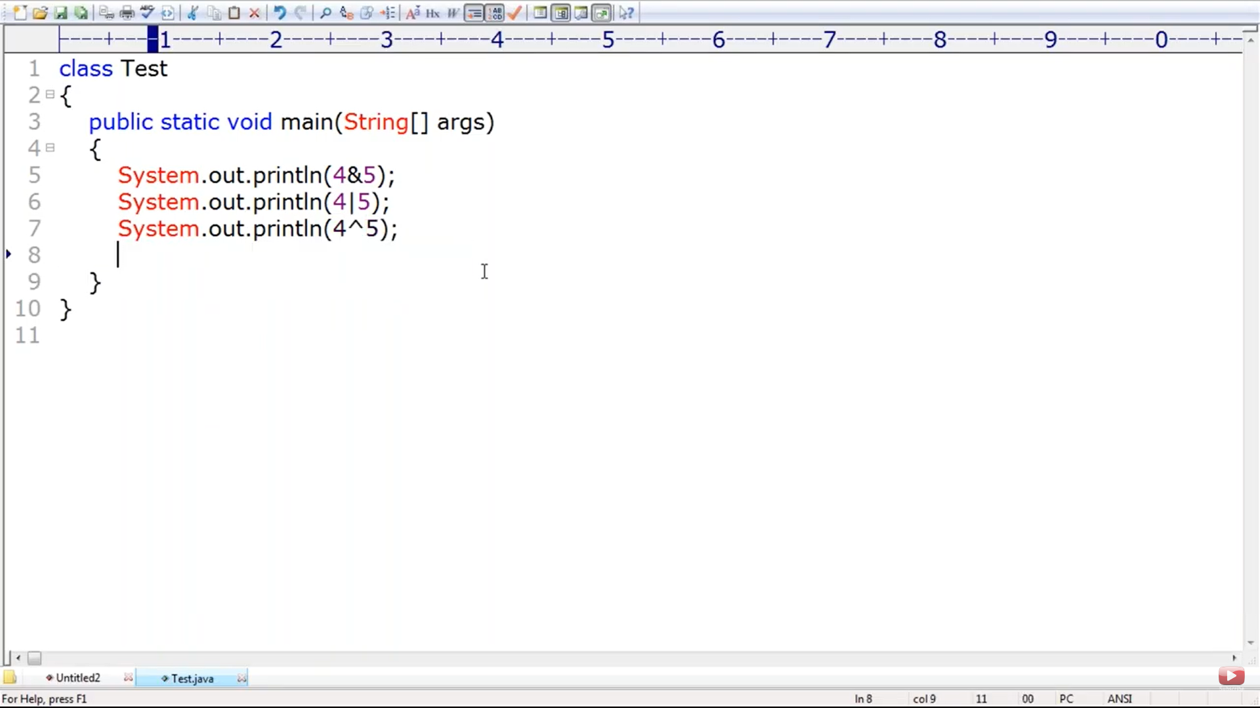

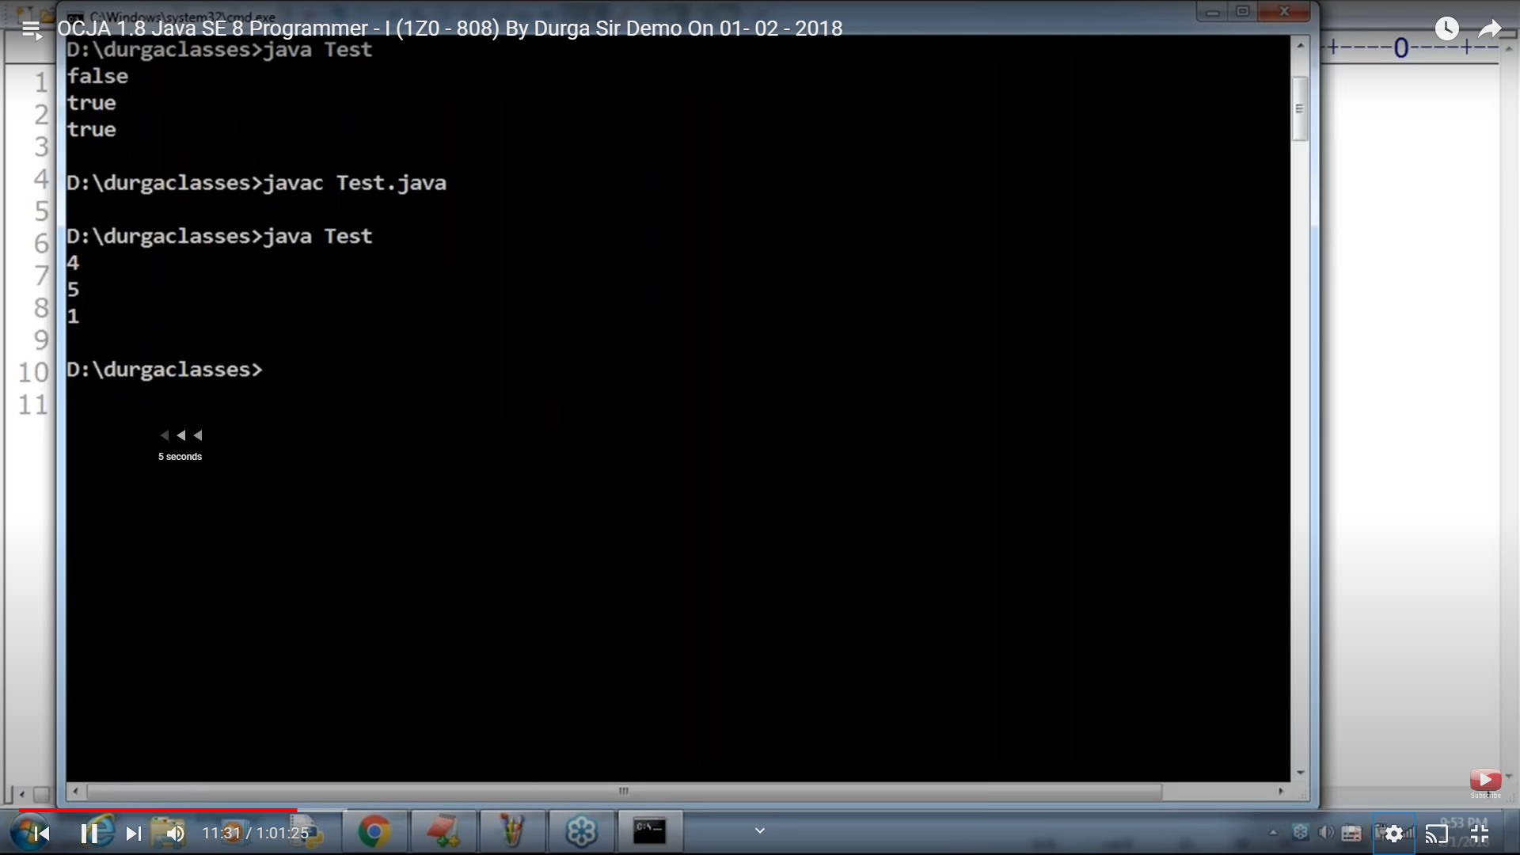

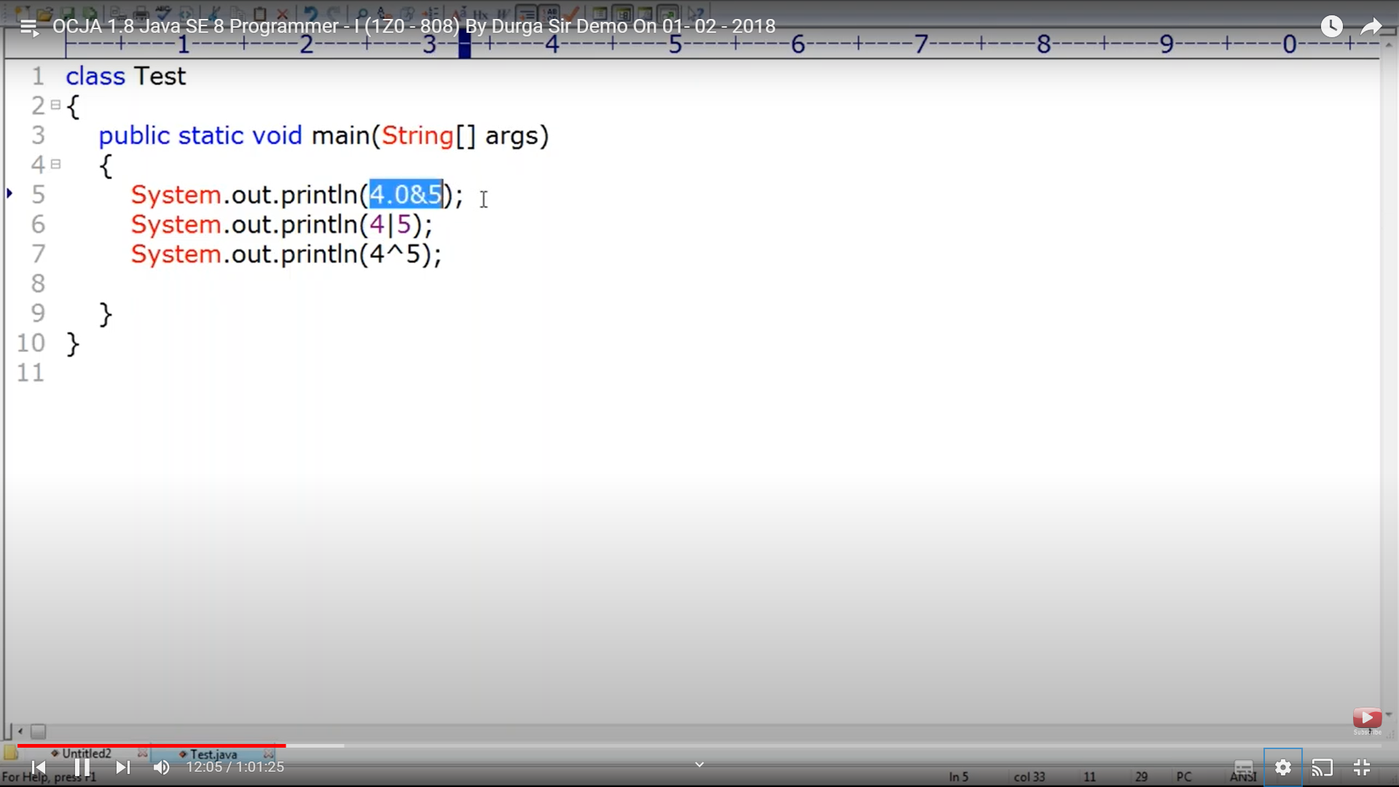

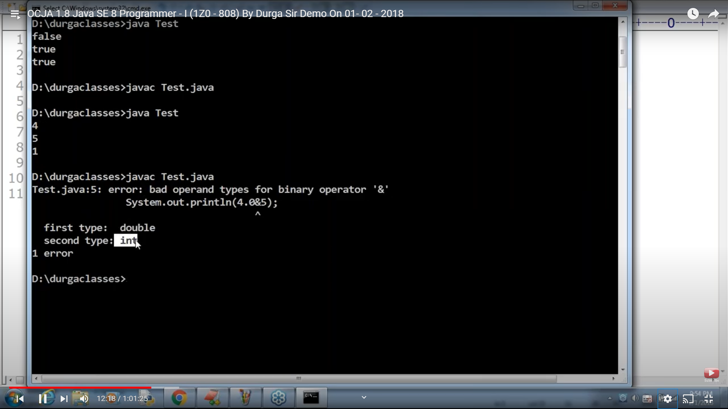

A internally means 95 and 97

Output -65 perform bitwise comparison

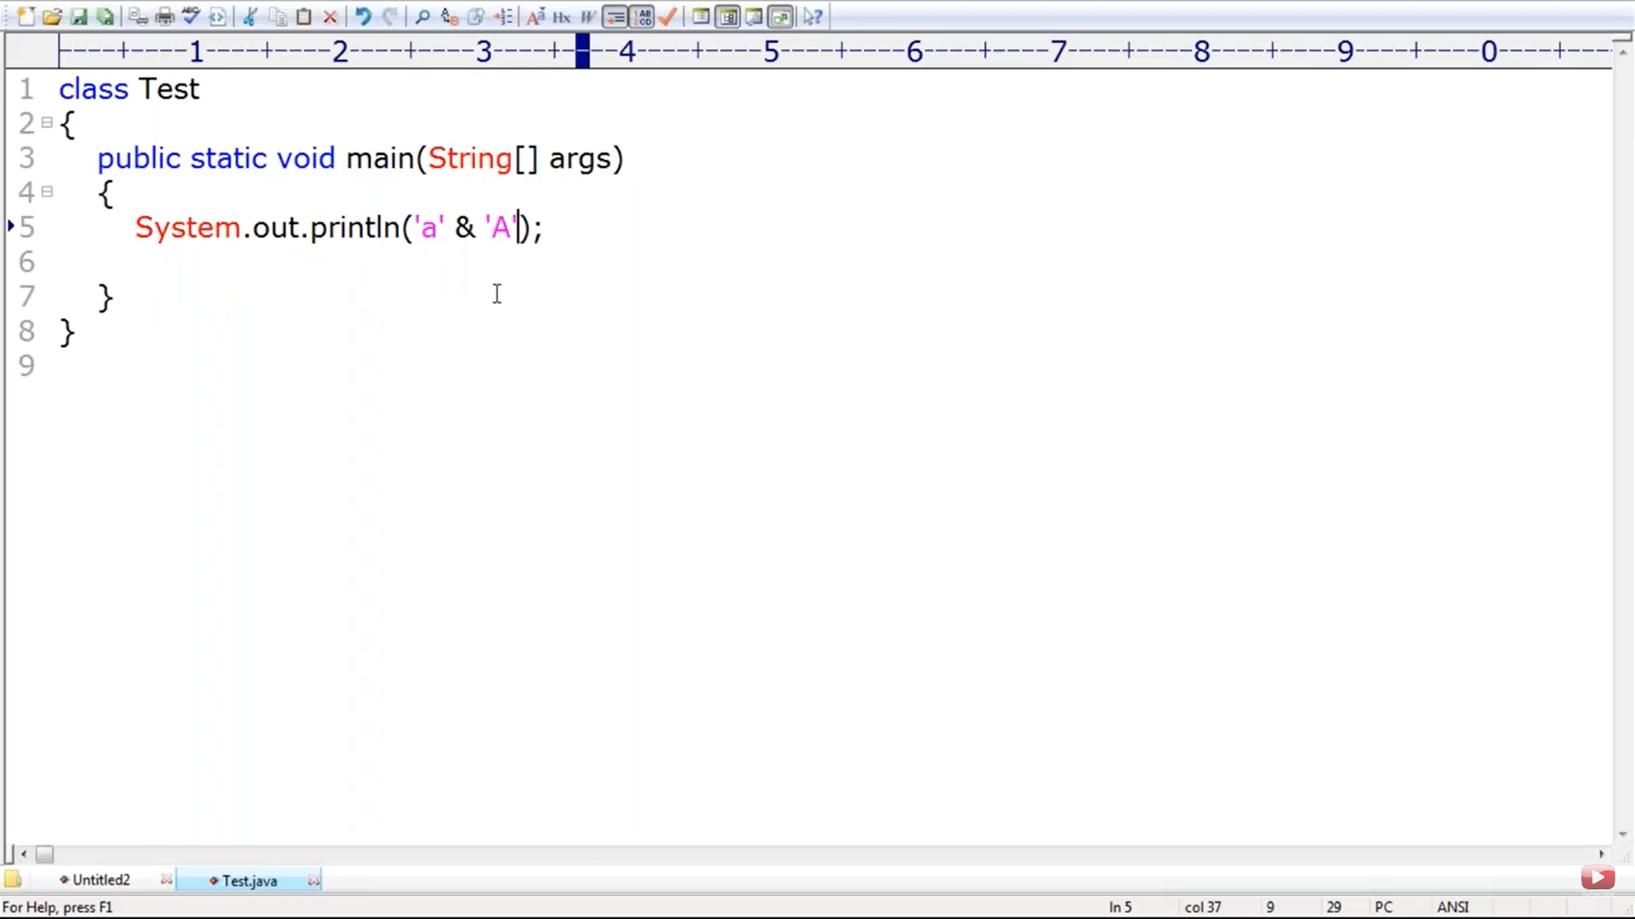

Bitwise complement op ~ is applicable only for integral nt boolean below is an error

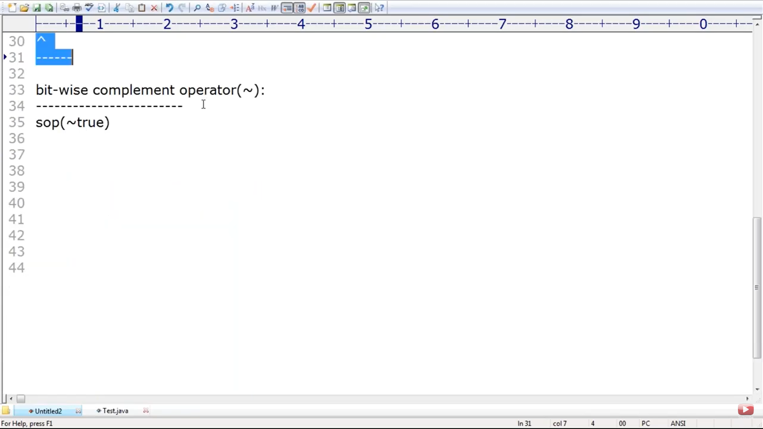

1s complement 0 becomes 1 and 1 becomes 0

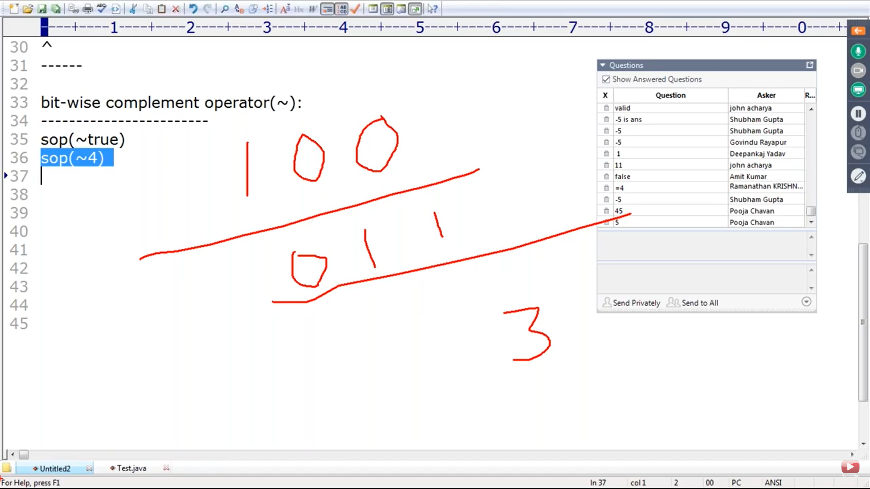

Applicable only for boolean not others . ~true -> false and false is true

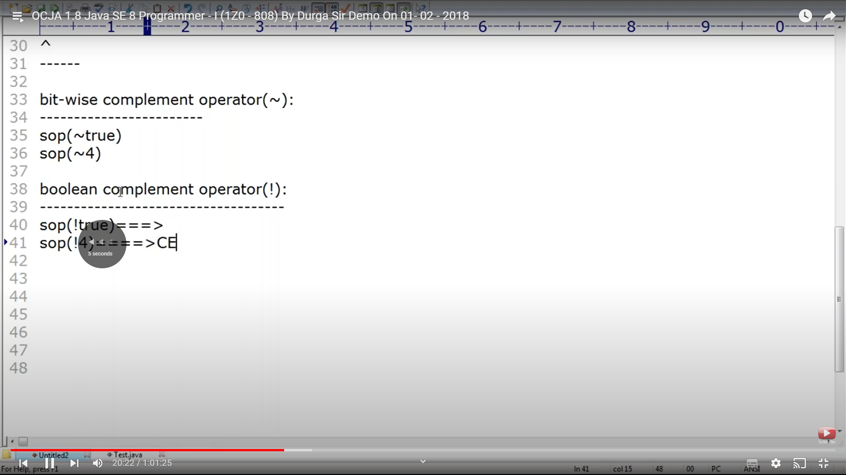

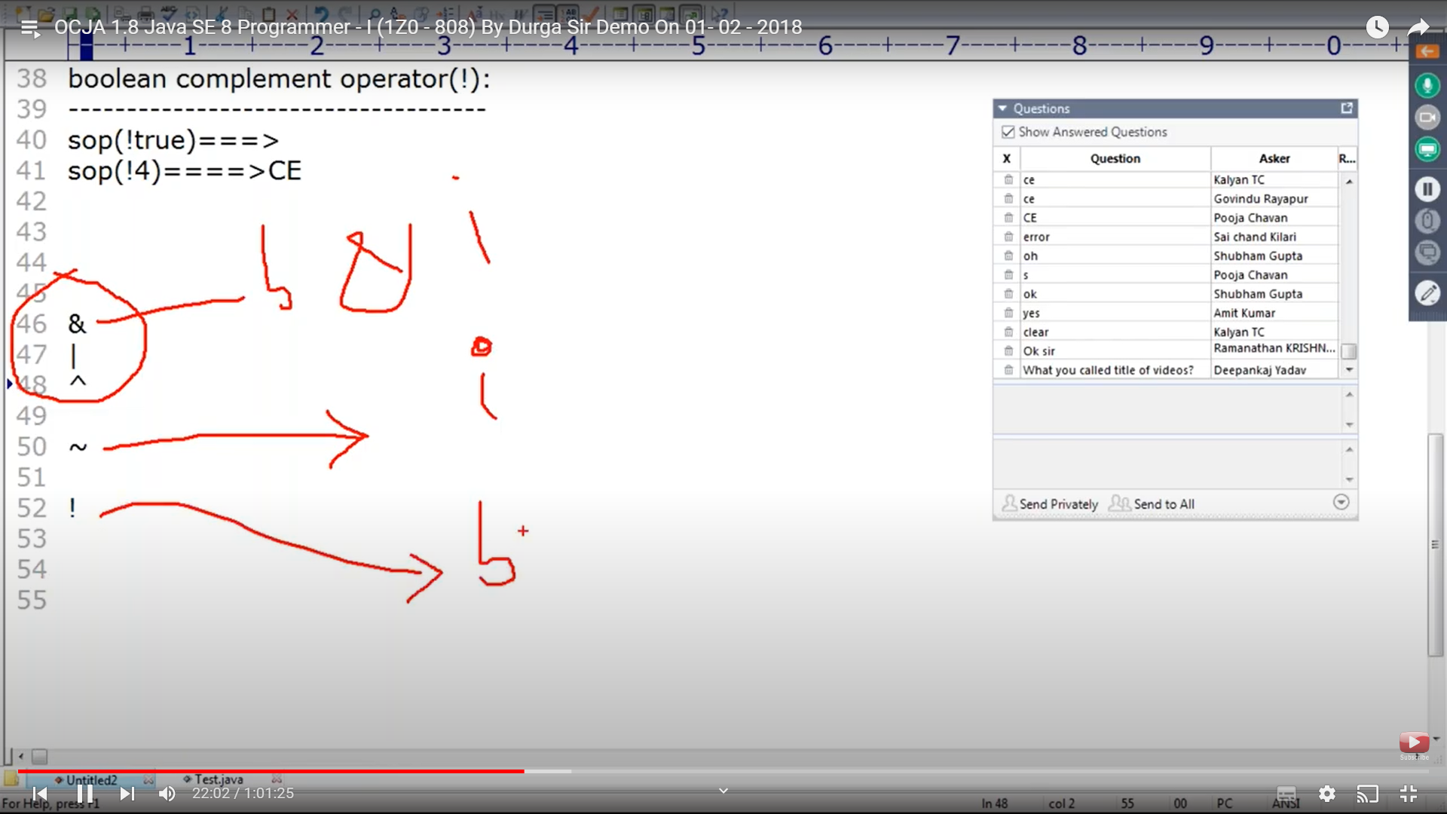

**If & and | - in the below both username and pwds will be evaluated and then it comes out even when 1 condition fails whereas in && || even if 1 fails it will not execute the second condition**

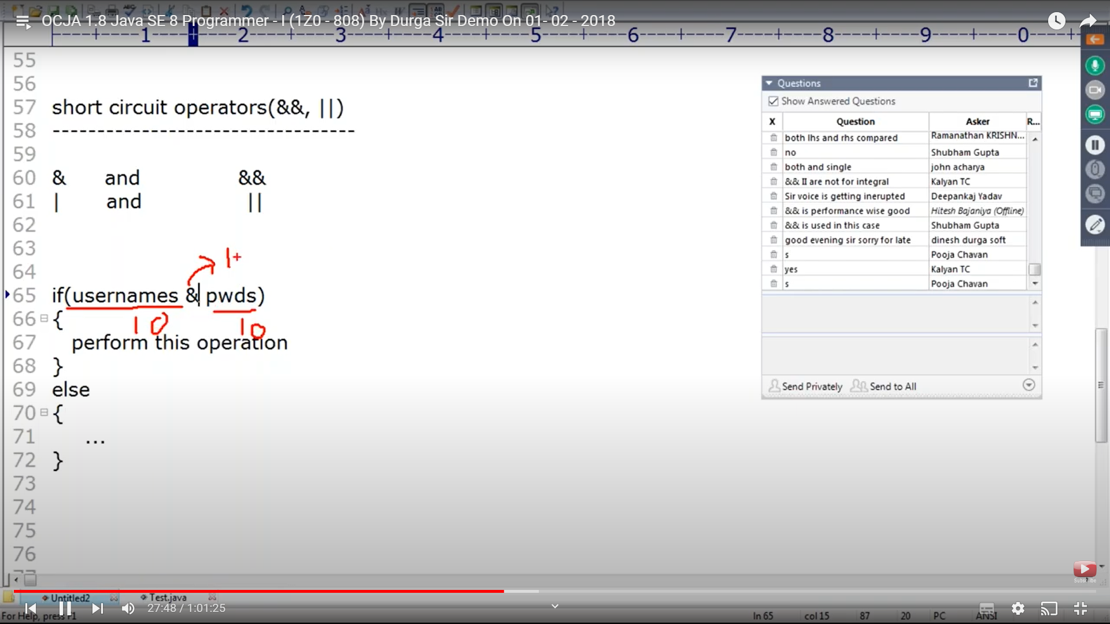

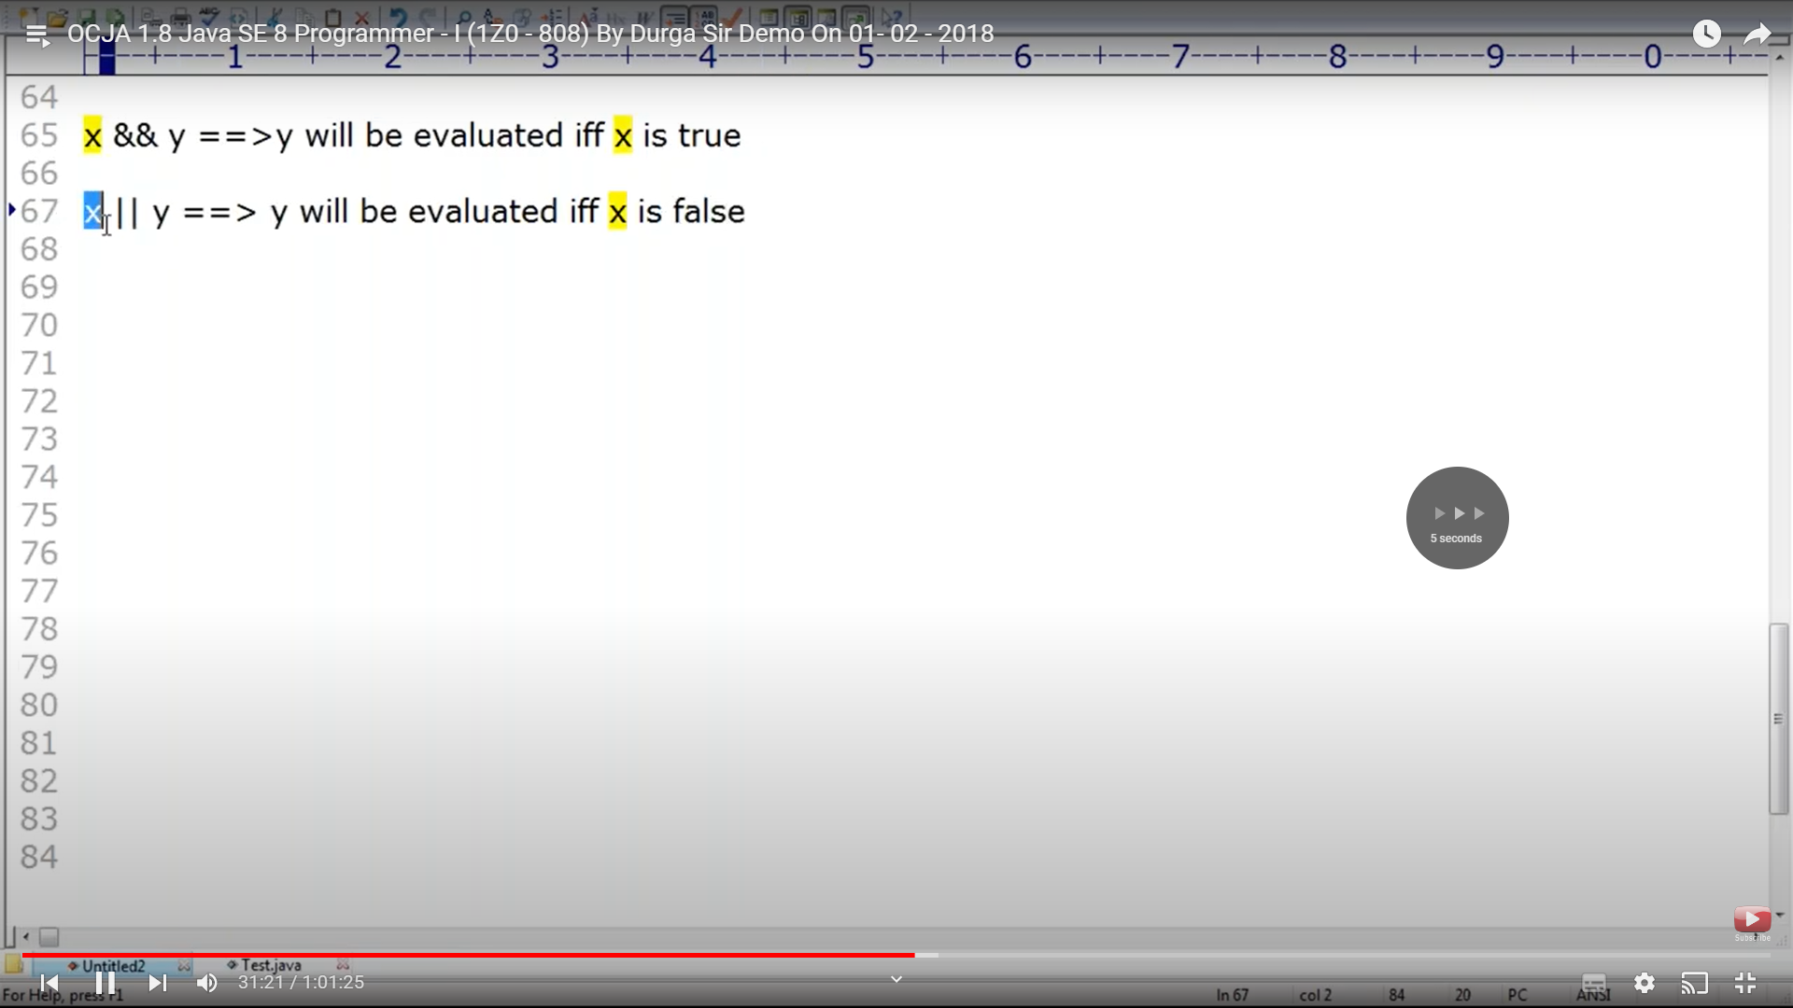

**&& || ops only applicable for Boolean and not integrals . whereas & | applicable for integers and boolean**

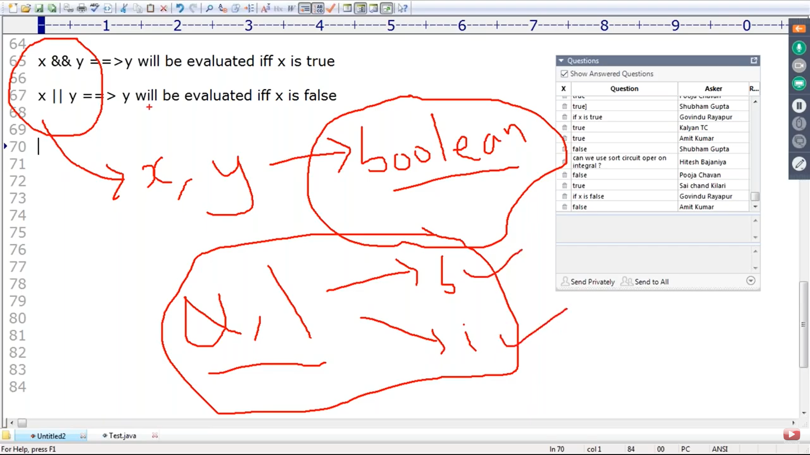

Very important - & will perform both .oversight

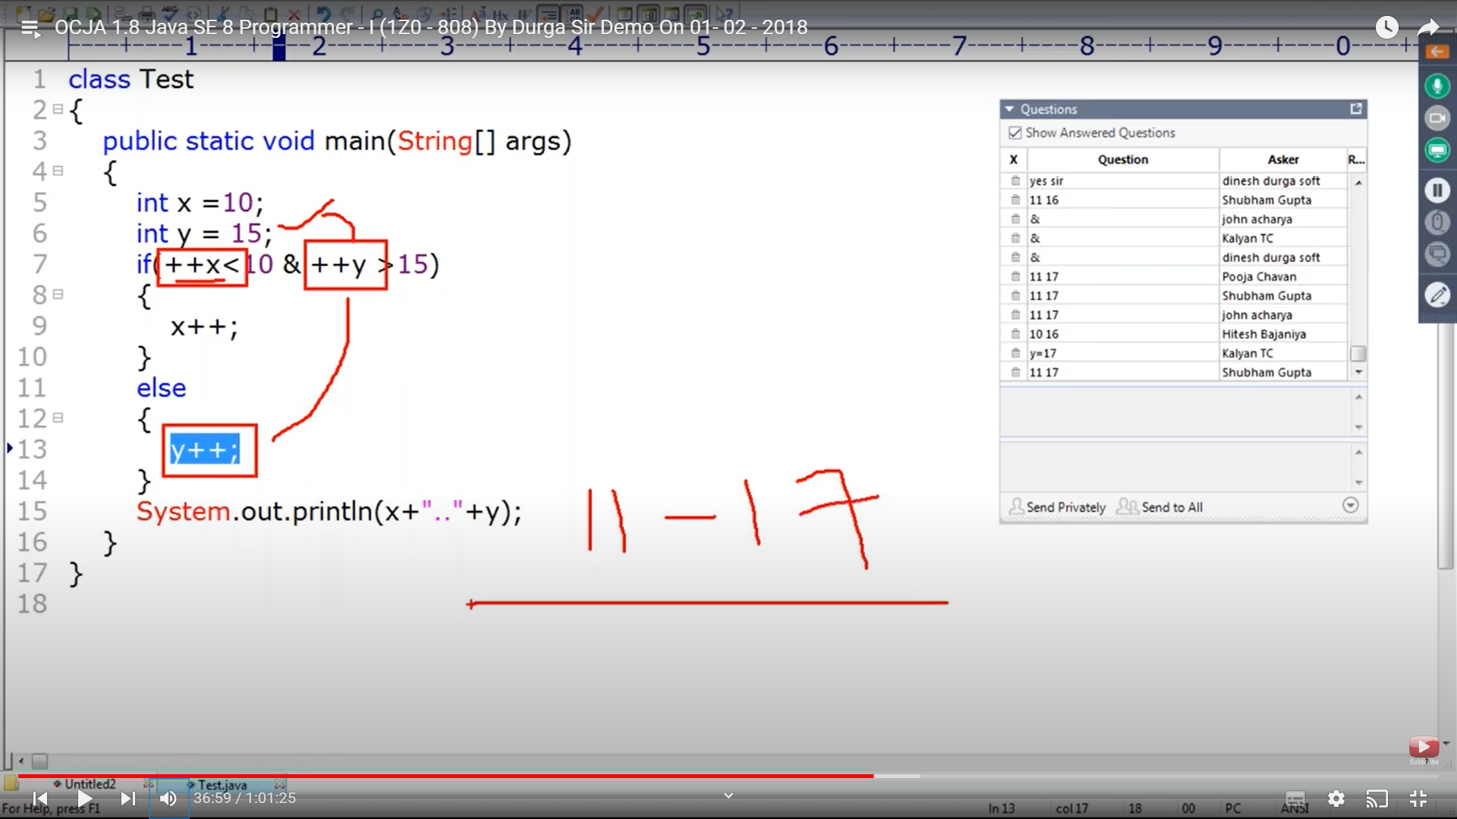

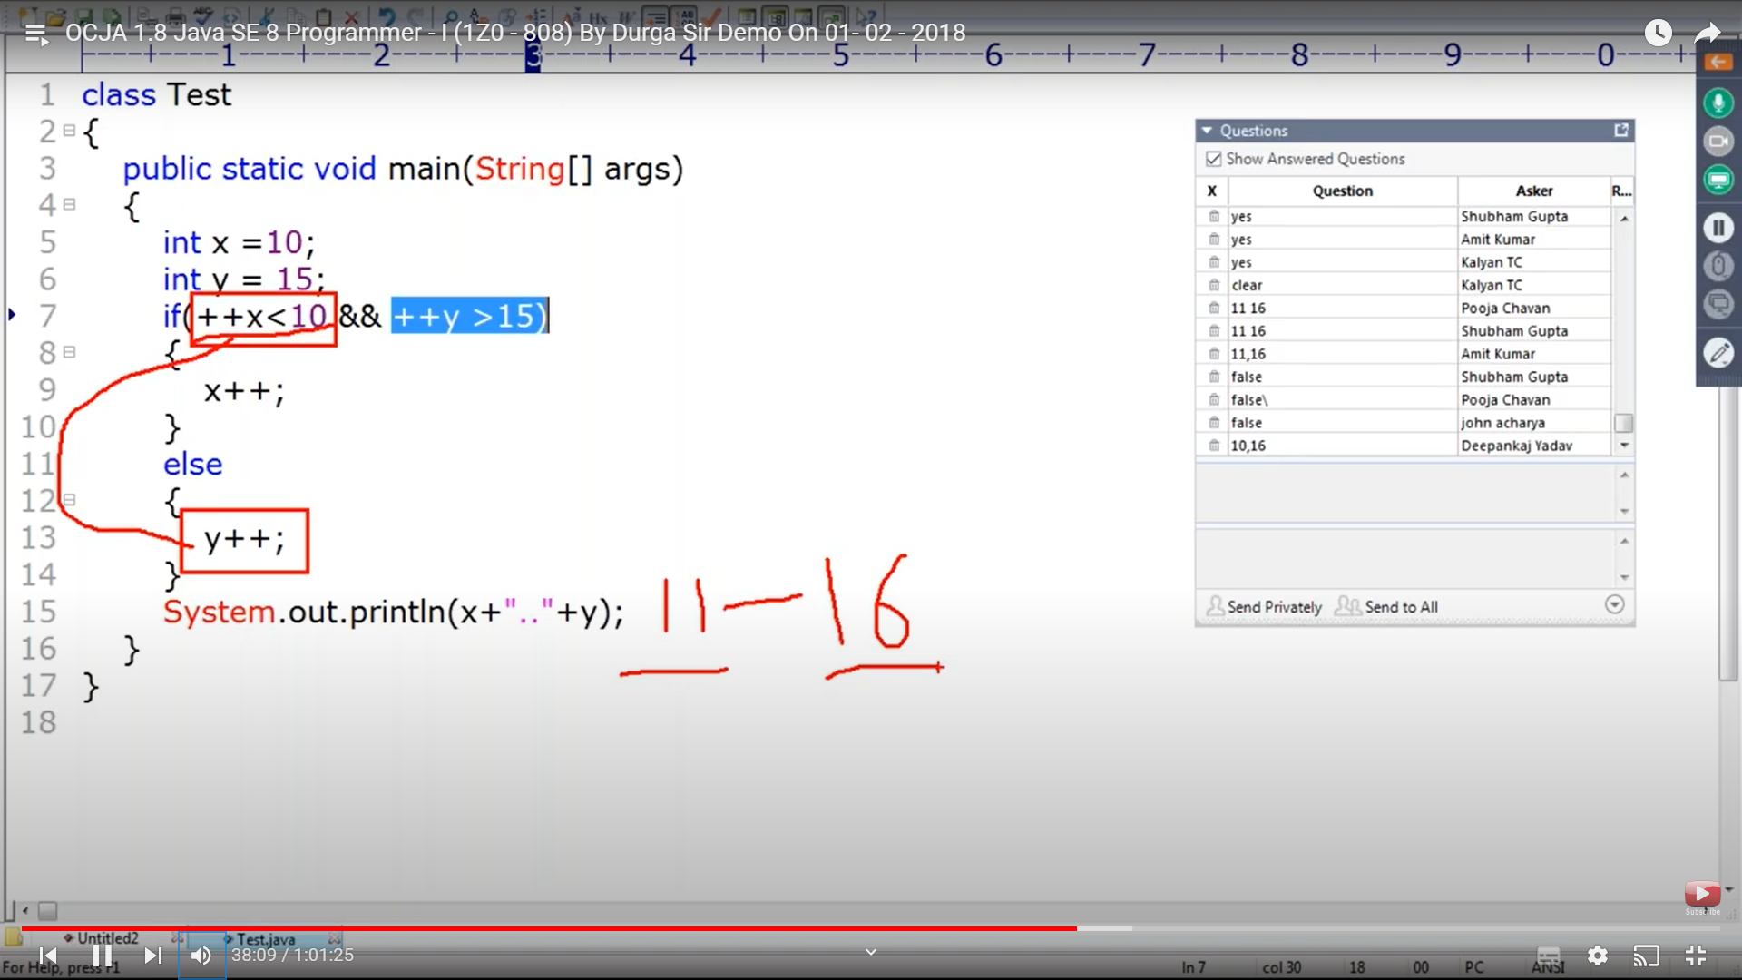

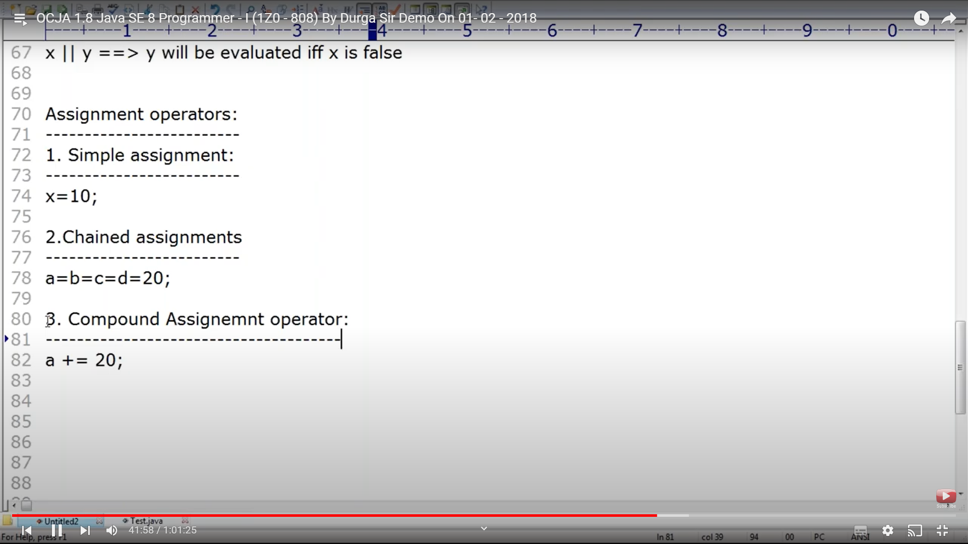

Not allowed in below

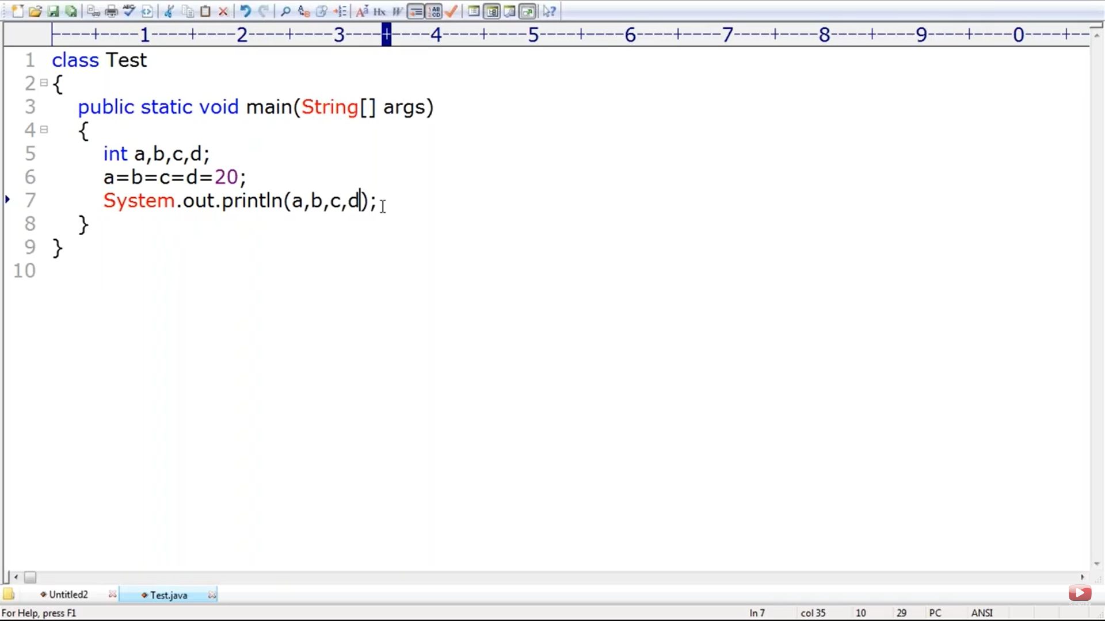

Assignent is right assocate , first assigns 20 to d and d is assigned to c , c is assigned to be so on

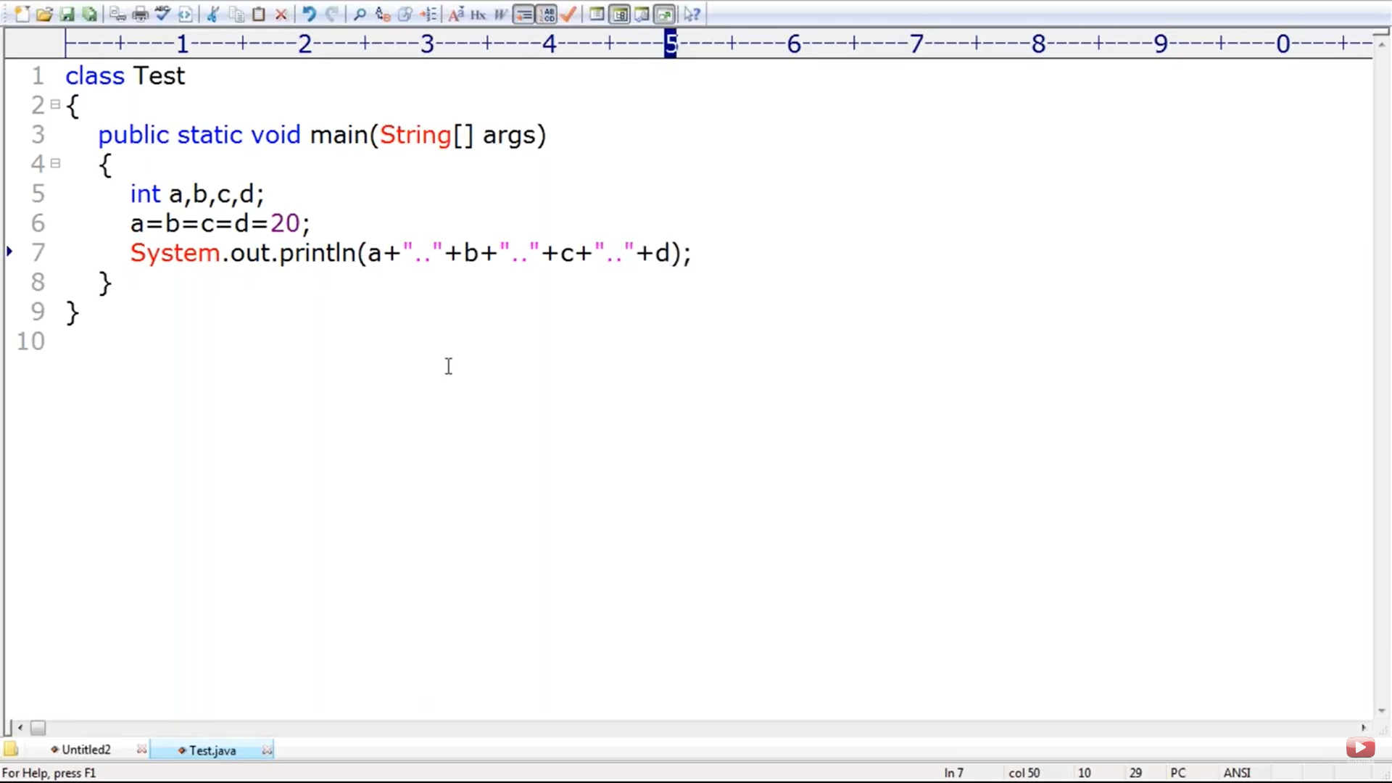

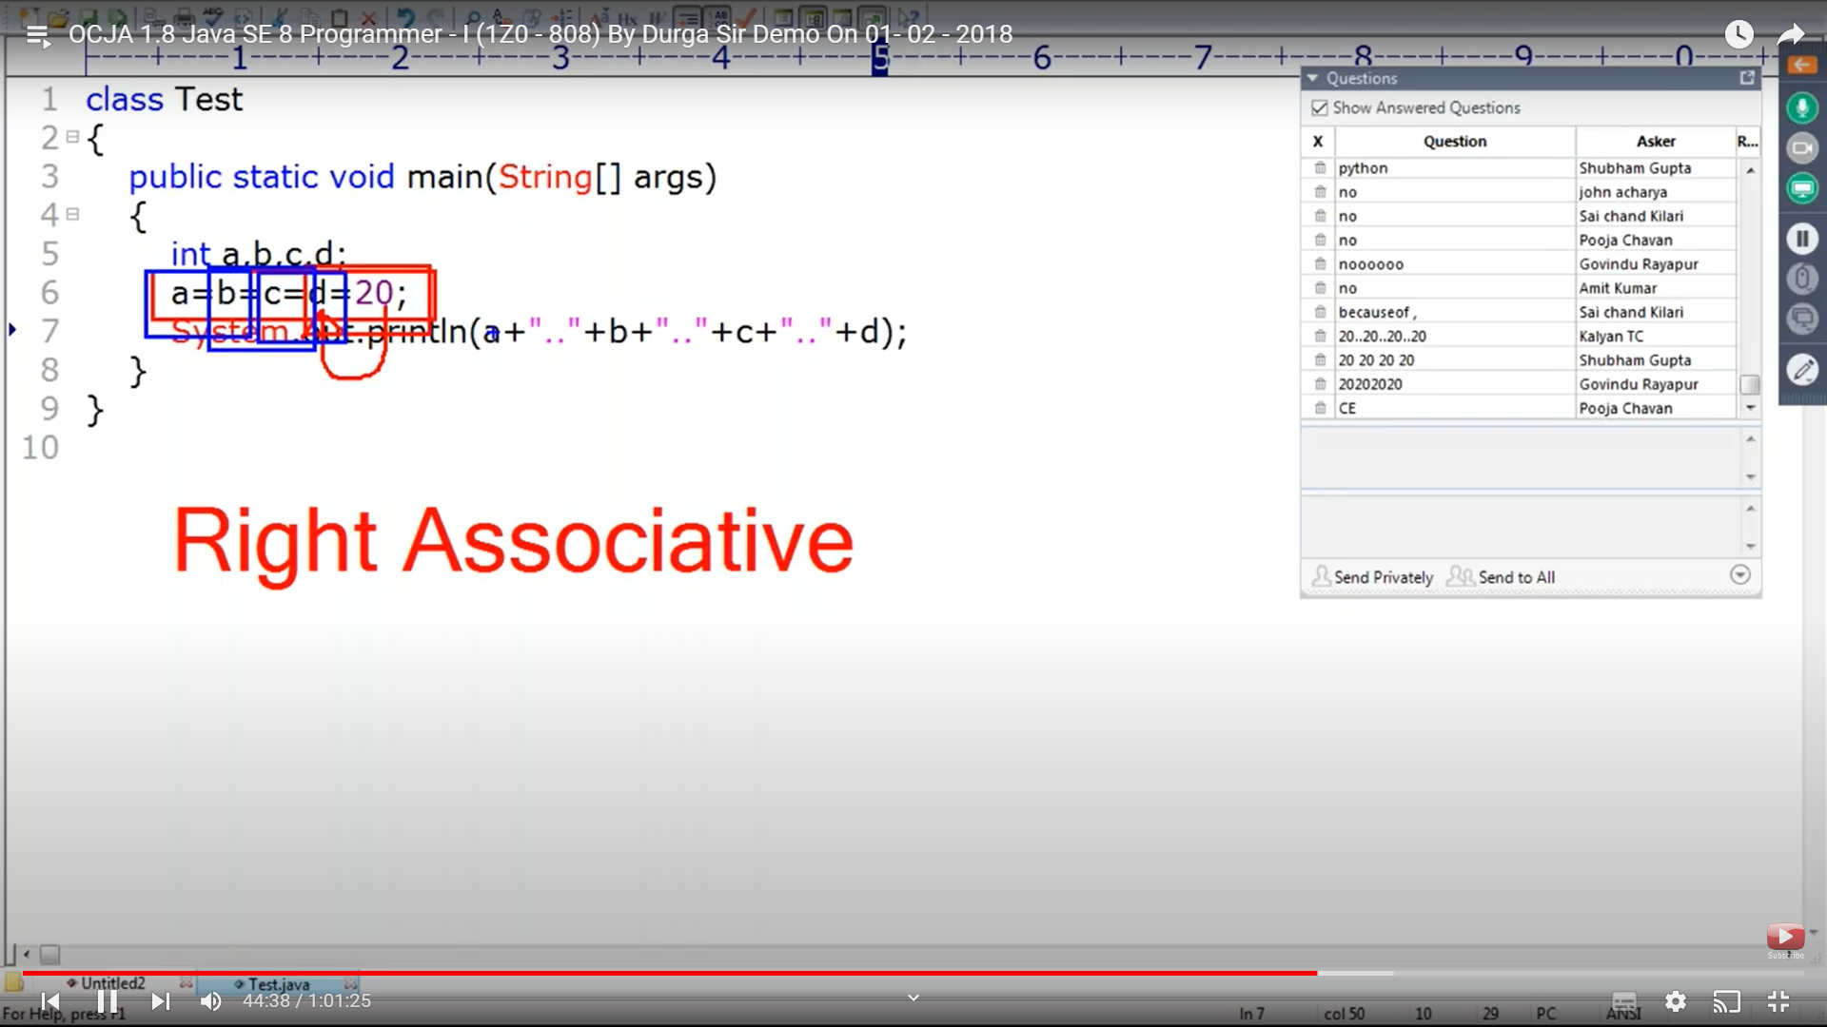

A is declared as in wheras others b ,c and d are not declared. Cannot find symbols b,c and d. Chained assignment is not possible at time of declaration

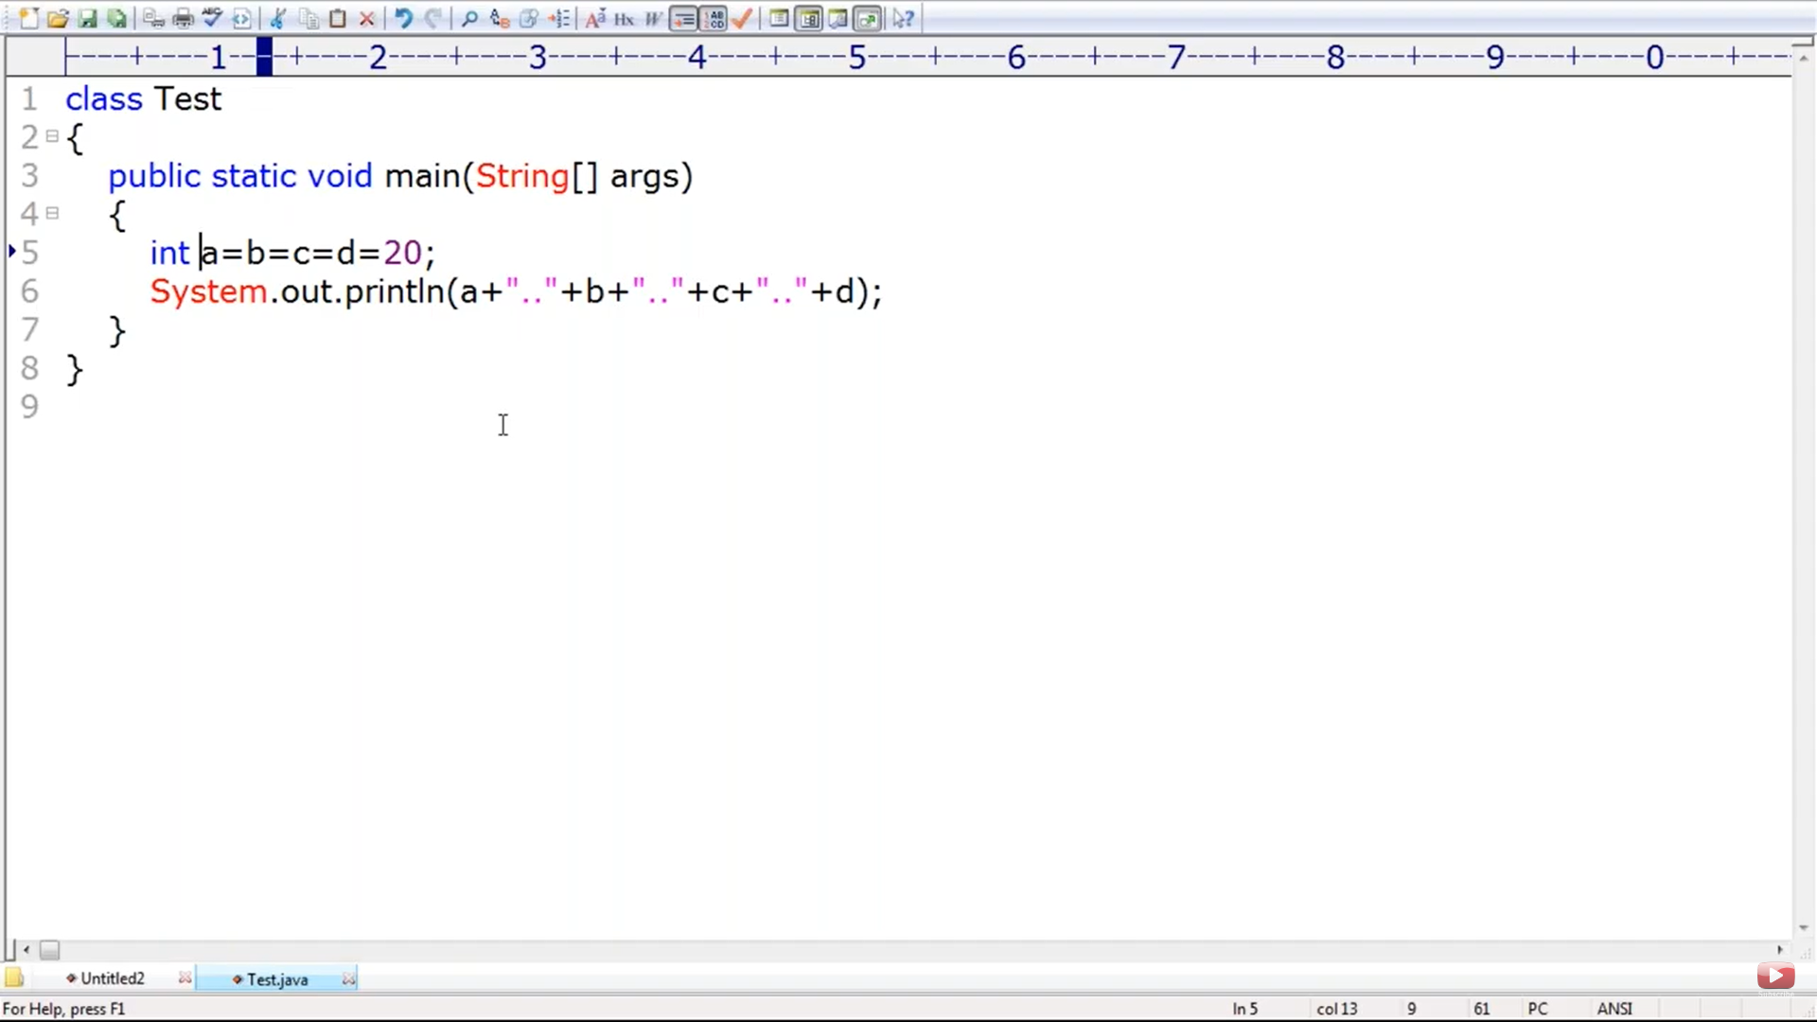

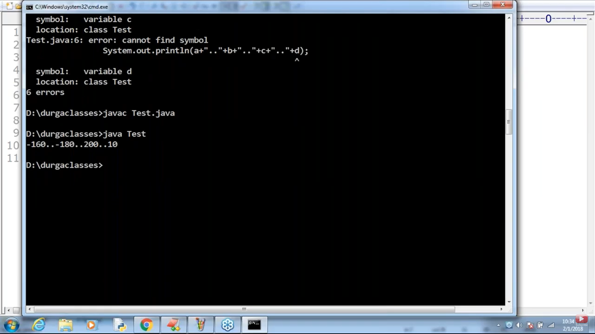

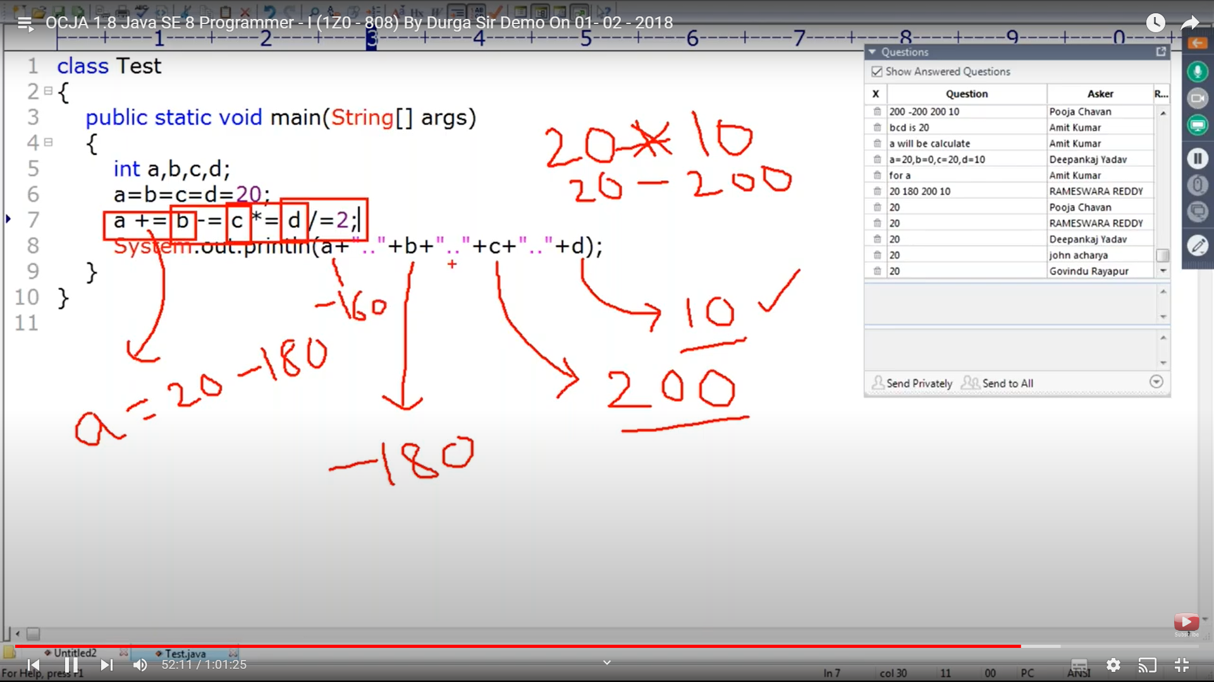

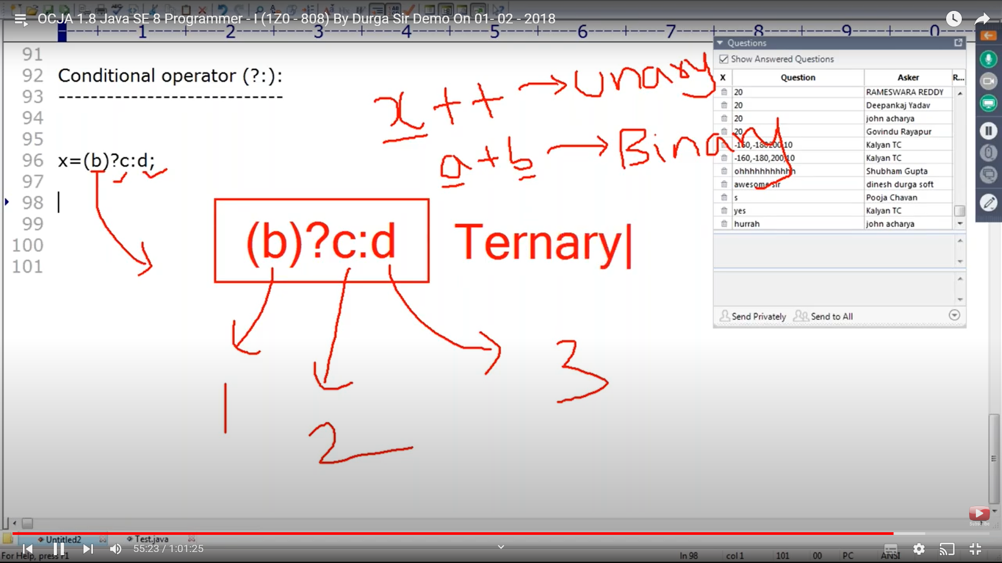

70

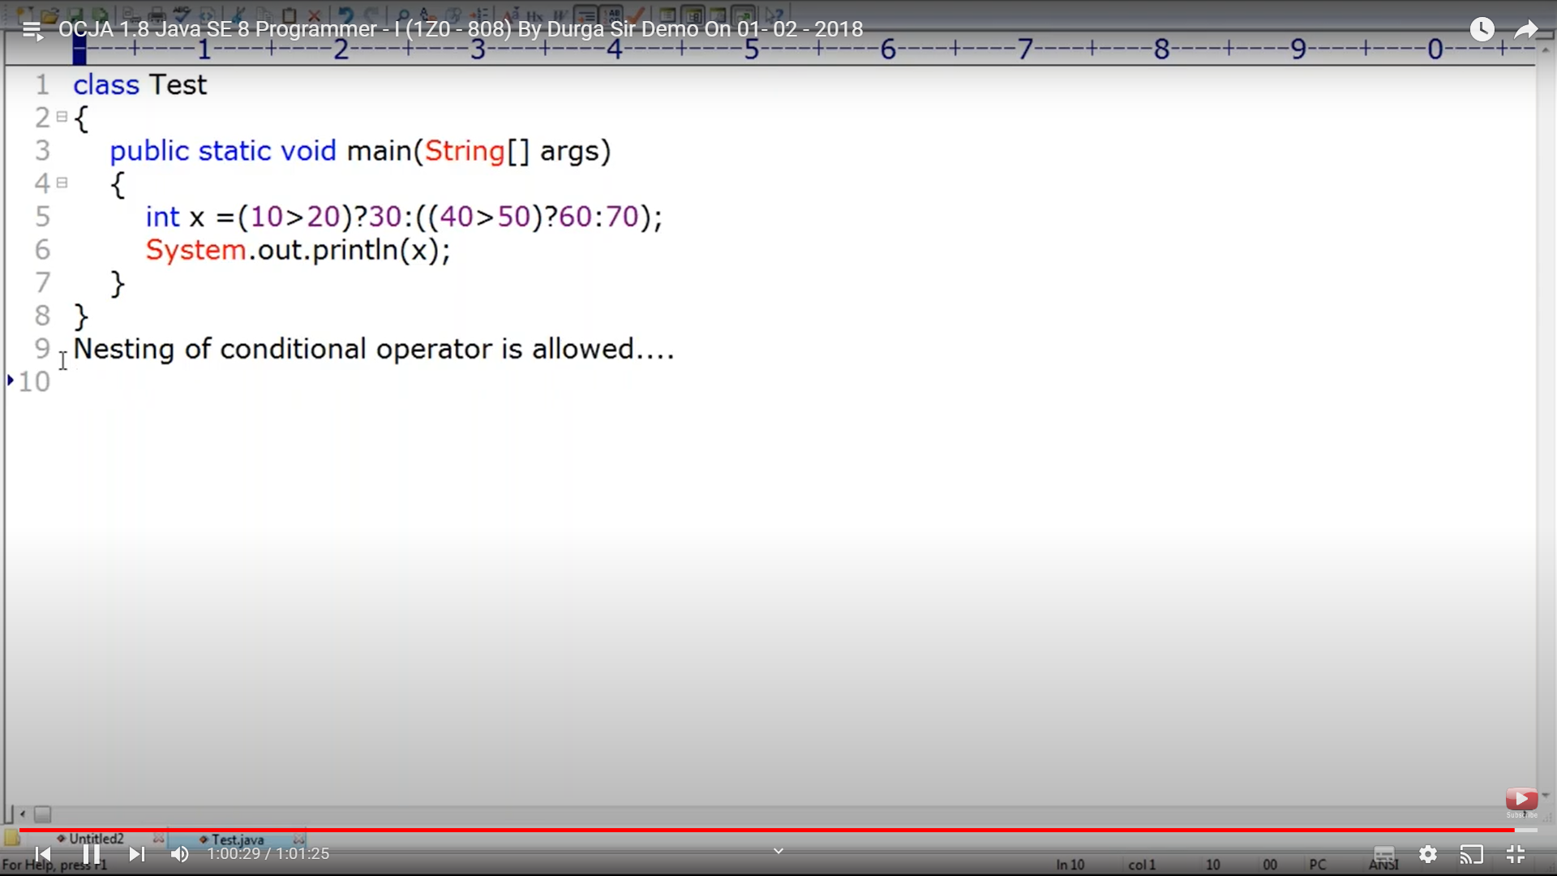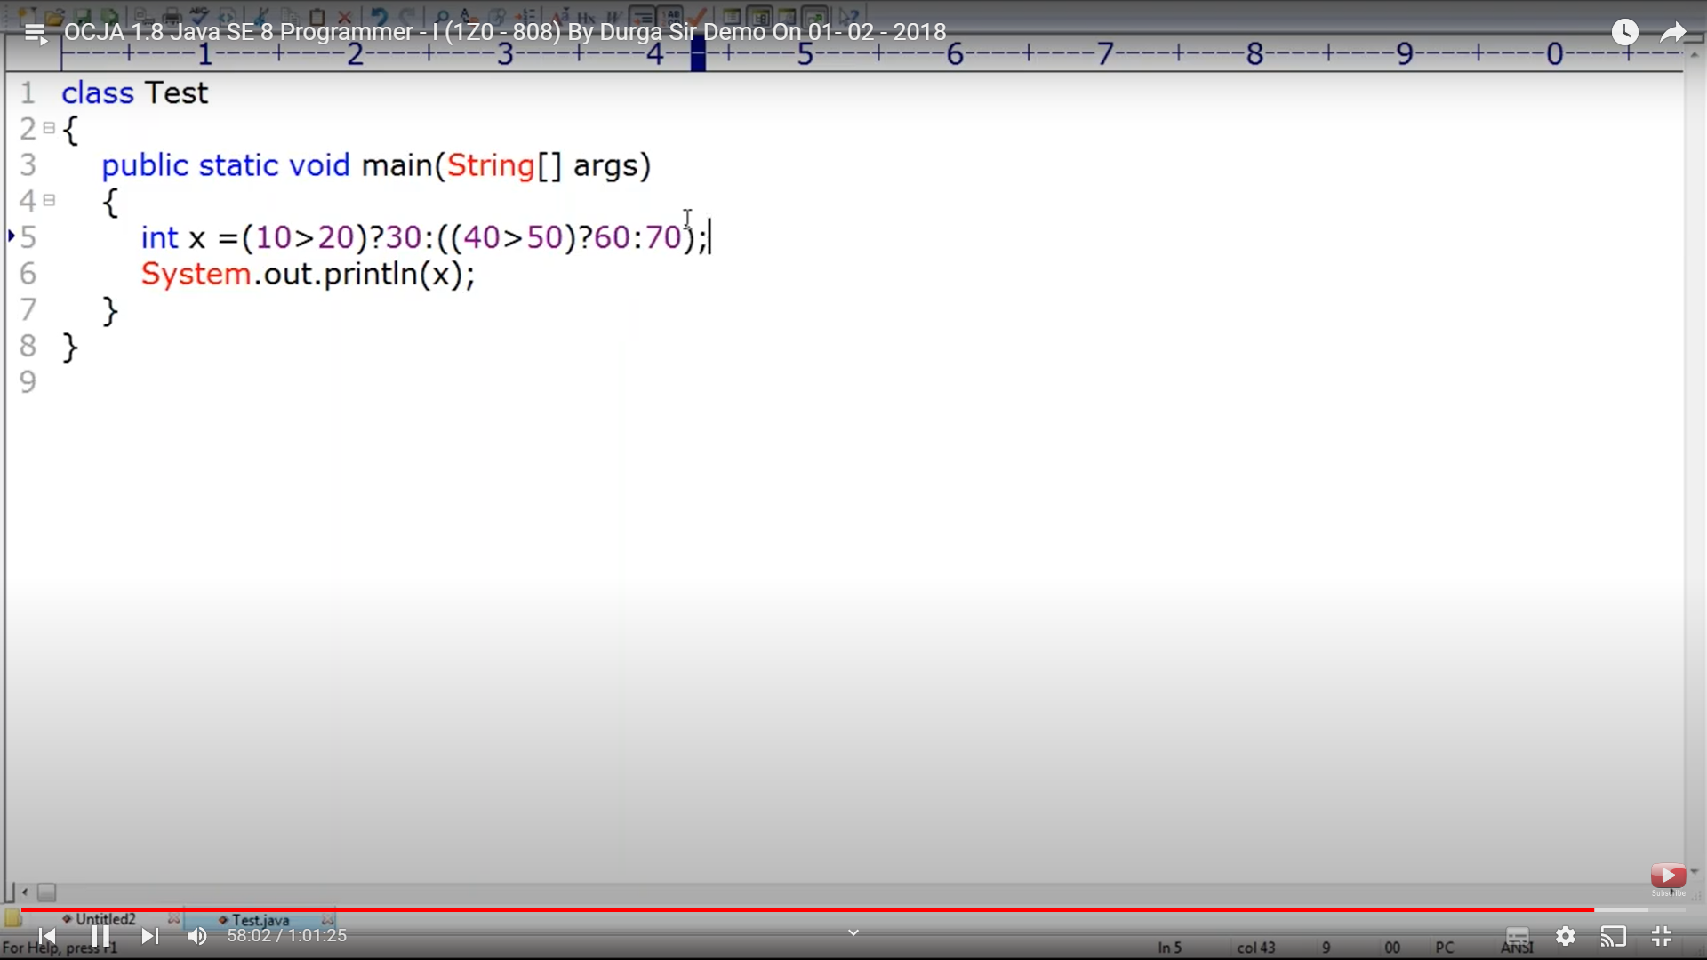

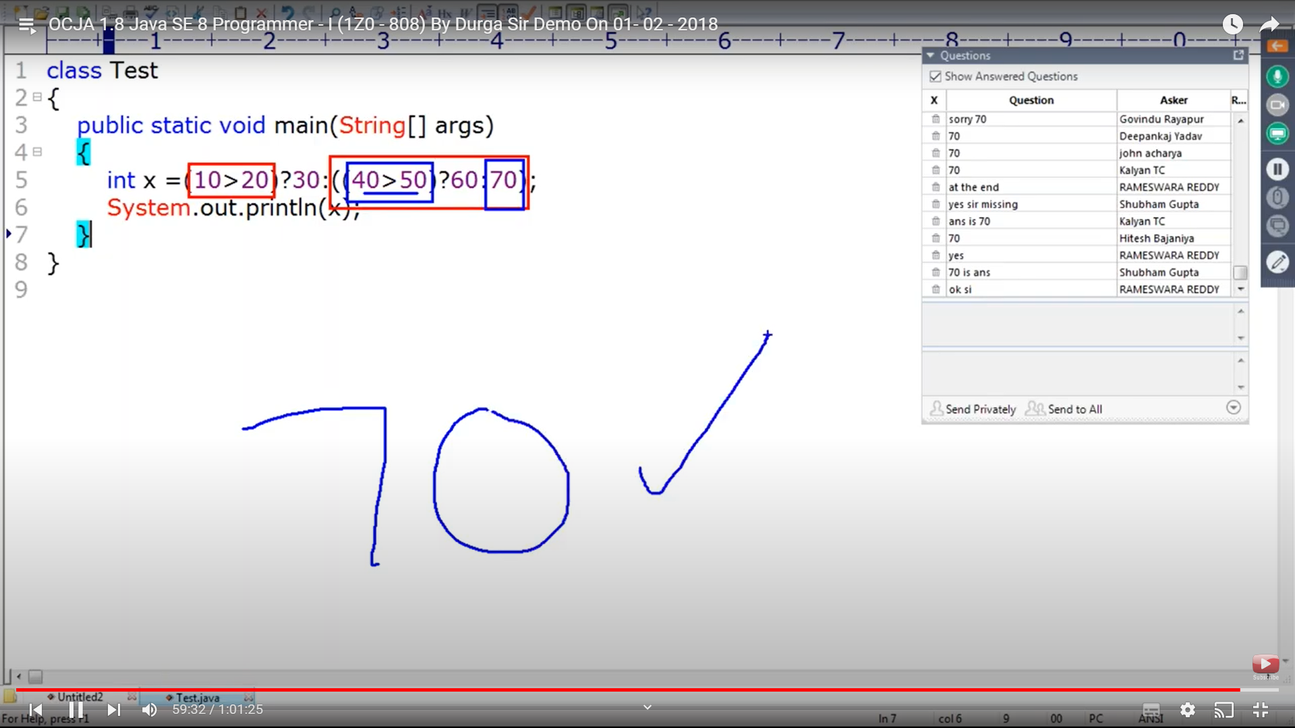**s**